**CS 2302 Data Structures**

**Fall 2019**

**Lab Report #7**

Due: December 4, 2019

Professor: Olac Fuentes

TA: Anindita Nath

**Introduction**

Lab 7: Algorithm Design Techniques focuses on using randomization to verify a Hamiltonian path and backtracking to find a potential Hamiltonian path. Dynamic programing is further explored through the edit distance function. The Adjacency List, Edge List, and Adjacency Matrix Classes all implement the insert_edge, delete_edge, display, draw, randomized_hamiltonian, and backtracking_hamiltonian functions. The main program also contains the generic randomized_hamiltonian function that was based on the pseudocode provided. Tests were conducted to compare the runtime complexity for each function depending on the graph type. The generalized randomized function had its own tests. For the edit distance function, the code provided by the instructor was altered to ensure that word replacements could only occur between vowels or between consonants. In all, the purpose of this lab was to evaluate the three types of algorithms: randomization, backtracking, and dynamic programming.

**Proposed Solution Design and Implementation**

**Overall Design**

This lab consists of five files: graph_AL.py, graph_AM.py, graph_EL.py, HashTable.py, and NicholeMaldonado_Lab7.py. The graph_AL.py, graph_AM.py, and graph_EL.py contain the classes for the adjacency list, adjacency matrix, and edge list. The HashTable.py was used to store random edges that would later be used to populate the tables for the automated tests and keep track of the edges used for a subset. The main part of the program lies in the NicholeMaldonado_Lab7.py. The program gives users the option to create their own graph or run automated tests.

The randomization algorithm created based on the pseudocode provided resides in the NicholeMaldonado_Lab7.py file. The other graph contain their own implementations, however, they were only used to perform a comparison between the different graph types and do not necessarily reflect the given method header. For the strict following of the randomization algorithm provided, view the function randomized_hamiltonian in NicholeMaldonado_Lab7. As for the backtracking, each graph implementation has their own backtracking function. The edit distance function for part 3 can be found in the NicholeMaldonado_Lab7.py file.

**Part 1**

Main Design:

When the program first starts, users have the option to create their own tests, evaluate their own edit distance between two strings, or run automated tests. If the user decides to create their own test, they are able to select the number of vertices the graphs will have and the edge factor. The edge factor is used to determine the number of edges the graph will have. For example, a graph with an edge factor of 1 will have the same number of edges as the same number of vertices. After making these decisions, the user is then able to determine whether they want to perform backtracking to identify a possible Hamiltonian path or perform a randomization algorithm to identify a possible Hamiltonian path. In order to perform these tasks, the function create_graph_menu is used to set up the graph. Allowing custom tests was a very important design decision that I made. Initially, I was just going to allow the user to enter edges. I realized that this would be very cumbersome, since the user would have to write edge after edge and may forget what edge they added. Thus, I decided by allowing an open test interface, the users would have more flexibility to test larger graphs with a varying number of edges. For the edit distance, users are also allowed to determine whether they want to test two particular strings or strings of a specific length. The function, custom_edit_distance, takes the users response and performs the edit distance accordingly.

If the user selected automated tests, then the function automated_test_setup, is called. From this function, users are able to select which function they wanted to test: generalized Hamiltonian cycle, generalized Hamiltonian cycle with reduced edges, randomization to detect a Hamiltonian cycle, backtracking to detect a Hamiltonian cycle, and edit distance. Based on the function selected, the corresponding “run_automated” function is called. In order to create the graphs that the operations would be performed on, the functions, generate_test_graphs and generate_test_graphs_with_hamiltonian, are used. The main difference between the generate_test_graphs and generate_test_graphs_with_hamiltonian is that the second function ensures that the graph contains a Hamiltonian path. Rather than finding random edges and hashing the edges, the generate_test_graphs_with_hamiltonian, selects random vertices and inserts an edge between the vertices. This results in a graph purely comprised of a Hamiltonian path. However, in order to keep the generate_test_graphs_with_hamiltonian consistent with the other function, random edges are then hashed to meet the required edge number. Creating graphs with guaranteed Hamiltonian paths was a very important design decision that I made. Initially, I used the generate_test_graphs and identified that many of the random graphs created did not have a Hamiltonian path. This was very alarming when testing functions, like the randomized algorithm, since the program could not find a path. Rather than guessing whether a graph contained a Hamiltonian cycle, I decided that it would be better to create a separate group of graphs with a guaranteed Hamiltonian cycle. As the tests will later show, these different groups of graphs experienced different runtimes.

Randomization Algorithm to Verify a Hamiltonian Cycle:

A total of four algorithms were used to verify a Hamiltonian Cycle. The first algorithm is based on the pseudocode provided and is referred to as the general randomization algorithm. The other algorithms take an adjacency list, adjacency matrix, or edge list and create random subsets from the pre-existing graph.

For the generalized algorithm, a subset of random edges, vertices, and trial number are passed as parameters. The number of trials is 10,000. For each trial, the function generate_random_subset is called which takes the vertices and edges as a parameter. This function uses an adjacency list to store the edges of the subset graph and format the cycle. In order to ensure that the graph only has one connected component, a disjoint set forest is used. A counter is initialized to the number of vertices to keep track of the number of edges added. For each iteration, a random edge is chosen from the list of edges. The edge’s insertion is attempted by using the insert_edge_no_duplicates function which operates just like the insert function but ensures that the edge has not already been inserted once. Since the edge picking is random, it is crucial to check for duplicates. Although one may believe that checking the adjacency list would be time consuming, the size of the list where the edge is inserted is always checked. If there are more than two edges for a vertex, then None is returned, symbolizing that the subset graph has more than two indegrees. For each edge inserted, a union is performed between the random edge’s source and destination. If the union is not successful, then two options could occur. If the number of edges is equal to 1, then the proposed Hamiltonian cycle is completed. Otherwise, a different cycle was created, so None is returned. Once the generate_random_subset has either returned the subset graph or None, the result is evaluated. If None is returned, then None, None is returned. Otherwise, the subset is first checked to ensure that every vertex has an indegree of two. Since the generate_random_subset function ensures that the number of indegrees is less than or equal to two, if a subset graph is found, then the indegree of each edge must be two. Since the adjacency list only allows two edges per vertex and a counter keeps track of the number of valid edges added, it can be deduced that each edge of a successfully created subset graph has exactly an indegree of two. The subset graph is then it is returned along with the cycle of edges. This cycle of edges is created by using the al_to_cycle function which iterates through the edges to form a list of the cycle.

As for runtime complexity, |V| edges need to be found where V is the number of vertices in the graph. This results in a minimum of |V| iterations to find an edge. Inserting an edge into the adjacency list is done in constant time, since at most two edges of a given vertex will be compared before inserting the third edge. As for the forest union, I used path compression for the find function resulting in log|V| for each random edge added. This results in a runtime complexity of O(|V|log|V|) where V is the number of vertices in the graph. Once the subset graph is created, the cycle needs be created resulting in O(|V| + |E|) where E is the number of edges and V is the number of vertices for that subset graph. This results in an overall runtime complexity of O(n(|V|log|V| + |V|)) where n is the number of trials. This simplifies to O(n(|V|log|V|)).

The randomized algorithm for the adjacency list consists of an outer function, randomized Hamiltonian, and inner recursive function, generate_random_subset. When the function, randomized_hamiltonian, is called, the user specifies the number of trials to be conducted. Before conducting the trials, the number of edges in the graph are first checked. If the graph does not have at least V number of edges, then the trials are never conducted and None, None is returned. This was an important design decision that I made because I realized that if a graph only had two edges and four vertices, for example, then an infinite loop would occur for the generate_random_subset. This is avoided by first checking the number of edges. Since the number of edges is checked, I also realized that if a vertex had 0 or 1 edge, then a Hamiltonian cycle cannot exist. Consequently, None, None is immediately returned without conducting the tests. For each trial, the recursive method generate_random_subset is called. In this function, the new adjacency list subset graph is created as well as a disjoint set forest. Rather than create the adjacency and then traverse the graph again to create the disjoint set forest, I decided that it would be better to do both actions simultaneously. While the expected number of edges for the new graph subset has not been created two random vertices are selected. Then, the subset graph inserts the vertex using the function insert_edge_no_duplicates, which operates similar to the insert edge function, but ensures that the duplicate edges cannot exist. Thus, before each edge is inserted, the vertex and destination are checked to ensure that the edge does not exist before being inserted. Although one may see this action as time consuming, it is, in fact, not. Since every vertex can only have two adjacent edges, each edge list for the adjacency list must have a length of two. Thus, every time an edge is inserted, the lengths are checked to ensure that the vertices have a degree equal to or less than two. If a vertex has more connecting edges, then None is returned. Otherwise, the disjoint forest unites both vertices. If the union method returns 0, signifying that the component is already connected and the number of vertices left is greater than one, then None is returned. If not, one is subtracted from the number of vertices signifying the success of an edge to the subset graph. Including the disjoint forest to check for a single connected component was a very important design decision that I made. Initially, I created my subset of edges, and then created a disjoint set forest to identify if it was connected. However, this was very time consuming since the subset would have to be iterated through again to create the disjoint set forest. By immediately using the disjoint set forest as the random edges were being created, the plausibility of the graph containing a Hamiltonian cycle was immediately known. If the union of two vertices was unsuccessful, since both belonged to the same root, and only one edge was remaining, then it is known that the graph could potentially contain a Hamiltonian cycle. Otherwise, if more than one edge still needs to be added, then it is known that a different cycle in the graph has occurred. If a random subset is found, then the subset graph is returned. While the cycle is being constructed, the indegree of each vertex is checked. If the indegree is not equal to two, then None is returned. If the subset graph is successfully created, then it is known that each vertex has an indegree of two. In order to clearly show this cycle, the function al_to_cycle is called. This function follows the trail of edges in the subset graph and records the edges as they appear. For example, the cycle is first initialized to the edge between the vertex zero’s first destination, d1, and vertex zero’s second destination, resulting in the form (d1, 0), (0, d2). The adjacency list then accesses the two edges adjacent to d2, namely d3 and d4, and selects the vertex that is not the previous vertex, in this case zero. This results in the format of (d1, 0), (0, d2), (d2, d3). Then, the adjacent vertices of d3 will be evaluated and the process will continue on until all the vertices have been visited. The cycle is then returned. This was a very important design decision because I wanted to clearly demonstrate the cycle. At first, I was just creating a list of the edges and returning them. However, this list was unordered, which made the existence of a cycle hard to visualize. Although the entire subset graph needs be traversed in order to create the ordered list of edges, this was the best decision in terms of runtime. Since random edges are being created, it is unknown whether, for example (0,1) should be inserted in the list or (1,0).

As for runtime complexity, |V| edges need to be found where V is the number of vertices in the graph. This results in a minimum of |V| iterations to find an edge. Inserting an edge into the adjacency list is done in constant time, since at most two edges of a given vertex will be compared before inserting the third edge. As for the forest union, I used path compression for the find function resulting in log|V| for each random edge added. This results in a runtime complexity of O(|V|log|V|) where V is the number of vertices in the graph. Once the subset graph is created, the cycle needs to be created resulting in O(|V| + |E|) where E is the number of edges and V is the number of vertices for that subset graph. Additionally, the adjacency list needs to be checked beforehand to ensure that the graph contains enough edges to considered. The runtime of this check would be O(|V|). This results in an overall runtime complexity of O(n((|V|log|V|) +|V|)) + (|V|)) where n is the number of trials. This simplifies to O(n(|V|log|V|)).

The randomization algorithm for the adjacency matrix is similar to randomization algorithm for the adjacency list, with some slight changes. The adjacency matrix has the outer, randomized Hamiltonian function, which calls the generate_random_subset function for each trial. Before calling the generate_random_subset function, the number of edges in the adjacency matrix is first evaluated to ensure that there are at least V edges, where V is the number of vertices. Failure to do so, could result in an infinite loop in the generate_random_subset function. Unlike the adjacency list implementation, the enough_edges function does not check if there is a vertex with 0 or 1 edge. Since the graphs are undirected, half of the adjacency matrix is only traversed. Thus, the other half of adjacency matrix is unknown. Initially, I thought about traversing the entire table, but realized that it would result in a longer runtime. This was a large compromise, but well worth it. For example, if a matrix was 1,000 by 1,000, a maximum of 500,000 cells would be checked rather than 1,000,000 cells. Additionally, in the scenario that enough edges existed, then the extra 500,000 cells checked was a waste of runtime. After checking the number of edges, the generage_random_subset_function is used. This function this time utilizes a hash table to store the edges. Whereas the adjacency list can easily be evaluated to determine if an edge has been used, the adjacency matrix cannot. If one needed to check if an edge was used, then the entire adjacency matrix row would need to be iterated through. Thus, by double hashing each edge to a bucket, the task is able to be done in constant time. Similar to the adjacency list, two random vertices are selected. If the current cell does not contain a negative one and does not already exist in the graph, which is determined by the hash table, then the edge is prepared to be inserted. Before inserting the edge however, the length of the bucket of each vertex is checked. If the current length is greater than or equal to two, None is returned since it is known that the current subset cannot contain a Hamiltonian path. Otherwise, the disjoint set forest unionizes the two vertices. If the two vertices have the same root and the number of edges that still need to be added is greater than one, then None is returned. This check essentially determines that if a cycle is created, then the current vertices must be the start and end of the complete Hamiltonian path. If all the checks pass, then the edge is inserted into the new subset adjacency matrix, and the number of edges to be inserted is decremented by one. If the subset graph is found, then it is returned as well as the hash table. The cycle is constructed and returned along with the subset adjacency matrix. In order to construct the cycle, the hash table has a function called format_elements, which will essentially trace through the edges and return the resulting cycle. Thus, its implementation is similar to the al_to_cycle function.

As for runtime complexity, |V| edges need to be found where V is the number of vertices in the graph. This results in a minimum of |V| iterations to find an edge. However, since the adjacency matrix is larger, there are |V|^2 possible combinations to choose. Thus, the possibilities of correctly choosing an edge each time is extremely slim. Inserting an edge into the adjacency matrix is done in constant time, since the two vertices are known. As for the forest union, I used path compression for the find function resulting in log|V| for each random edge added. This results in a runtime complexity of O(|V|log|V|) where V is the number of vertices in the graph. Once the subset graph is created, the cycle needs be created resulting in O(|V| + |E|) where E is the number of edges and V is the number of vertices for that subset graph. Beforehand, half of the adjacency matrix will also need to be evaluated in order to ensure that enough edges exists. This results in O(|V^2|) where V is the number of edges. In the worst case, the entire adjacency matrix will be iterated through since each vertex will be evaluated, resulting in the row to be evaluated. This results in a total runtime complexity of O(n((|V|^2)) where n is the number of trials.

The randomization algorithm for the edge list is similar to randomization algorithm for the adjacency matrix, with some slight changes. The edge list has an outer, randomized_hamiltonian function which calls the generate_random_subset function for each trial. The generate_random_subset function performs the same task and uses a hash table to store the edges. Unlike the other implementations, a single random index is chosen ranging from 0 to the length of the edge list. This will determine the edge to be added. If the edge is able to be successfully hashed in both buckets, then the edge is prepared to be inserted. Before inserting the edge however, the length of the bucket of each vertex is checked. If the current length is greater than or equal to two, None is returned since it is known that the current subset cannot contain a Hamiltonian path. Otherwise, the disjoint set forest unionizes the two vertices. If the two vertices have the same root and the number of edges that still need to be added is greater than one, then None is returned. If all the checks pass, then the edge is inserted into the new subset edge list, and the number of edges to be inserted is decremented by one. If the subset graph is found, then it is returned as well as the hash table. The randomized_hamiltonian will then ensure that each vertex has an indegree of two by simply checking the length of the edge list subset. If the length of the edge list subset is equal to the number of vertices from the original graph, then each vertex will have an indegree of two. Although one could reason that a vertex could have an indegree of three and another vertex could have an indegree of one, resulting in a false comparison, this is in fact wrong. By using the hash table, it is known that each vertex has an indegree of two. Thus, the problem stated above could never occur. The cycle is then constructed and returned along with the subset edge list. In order to construct the cycle, the hash table again uses the format_element function.

As for runtime complexity, |V| edges need to be found where V is the number of vertices in the graph. This results in a minimum of |V| iterations to find an edge. Since the edge list is the smallest of the three graphical representations, there are E possible edges to choose. Thus, the possibility of correctly choosing an edge each time is improved from the former. Inserting an edge into the edge list is achieved in O(log|E|), since the edge list is ordered. As for the forest union, I used path for the find function resulting in log|V| for each random edge added. This results in a runtime complexity of O(|V|log|V|) where V is the number of vertices in the graph. Once the subset graph is created, the cycle is created in O(|V| + |E|) where E is the number of edges and V is the number of vertices for that subset graph. This results in a runtime complexity of O(n(m(log|E| + |V|log|V|)) plus O(V + E) if a cycle is found, where m is the number of times it takes to find the edges to create the random subsets, and n is the number of trials. This simplifies to O(m(VlogV)). However, it is also important to note, that each vertex will be visited once resulting in the entire edge list to be iterated through to find the adjacent edges. This results in a total runtime complexity of O(|V| * |E|).

**Part 2**

Backtracking to find a Hamiltonian Cycle:

For the adjacency list, the backtracking function consists of an outer backtracking_hamiltonian function and the recursive backtracing_hamiltonian_recur. For the backtracing_hamiltonian function, the start vertex of the cycle is passed in as a parameter. Since a cycle does not have to start at a set vertex, I decided to allow different variations of the cycle to be chosen rather than always starting at vertex 0. The function then creates a disjoint set forest which is used to ensure that a cycle, other than the Hamiltonian cycle, is not created. The backtracking_hamiltonian_recur cycle is then called with the start vertex, disjoint set forest, and start_vertex again passed as a parameter. The start_vertex is passed twice as a parameter because the first instance denotes the current vertex being evaluated and the second instance is used to reference the start of the cycle. The recursive method all includes a num_seen variable which defaults to one when it is first called. One of the base cases for the recursive function is when num_seen equals the number of vertices. If this occurs, then the find_edge method is called. The find_edge method accepts a source and target vertex and identifies if the adjacency list contains an edge from the source to target vertex. In this case, the source vertex is always the last most vertex in the path and the target vertex is the original starting vertex. If the edge exists, then a list with the edge is returned and a subset graph with the new edge is returned. This list of edges will repeatedly append all the other edges from the prior recursive calls. Another base case for the recursive function is if the current vertex has only adjacent edge. If this occurs, the adjacent vertex will have to be passed through twice in order to reach the vertex. This violates the property of a Hamiltonian path, so None and -1 are returned. If both base cases are not met, the adjacent edges of the current vertex are iterated through. For each adjacent edge, the disjoint set forest’s parent is first checked at the destination vertex. If the cell contains a -1, then it is known that the vertex has not been visited yet. The current vertex and adjacent vertex are both unionized. If the vertices are already connected components, then the next adjacent edge is evaluated. Otherwise, a recursive call is made passing in the destination as the current vertex, the forest, start_vertex, and the num_seen plus one. Once all the recursive calls are made and the base case is met, three possibilities can occur. The first is that the subset is not None, which means that the Hamiltonian path was found. The current edge will then be appended to the subset obtained and the edge will be inserted in the graph. The subset of edges and the subset graph will then be returned. If the subset graph is -1, then it is known that a Hamiltonian path cannot occur, so None and -1 are returned. Otherwise, it is possible that a Hamiltonian path could exist. Thus, the backtracking portion of the algorithm will occur. In order to backtrack, the forest’s parent at the current adjacent vertex is marked with a negative one. This removes the current adjacent vertex from the forest. The next adjacent vertex is then evaluated and the process repeats. If all the adjacent edges are iterated through, then the program will back track to the last recursive call and therefore pass None, None. In all, this algorithm will follow a path and use the disjoint forest set to prevent cycles and ensure that a vertex has not been seen more than once. If the path does not lead to a Hamiltonian path, then it backtracks to the previous vertex and tries a different path. Once the recursive function has finished, the backtracking_hamiltonian cycle returns the edges and subset graph. If the subset is None, then a Hamiltonian path does not exist and None, None is returned.

For the runtime complexity of the recursive function, in the worst case, the algorithm will continue to backtrack and attempt to find different paths. Thus, for a single recursive instance V recursive calls will be made where V is the number of vertices not yet visited. The number of vertices not yet visited will decrease by one for each recursive call resulting in V(T(V - 1)). Insertions in the graph are achieved in constant time. For each recursive call, union is applied for each adjacent edge whose destination vertex has not been visited. This results in an additional O(mlogn) where m in the number of adjacent edges and n is the number of vertices that have already been visited. This results in a total of |V|(T(|V| - 1)) + mlogn where V is the number of vertices not yet visited, m is the number of adjacent edges for the current vertex and n is the number of vertices that have already been visited. This simplifies to the overall runtime complexity of O(|V|!). If the base case is reached, then the adjacent vertices of the last edge are checked. However, this check is insignificant when adding it to the overall runtime complexity.

The backtracking implementation for the adjacency matrix is similar to that of the adjacency list. The backtracking_hamiltonian function and backtracking_hamiltonian_recur function are both used. The current vertex, disjoint set forest, and start_vertex are initially passed as a parameter. The num_seen is also a parameter whose default value is one. Similar to the adjacency list, if the num_seen equals the number of vertices, then the adjacency matrix is evaluated to ensure that an edge exists from the current vertex to the start vertex. If the edge exists, then a list with edge and a new subset graph is returned. Otherwise, None, None is returned. Unlike the adjacency list, identifying whether a vertex only has one edge is difficult. Thus, a num_adjacent counter is used to count the number of adjacent edges while the current row for the vertex is being iterated through. For each adjacent vertex, the counter is incremented. If the entire row is iterated through the num_adjacent is equal to one, then None and -1 are returned. This was an important design decision because graphing a vertex with just one edge cannot contain a Hamiltonian path. Rather than backtracking, the entire search ends. Aside from the num_adjacent counter, the row of the adjacency matrix is iterated through. If an adjacent edge is found, the disjoint set forest is checked to ensure that the current vertex has not already been seen. If not, the current vertex and adjacent vertex are unionized. If the vertices are already connected components, then the iteration through the row is continued. Otherwise, a recursive call is made with the adjacent vertex, forest, start_vertex, and num_seen plus one passed as parameters. After all the recursive calls have been made and a base case has been reached, then the same three possibilities can occur. If the returned subset is not None, then the current edge is appended and added to the subset graph. The subset and subset graph are then returned. If the subset graph is a -1, then None and -1 are returned. Otherwise, the forest’s parent at the adjacent vertex is marked as a -1 and the search for adjacent edges continues. By marking the forest parent at the adjacent vertex as -1, the recursive function is able to backtrack and later incorporate the vertex again into the path. If the entire row has been iterated, then None, None is returned and the backtracking continues. Once the recursive function has been completed, then the returned subset is analyzed. If it is None, then None, None is returned. Otherwise the subset and subset graph are returned.

For the runtime complexity of the recursive function, in the worst case, the algorithm will continue to backtrack and attempt to find different paths. Thus, for a single recursive instance V recursive calls will be made where V is the number of vertices not yet visited. The number of vertices not yet visited will decrease by one for each recursive call resulting in V(T(V - 1)). Insertions in the graph are achieved in constant time. For each recursive call, union is applied for each adjacent edge whose destination vertex has not been visited. This results in an additional O(mlogn) where m in the number of adjacent edges and n is the number of vertices that have already been visited. Additionally, since the adjacency matrix requires the entire row of a current vertex to be iterated through, there is |V| additional work. This results in a total of |V|(T(|V| - 1)) + mlogn + |V| where V is the number of vertices not yet visited, m is the number of adjacent edges for the current vertex and n is the number of vertices that have already been visited. Additionally, since the adjacency matrix requires the entire row of a current vertex to be iterated through, the runtime complexity is expected to be higher than that of the other graphical implementations. The overall runtime complexity is O(V!) but is higher than the adjacency list since each row must be iterated through to find adjacent edges.

The edge list implementation of backtracking is similar to the adjacency list’s backtracking algorithm. The backtracking_hamiltonian function and backtracking_hamiltonian_recur function are both used. The current vertex, disjoint set forest, and start_vertex are initially passed as a parameter. The num_seen is also a parameter whose default value is one. Similar to the adjacency list, the num_seen equals the number of vertices, then the edge list is evaluated to ensure that an edge exists from the current vertex to the start vertex using the find_edge function. If the edge exists, then a list with the edge and a new subset graph is returned. Otherwise, None, None is returned. Unlike the adjacency list, identifying whether a vertex only has one edge is difficult. Thus, a num_adjacent counter is used to count the number of adjacent edges while the edge list is being iterated through. For each adjacent vertex, the counter is incremented. If the entire segment of the edge list where the adjacent vertex could reside is iterated through and the num_adjacent is equal to one, then None and -1 are returned. This was an important design decision because a vertex with just one edge cannot contain a Hamiltonian path. Thus, rather than backtracking, the entire search ends. Additionally, since the edge list is ordered, only a segment of the edge list needs to be iterated through as demonstrated in Lab # 6. While iterating, if an adjacent edge is found, the disjoint set forest is checked to ensure that the current vertex has not already been seen. If not, the current vertex and adjacent vertex are unionized. If the vertices are already connected components, then the iteration continues. Otherwise, a recursive call is made with the adjacent vertex, forest, start_vertex, and num_seen plus one passed as parameters. After all the recursive calls have been made and a base case has been reached, then the same three possibilities can occur. If the returned subset is not None, then the current edge is append and added to the subset graph. The subset and subset graph are then returned. If the subset graph is a -1, then None and -1 are returned. Otherwise, the forest’s parent at the adjacent vertex is marked as a -1 and the search for adjacent edges continues. By marking the forest parent at the adjacent vertex as -1, the recursive function is able to backtrack and later incorporate the vertex again into the path. If the entire segment of the edge list has been iterated, then None, None is returned and the backtracking continues. Unlike the other two graphical representations, the edge list can contain the current vertex as the source or destination of an edge in an undirected graph. Thus, while iterating through the edge list, both the source and destination of each edge are checked. Once the recursive function has been completed, then the returned subset is analyzed. If it is None, then None, None is returned. Otherwise the subset and subset graph are returned.

For the runtime complexity of the recursive function, in the worst case, the algorithm will continue to backtrack and attempt to find different paths. Thus, for a single recursive instance V recursive calls will be made where V is the number of vertices not yet visited. The number of vertices not yet visited will decrease by one for each recursive call resulting in |V|(T(|V| - 1)). Insertions in the graph are in log|E| time where E is the number of edges in the current subset edge list. For each recursive call, union is applied for each adjacent edge whose destination vertex has not been visited. This results in an additional O(mlogn) where m in the number of adjacent edges and n is the number of vertices that have already been visited. This results in a total of |V|(T(|V| - 1)) + mlogn + log|E| where V is the number of vertices not yet visited, m is the number of adjacent edges for the current vertex, n is the number of vertices that have already been visited, and E is the number of Edges in the current subset edge list. Additionally, since a portion of the edge list needs to be iterated, in the worst case the entire edge list will be iterated through to find the adjacent edges. Thus, the edge list is expected to have a higher runtime complexity then the adjacency list but lower than the adjacency matrix. This simplifies to the overall runtime complexity of O(|V|!).

**Part 3**

Edit Distance:

For the edit distance function, the provided code was altered to ensure that if characters are interchanged, they are both consonants or vowels. The parameters for the function are the two strings. In order to follow the rule above, an initial vowel set is created with all the vowels. Then for every cell evaluated, the four possibilities are compared. If the current characters of both strings match, then the cell’s diagonal value is copied in the current cell. Otherwise, the three surrounding cells are evaluated. In order to do so, an array of the three surrounding cell values is created. Then an order array is populated with the indices of n if it was sorted by using numpy’s argsort function. Then, if the first index corresponds the replacement value, each character is evaluated. If both characters are in the vowel set or not in the vowel set, then the replacement can be made, otherwise, the next index is selected, and that value is chosen. If the order array’s first index does not match the replacement value, then the current cell is just assigned to that value plus one. Using the argsort function was an important design decision that I made. I realized that the second minimum value would need to be known in the event that the replacement was the minimum value and the characters could not be swapped.

As for runtime complexity, the entire matrix needs to be iterated through resulting in O((s1 + 1) *( s2 + 1)) where s1 is the length of the first string and s2 is the length of the second string. Additionally, since argsort will only ever evaluate three characters, the time for the argsort is constant.

**Experimental Results**

NOTE: AL stands for Adjacency List, AM stands for Adjacency Matrix, and EL stands for Edge List.

NOTE: For all sample outputs, a graph with 10 vertices and 15 edges were used. In doing so, the graph implementations are clearly able to be viewed.

**Part 1**

**Generalized Randomization:**

For the Generalized Randomization test, a total of three tests were run with three trials per test. The three cases were conducted on graphs with 150 edges and 100 vertices, 250 edges and 375 vertices, and 750 edges and 500 vertices. The number of edges is 1.5 times the number of vertices. This ratio was applied on all the test to produce an average number of vertices to ensure that the graphs were not sparsely populated but also not fully populated. The trial number for each test was set to 10,000. Each case also tests undirected and weighted graphs. I thought that these cases were important to identify how the runtime complexity for the generalized randomization function would vary between the different graphs and their sizes. Additionally, by using the generalized algorithm, I would be able to demonstrate tests on a regular implementation and an implementation based on the individual graph types.

Sample Output For General Randomization Algorithm:

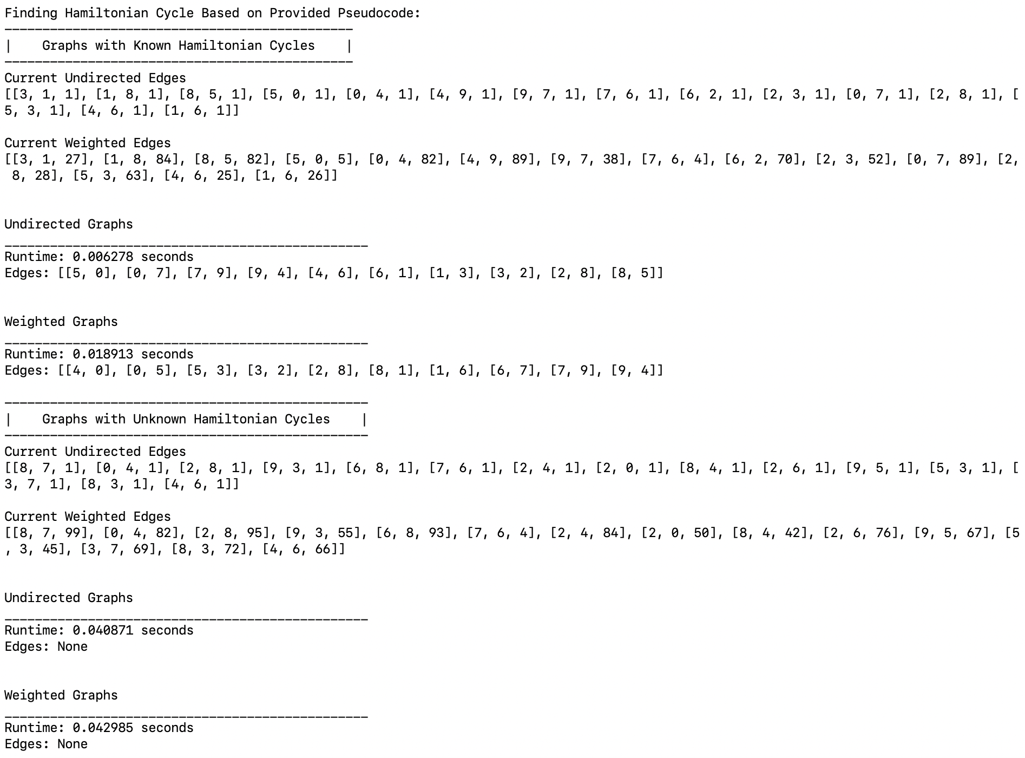

Undirected Hamiltonian Cycle:

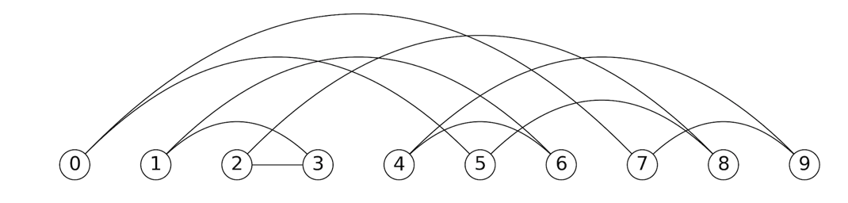

Weighted Hamiltonian Cycle:

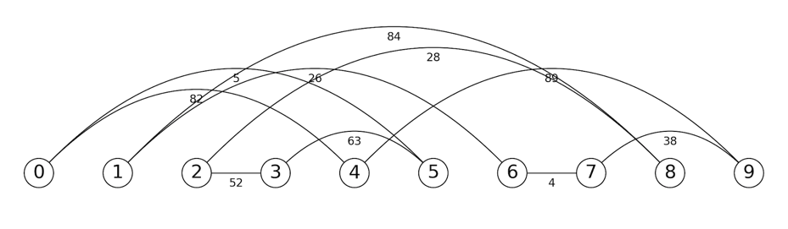

Case 1 (“150 edges, 100 vertices”):

* 150 edges per graph
* 100 vertices



Case 2 (“375 edges, 250 vertices”):

* 375 edges per graph
* 250 vertices



Case 3 (750 edges, 500 vertices”):

* 750 edges per graph
* 500 vertices





From the tests it is evident that the graphs with a known Hamiltonian cycle had a higher runtime. This is because the random set of edges created are more likely to be populated than those with the unknown random edges. Since the random graphs with a known Hamiltonian cycle are more likely to populate the subset of edges, more operations need to be performed. For the unknown graphs, it is more likely for a vertex with an indegree greater than two or equal to one be selected. Due to this, the subset of edges will most likely be returned before fully populating the edge list, resulting in fewer operations.

**Generalized Randomization Reduced Edges:**

For the Generalized Randomization Reduced Edges test a total of four tests were run with three trials per test. The three cases were conducted on graphs with 11 edges and 10 vertices, 24 edges and 22 vertices, 29 edges and 27 vertices, and 49 edges and 45 vertices. The number of edges is 1.1 times the number of vertices. This ratio was applied due to the accuracy percentage test defined below. From these tests, it was realized that the ratio of edges to vertices was crucial. Therefore, these tests were conducted to determine how accurate the randomization algorithm would be for a graph with fewer edges. Each case also tests undirected and weighted graphs.

Sample Output For Generalized Randomization with Reduced Edges:

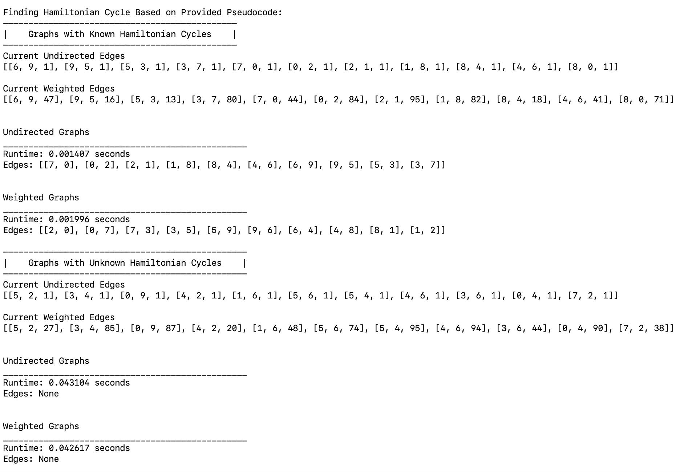

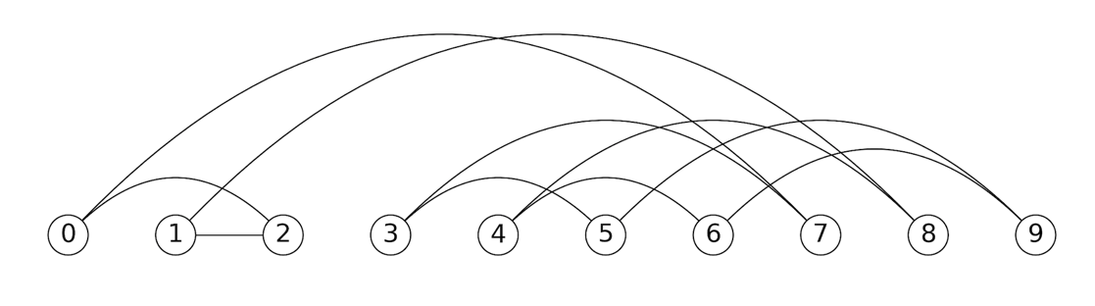

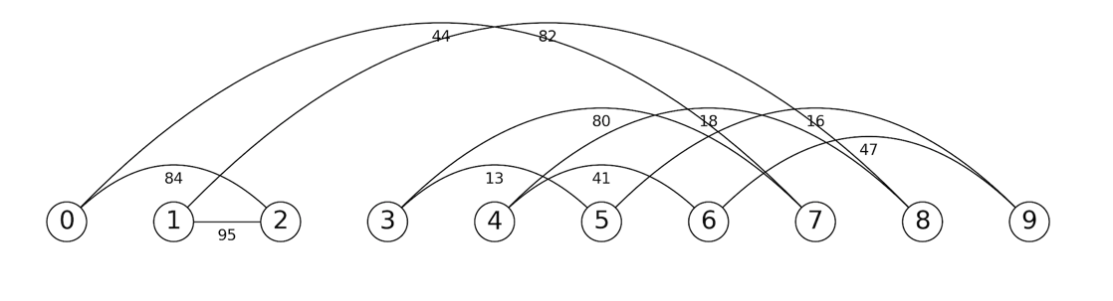

Case 1 (“11 edges, 10 vertices”):

* 11 edges per graph
* 10 vertices





Case 2 (“24 edges, 22 vertices”):

* 24 edges per graph
* 22 vertices





Case 3 (“29 edges, 27 vertices”):

* 29 edges per graph
* 27 vertices





Case 4 (“49 edges, 45 vertices”):

* 49 edges per graph
* 45 vertices









From the graphs above, it is clear that the percentage of accuracy is essentially nonexistent for the graphs with 45 vertices. Even though the graph only has 49 vertices, it was unable to find a successful subset in 10,000 trials. However, this is as expected since approximately 45! possible combinations could be chosen. One reason why the graph with 45 vertices could never find a Hamiltonian cycle is due to the amount of edges versus vertices. For the other graphs, no more than 2 extra edges exist. For the graph with 45 vertices, an extra 4 edges were included. As for the runtime complexity, both runtimes for the weighted and undirected graphs remained the same. This was expected since the algorithm’s implementation does not change on whether the graph is weighted or unweighted.

**Randomization:**

For the Randomization test, a total of three tests were run with two trials per test. The three cases were conducted on graphs with 150 edges and 100 vertices, 250 edges and 375 vertices, and 750 edges and 500 vertices. The number of edges is 1.5 times the number of vertices. This ratio was applied on all the tests to produce an average number of vertices to ensure that the graphs were not sparsely populated but also not fully populated. The trial number for each test was set to 1000. Each case also tests undirected and weighted graphs. I thought that these cases were important to identify how the runtime complexity for the randomization function would vary between the different graphs and their sizes.

Sample Output For Randomization of Undirected Graphs:

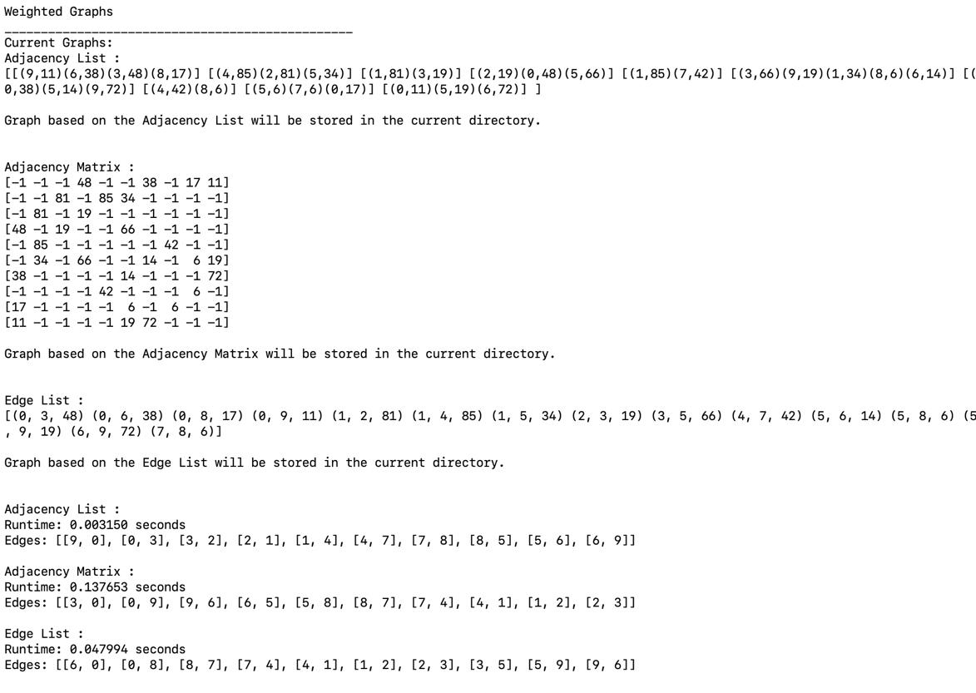

Edge List:

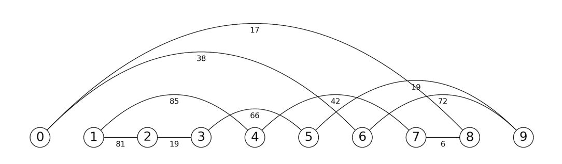

Adjacency Matrix and Adjacency List:

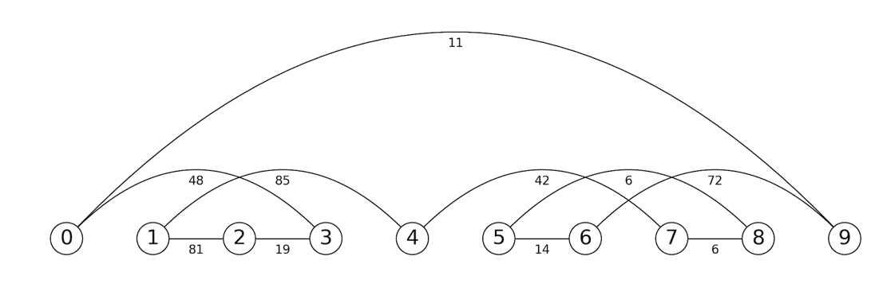

Case 1 (“150 edges, 100 vertices”):

* 150 edges per graph
* 100 vertices



Case 2 (“250 edges, 375 vertices”):

* 250 edges per graph
* 375 vertices



Case 3 (“500 edges, 750 vertices”):

* 500 edges per graph
* 750 vertices











From the graphs it is evident that adjacency matrix had the longest runtimes. This was expected due to the size of the adjacency matrix. Since the randomization method is simply picking random vertices, a total of V^2 random vertex pairs could be computed. As can be seen from Lab #6, a majority of the adjacency matrix is populated with -1 rather than actual edges. Thus, the randomization method for the adjacency vertex has a smaller chance of finding an adjacent edge and most importantly, an adjacent edge with a destination vertex that has not already been visited. As for the edge list and weighted adjacency list, both implementations have very similar runtimes for the known Hamiltonian cycle tests, however the edge list’s runtime is slightly higher. This is attributed to the fact that the edge list requires O(log|E|), where E is the number of edges, time to insert an edge. The adjacency list on the other hand, can insert the edge in constant time. For the randomization function, there are E possible choices. For the adjacency list, there are 2E choices, since the adjacency list will list an edge twice for an undirected graph. Thus, the edge list is more likely to pick an already used edge than the adjacency list. However, as hypothesized, the runtimes are very similar proving that they are both approximately O(m(|V|log|V|)) where m is the number of times it takes to find the edges to create the random subsets and V is the number of vertices. As for the unknown Hamiltonian cycle tests, the adjacency list’s was minute compared to all the other runtimes. This is attributed to the fact that the adjacency list performs an additional check while determining if the graph has at least V edges, where V is the number of vertices. Since the number of outgoing edges can be accessed in constant time, the length of each outgoing edge set is checked. If it is equal to one, which all of the cases demonstrated, then the test is immediately suspended. However, for the unknown Hamiltonian cycle graphs, there are instances in which this does not occur. For example, when testing the unknown Hamiltonian cycle graphs with 5 vertices, there are instances in which the runtime is similar to that of the known Hamiltonian cycle adjacency list times (See figure below). Additionally, as can be seen from the last tables, the runtimes for the adjacency matrix are extremely high. Due to this, the maximum number of vertices tested were 500.

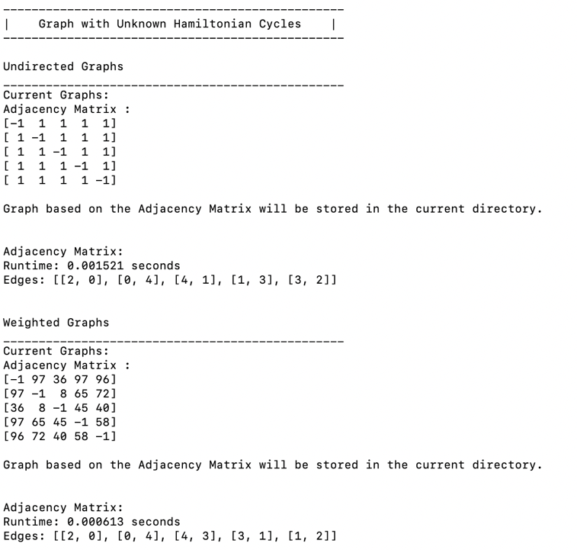

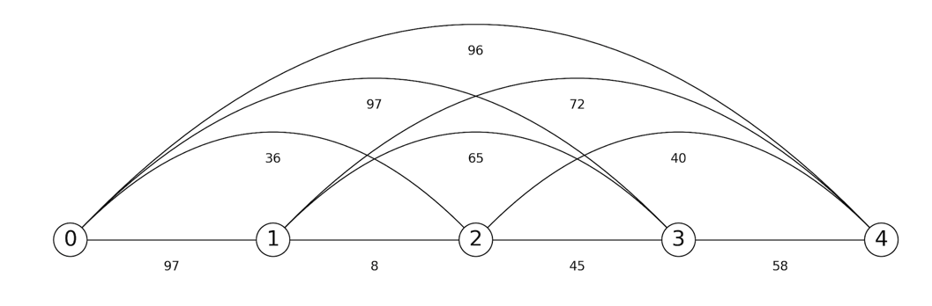

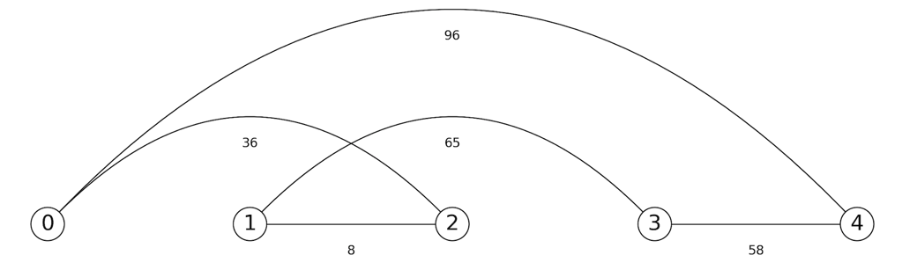

**Randomization with Varying Trials:**

For the Randomization with Varying Trials test, a total of four tests were run with two trials per test. The four cases were conducted on graphs with 15 edges and 10 vertices, 22 edges and 15 vertices, 30 edges and 20 vertices, and 750 edges and 500 vertices. The number of edges is 1.5 times the number of vertices. Each case also tests undirected and weighted graphs. I thought that these cases were important because the number of test trials can significantly affect the runtime and I wanted to determine which trial number would be the most plausible.

Case 1 (“15 edges, 10 vertices”):

* 15 edges per graph
* 10 vertices





Case 2 (“22 edges, 15 vertices”):

* 22 edges per graph
* 15 vertices





Case 3 (“30 edges, 20 vertices”):

* 30 edges per graph
* 20 vertices





Case 3 (“750 edges, 500 vertices”):

* 750 edges per graph
* 500 vertices

















From the graphs above, the adjacency matrix had the highest runtimes, followed by the edge lists, and then the adjacency lists. As explained in the test above, the runtimes are significantly affected by the size of the graphical representation. Whereas V^2, where V is the number of vertices, possible choices exists for an adjacency matrix, only E, where E is the number of edges, exists for an edge list. As for the trials, there is an increase in the runtimes as the number of edges increase. For the adjacency matrix with 1,500 trials, the runtime was nearly 45 seconds. As the next test will demonstrate, these 1,500 trials had no effect on the overall accuracy, demonstrating that an increase in the number of trials will not necessarily increase the accuracy.

**Randomization with Varying Trials Accuracy:**

For the Randomization with Varying Trials Accuracy, a total of four tests were run with two trials per test. The four cases were conducted on graphs with 15 edges and 10 vertices, 22 edges and 15 vertices, 30 edges and 20 vertices, and 750 edges and 500 vertices. The number of edges is 1.5 times the number of vertices. Each case also tests undirected and weighted graphs. Unlike the other tests which compare the runtimes, this test determines whether the randomization method was able to correctly determine if a graph contained a Hamiltonian path. The graphs tested were randomly created however, extra code ensures that a Hamiltonian exists. I thought that these cases were important because the randomization’s ability to accurately identify a graph is crucial. Although the runtimes are lower than the backtracking, I wanted to identify which implementation would be better.

Case 1 (“15 edges, 10 vertices”):

* 15 edges per graph
* 10 vertices





Case 2 (“22 edges, 15 vertices”):

* 22 edges per graph
* 15 vertices





Case 3 (“30 edges, 20 vertices”):

* 30 edges per graph
* 20 vertices





Case 3 (“750 edges, 500 vertices”):

* 750 edges per graph
* 500 vertices









From the graphs above, the adjacency list was more likely to accurately determine if a graph had a Hamiltonian path. The adjacency matrix had the next highest accuracy percentage followed by the edge list. The reason why the adjacency list has the highest accuracy percentage is probably attributed to its duplicate edges. By having duplicate edges, the algorithm is more likely to select an edge that has not been picked and therefore select more combinations. For the edge list, since the size is limited, picking random edges is more limited, resulting in less combinations. However, in all cases the accuracy essentially depletes for the graphs with more than 15 vertices and 22 edges. The reason why is due to the sheer number of possible combinations. Additionally, as the difference between the number of edges and number of vertices increases, the more combinations are possible. This dramatically decreases the randomizations algorithms’ ability to find a Hamiltonian path.

**Backtracking:**

For the Backtracking test, a total of three tests were run with two trials per test. The three cases were conducted on graphs with 30 edges and 20 vertices, 40 edges and 27 vertices, and 67 edges and 45 vertices. The number of edges is 1.5 times the number of vertices. Each case also tests undirected and weighted graphs. I thought that these cases were important to identify how the backtracking compared with the randomization method. Unlike the randomization method, the backtracking method will eventually find a Hamiltonian cycle if it exists. For the tests, two different types of random graphs were used, graphs with a known and graphs with an unknown Hamiltonian cycle.

Sample Output for Backtracking:

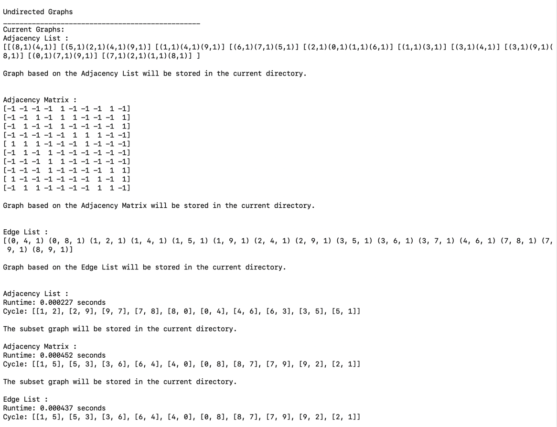

Original Graph:

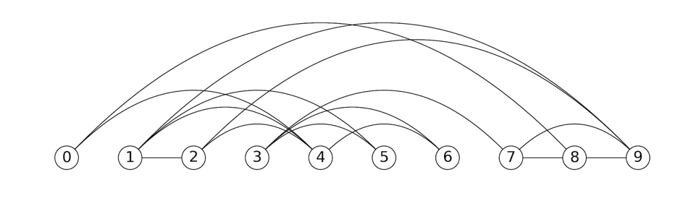

Subset Graph:

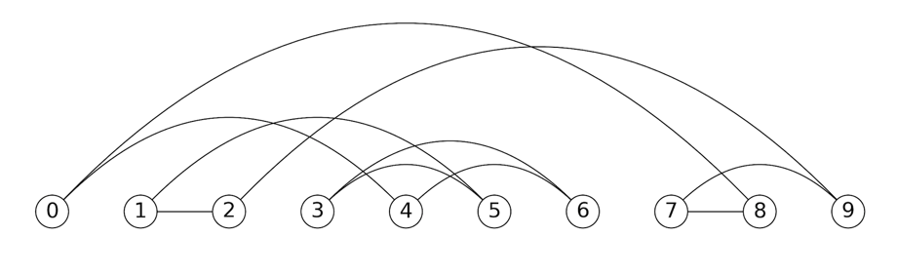

Case 1 (“30 edges, 20 vertices”):

* 30 edges per graph
* 20 vertices



Case 2 (“40 edges, 27 vertices”):

* 40 edges per graph
* 27 vertices



Case 3 (“67 edges, 45 vertices”):

* 67 edges per graph
* 45 vertices







From the first graph, it is evident that the adjacency matrix had the highest runtime followed by the edge list. For the adjacency matrix, the entire row of a vertex needs to be iterated through in order to find all the adjacent vertices. For the edge list, a portion of the edge list needs to be iterated through in order to find the adjacent edges. For the adjacency matrix, only the adjacent edges need to be iterated through. Thus, the runtimes for the adjacency matrix and edge list are dramatically higher since more iterations need to occur in order to find the adjacent edges. Additionally, for the edge list, for the last vertex of the graph, the entire edge list needs to be iterated through. This clearly explains why the edge list has high runtimes. As for the second graph, the best case scenarios of the backtracking algorithm is evident. For many of the unknown graphs, a vertex usually had a single edge. By checking for vertices with single edges, the runtime is able to dramatically decrease for graphs without a Hamiltonian cycle. For the adjacency list, the runtimes are lower since the length of the adjacency list at the vertex only needs to be checked. For the adjacency matrix and edge list, all the adjacent edges need to be found first, before determining if a vertex only has a single edge.

**Backtracking and Randomization Comparison:**

The following two graphs were obtained from the prior tests and used to compare the runtimes for both the backtracking and randomization algorithm to find a Hamiltonian path. A single graph comparing all the runtimes was not obtained since the graphs vary drastically. This will be further explained and evaluated below.







From the graphs above, it is evident that the randomization had slightly higher runtimes than the runtimes for backtracking for the different graph implementations. However, the randomization algorithm was able to test graphs nearly ten times the size of the backtracking graphs. Thus, one may assume that the randomization algorithm is more efficient since it is able to handle larger graphs in nearly the same amount of times as the backtracking graphs. However, before making this conclusion, the results of the accuracy tests should be noted. For large graphs, such as 500 vertices, a Hamiltonian path was never found even though a path existed in all the graphs tested. Thus, although the randomization algorithm is able to handle larger graphs, its ability to accurately find a Hamiltonian path for larger graphs is nonexistent. In fact, for the accuracy test with 500 vertices, I conducted one test for the adjacency list with 100,000 trials to identify if a Hamiltonian path would ever be found. The test itself took nearly 250 seconds and a Hamiltonian path was not found. As for the best algorithm between the two, there is none. In fact, the data collected clearly represents why finding a Hamiltonian path is considered an NP Complete problem. If one wanted to try to find a Hamiltonian path for an extremely large graph, then the best choice would be the randomization algorithm. However, the possibility of actually finding the path would be very rare. If the backtracking algorithm was used for a graph of, say 100,000 vertices, years may occur, before a decision is finally found. For smaller graphs, backtracking is the safest way to ensure that a Hamiltonian path exists. Additionally, the runtimes between the generalized randomization (graph 3) and different graph representation randomization (graph 2), the difference between the adjacency list implementation is slightly higher. Although both the generalized and adjacency list implementation use adjacency lists, the pure adjacency list implementations perform more operations. Whereas the generalized randomization is only using a subset of edges, the adjacency list is using an Adjacency List object to find the random edges and create a new adjacency list.

**Edit Distance:**

For the Edit Distance test, a total of three tests were run with three trials per test. The three cases were conducted on 7 X 7 matrices, 11 X 11 matrices, and 21 X 21 matrices. I thought that this test case was crucial to determine how the size of the matrices would affect the runtimes. Furthermore, the sizes defined above were used since the WordSample.txt file had a majority of the words in the length described. This distribution file can be found in Files directory and is called Distribution.txt. The words tested come from the WordSample.txt file and can also be found under the Files directory in Github.

Sample Output for Edit Distance:

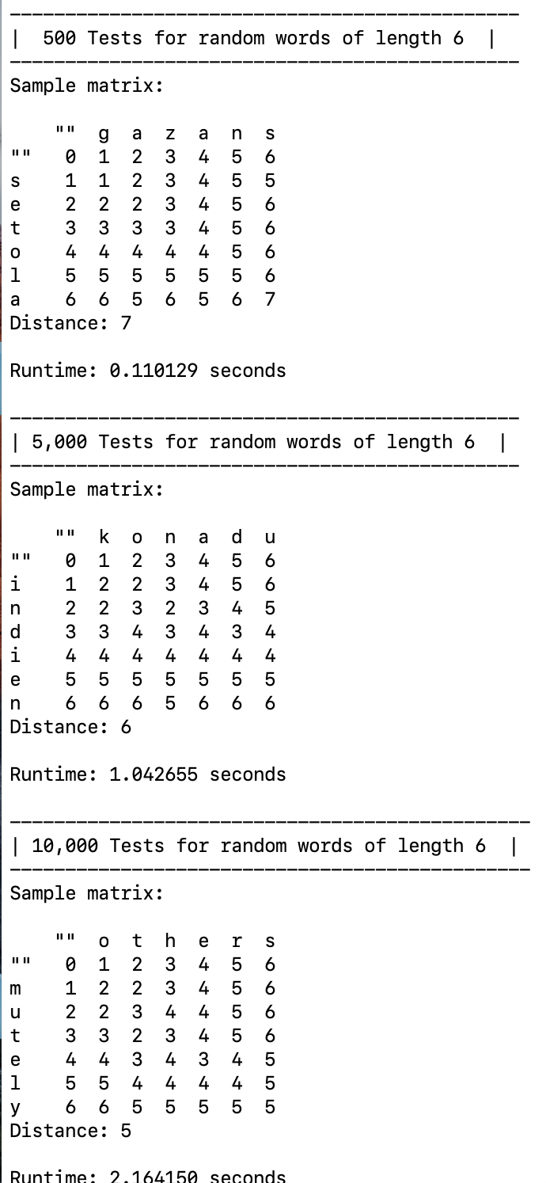

Case 1 (“500 Trials”):

* 7 X 7 matrices, 11 X 11 matrices, 21 X 21 matrices



Case 2 (“5,000 Trials”):

* 7 X 7 matrices, 11 X 11 matrices, 21 X 21 matrices



Case 3 (“10,000 Trials”):

* 7 X 7 matrices, 11 X 11 matrices, 21 X 21 matrices





As the graph demonstrates, the 21 X 21 matrix had the highest runtime. This is because a total of 441 cells needed to be visited whereas only 49 cells needed to be visited for the 7 X 7 matrix. From the graph, it is also clear that the runtime is O((s1 + 1) * (s2 + 1)) where s1 is the length of string one and s2 is the length of string two. The matrices with the largest word lengths had the longest runtimes and the smallest string lengths had the lowest times. Furthermore, whereas the 11 X 11 matrix was taking approximately 5.25 seconds for 10,000 trials, the 21 X 21 matrix was taking nearly 20 seconds.

**Conclusion**

In all, I learned about np-complete and the difference between verifying a graph and providing a solution. When I first started the lab, I ran tests, as demonstrated, with graphs with unknown Hamiltonian cycles. At first, I was confused because a possible Hamiltonian cycle was never found. However, after attending class, I learned that NP-complete problems can only be verified in polynomial time. This is why the randomization algorithm was more likely to verify that a Hamiltonian exists, rather than find the cycle. This lab also helped me further analyze my data structures. When creating the edit distance function, I realized that I would need to store all the words from the SampleWords.txt file and be able to access them based off the word lengths. At first, I was thinking of using a B-Tree, however, I remembered from previous labs that hash tables had a faster implementation. Since a specific word length needed to be accessed, I realized that I could just hash the words based on their length. Lastly, this lab allowed me to compare the differences between backtracking, randomization, and dynamic programming. I learned that for a dynamic programming algorithm, smaller subproblem solutions that may reoccur, need to be computed and stored. In doing so, faster runtimes are expected.

**Appendix A**

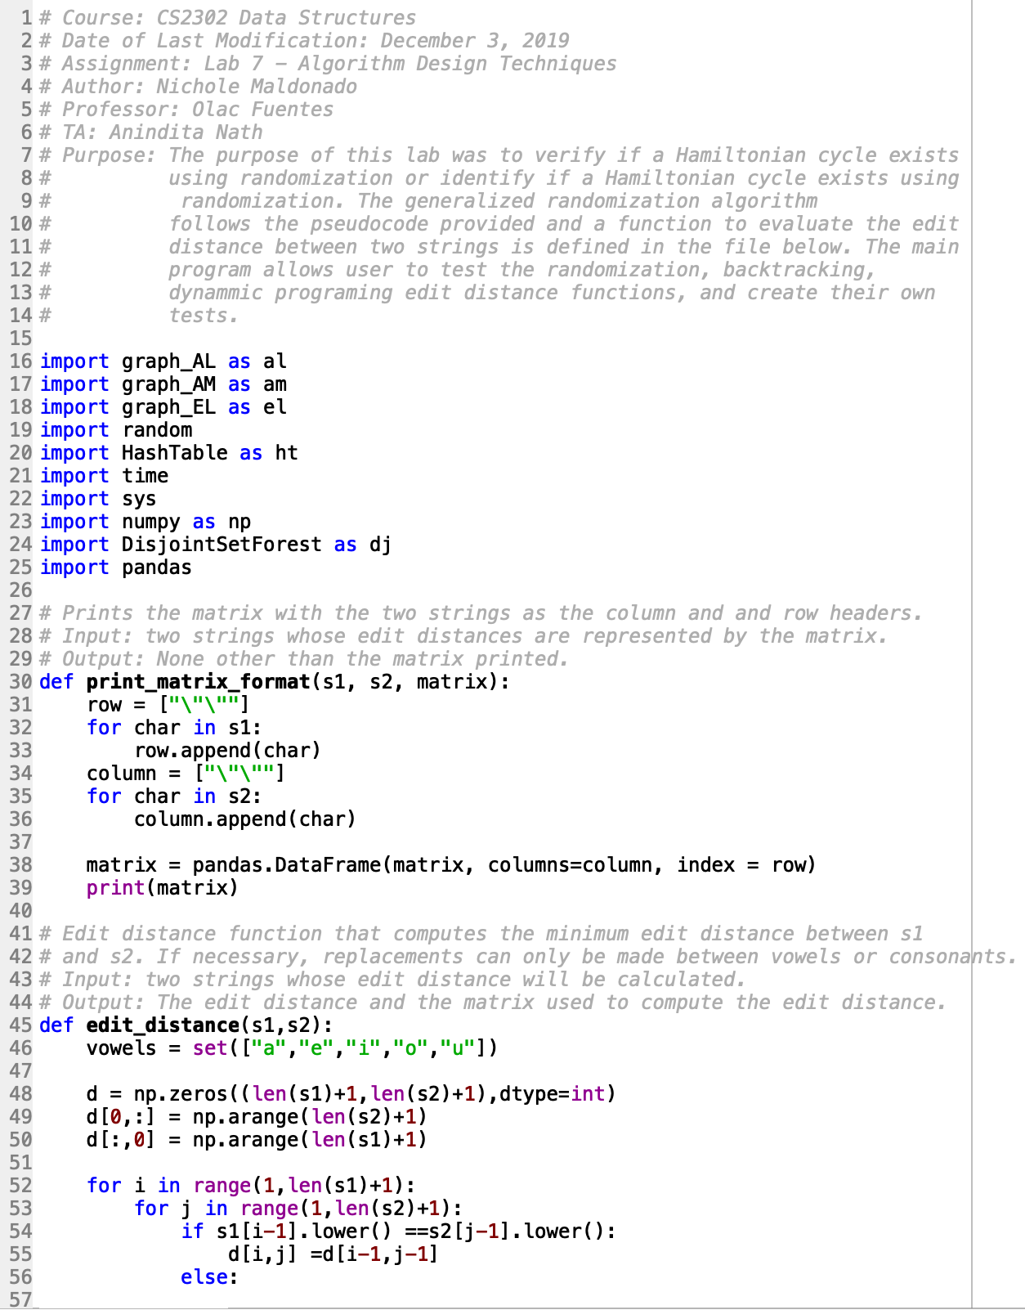

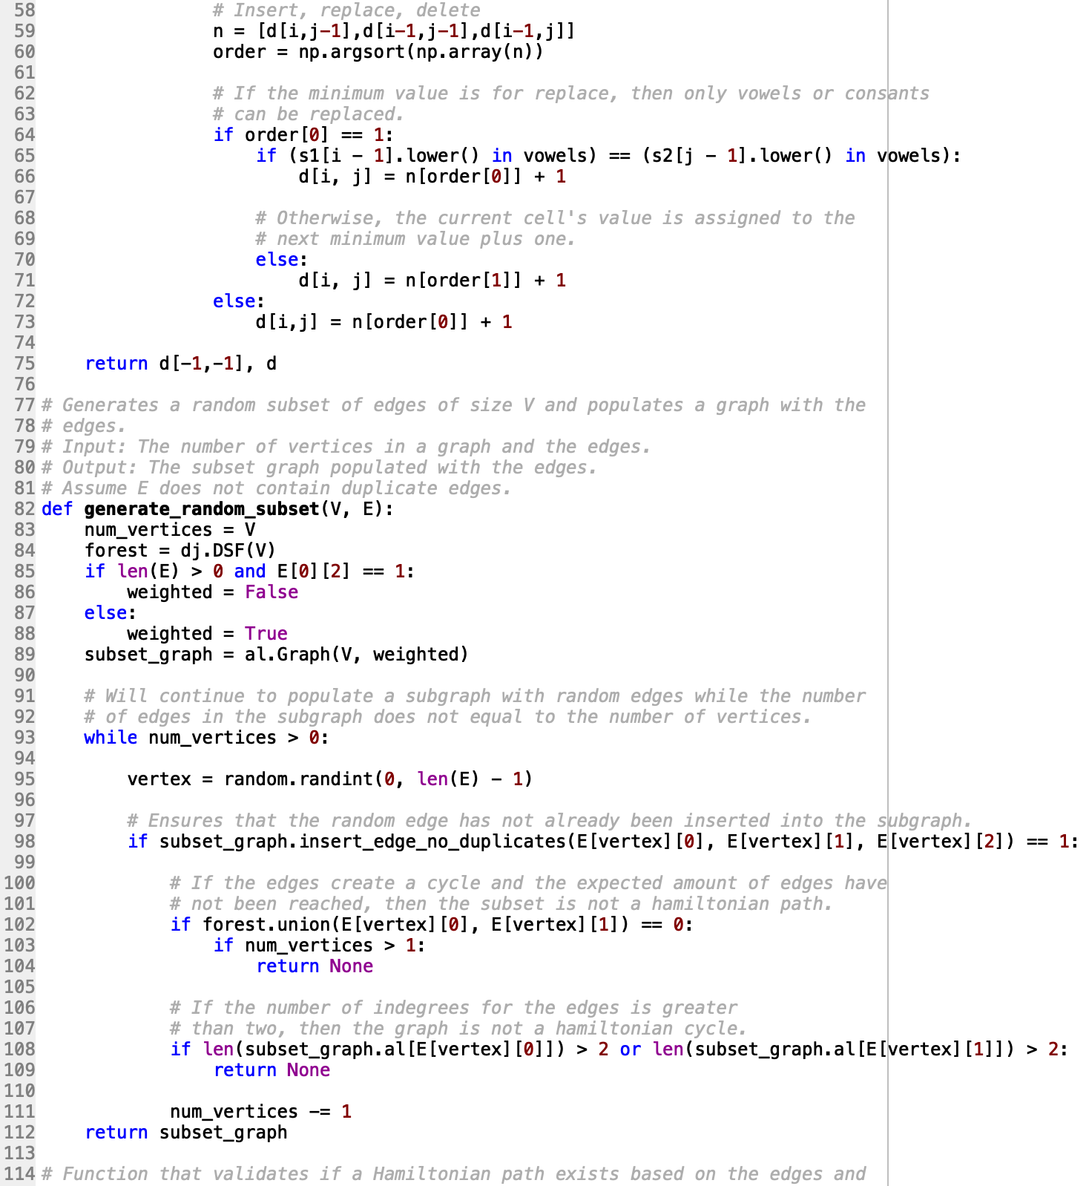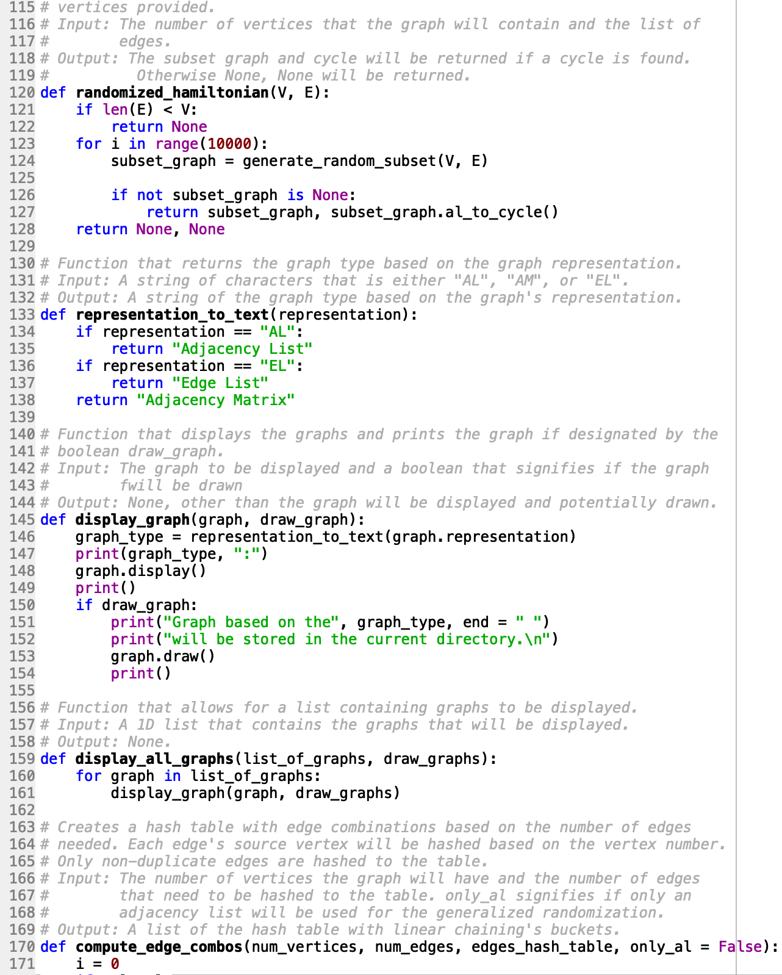

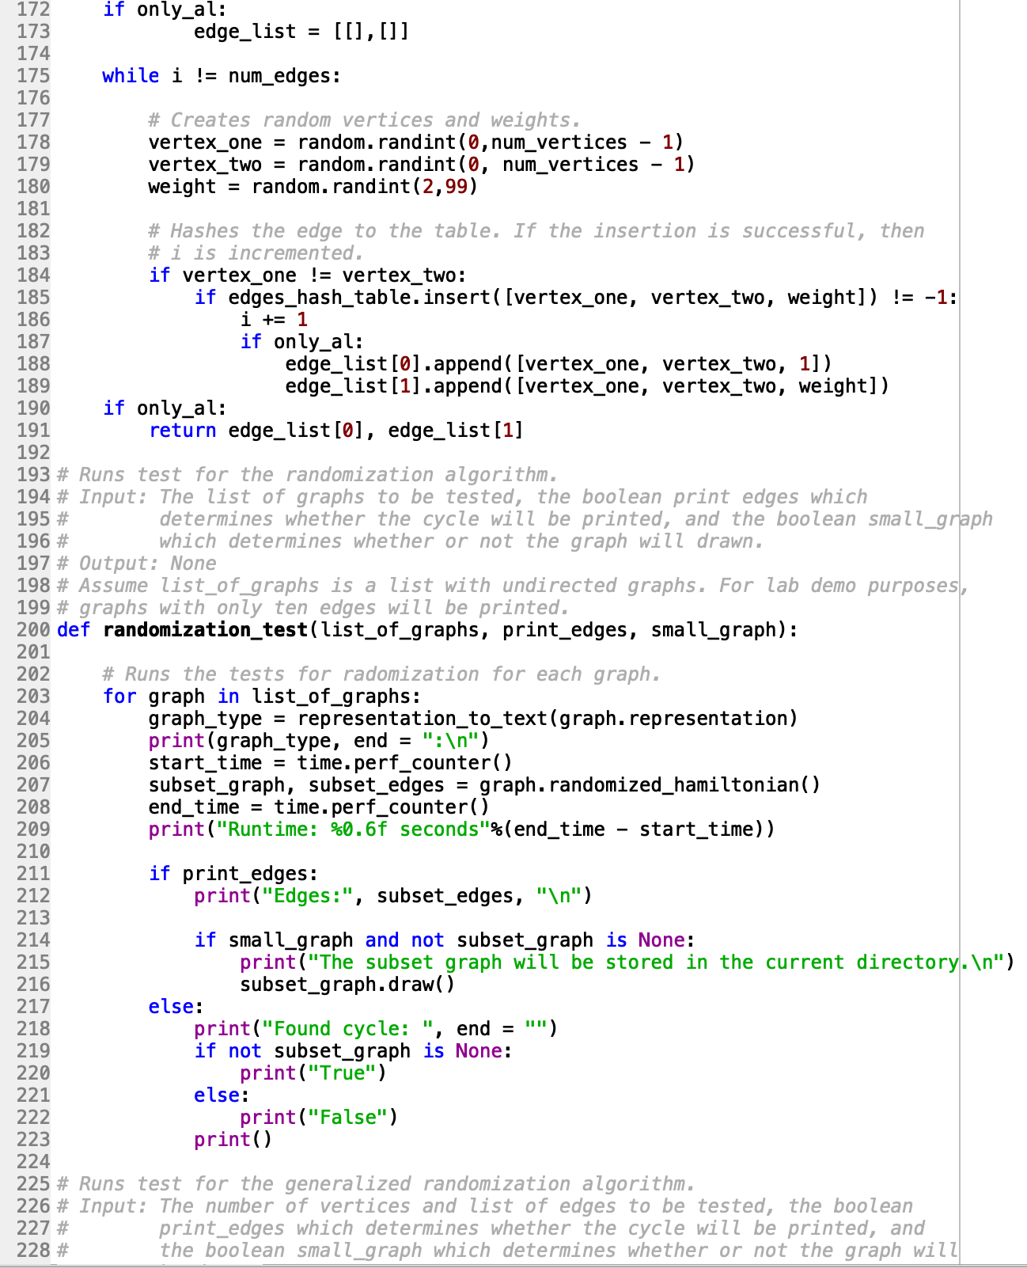

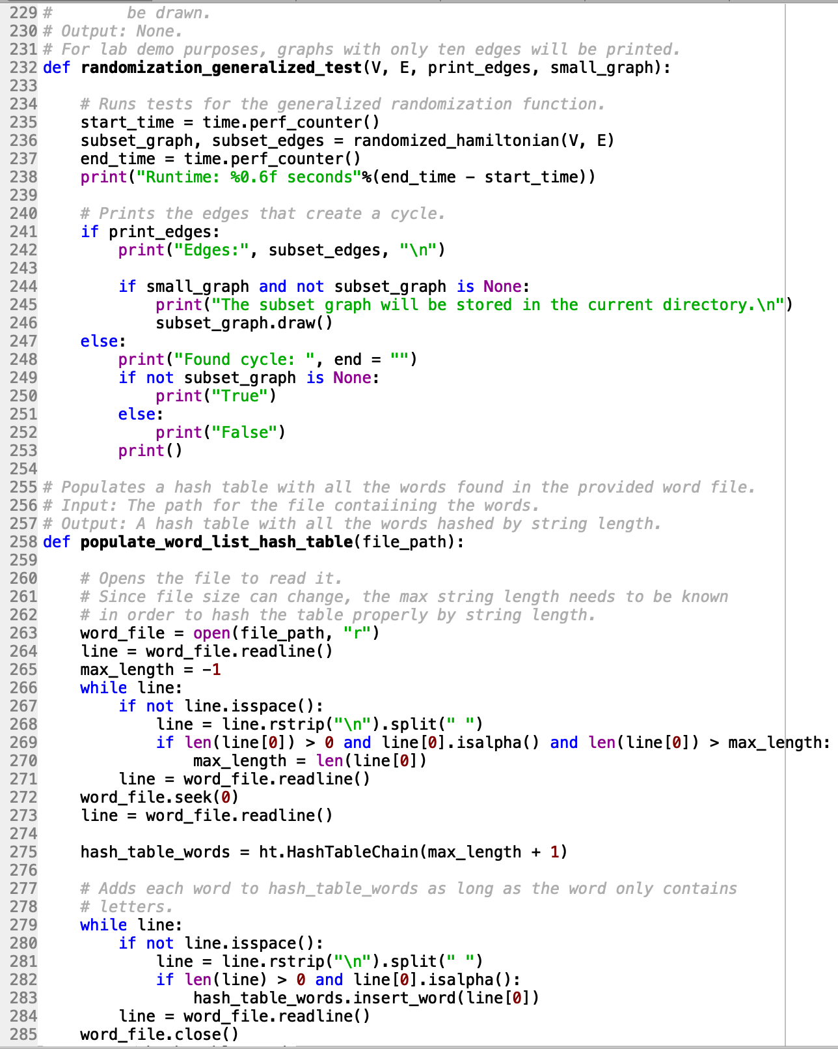

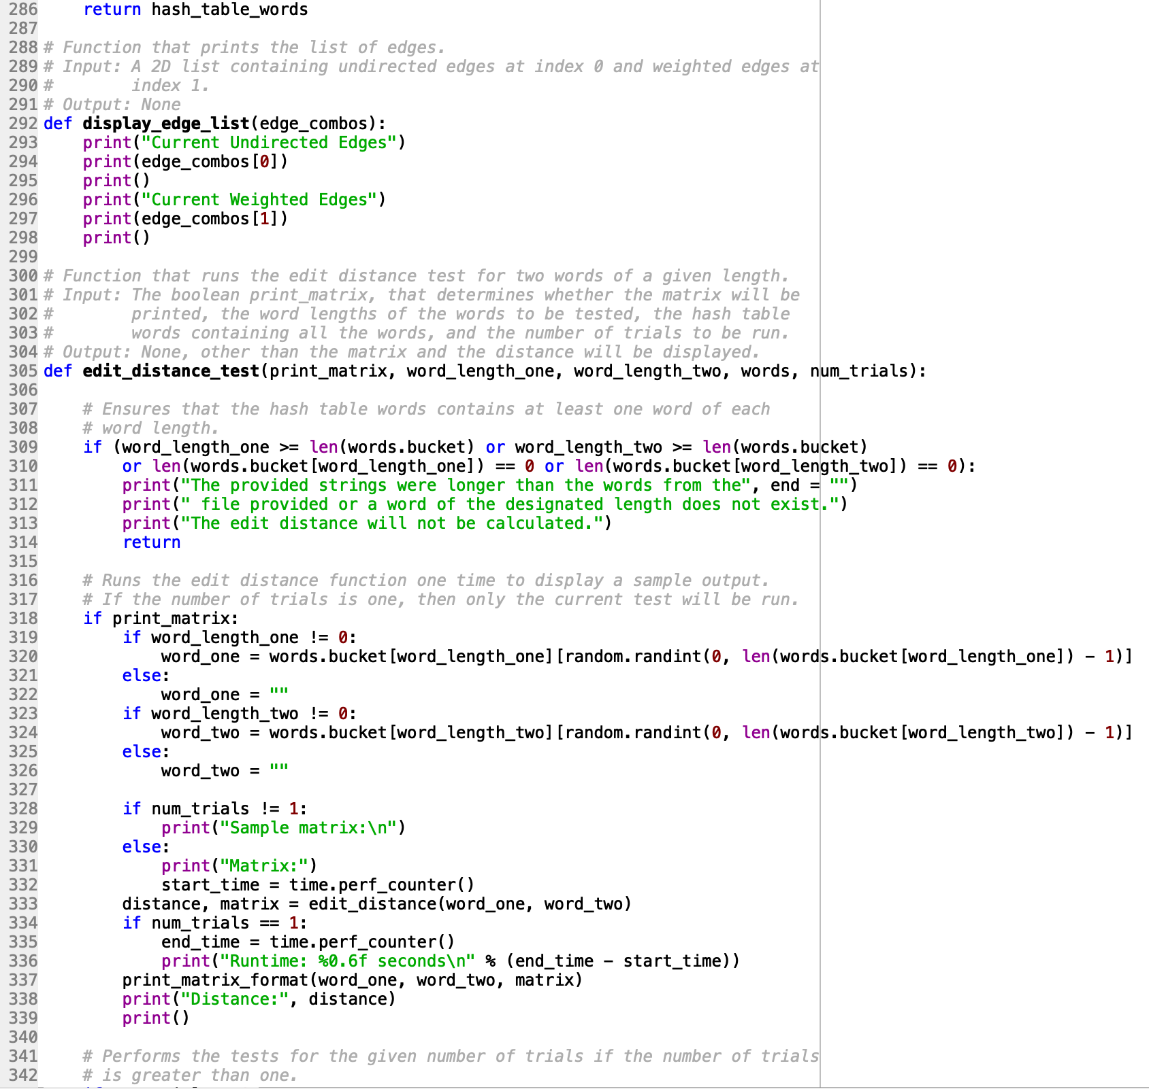

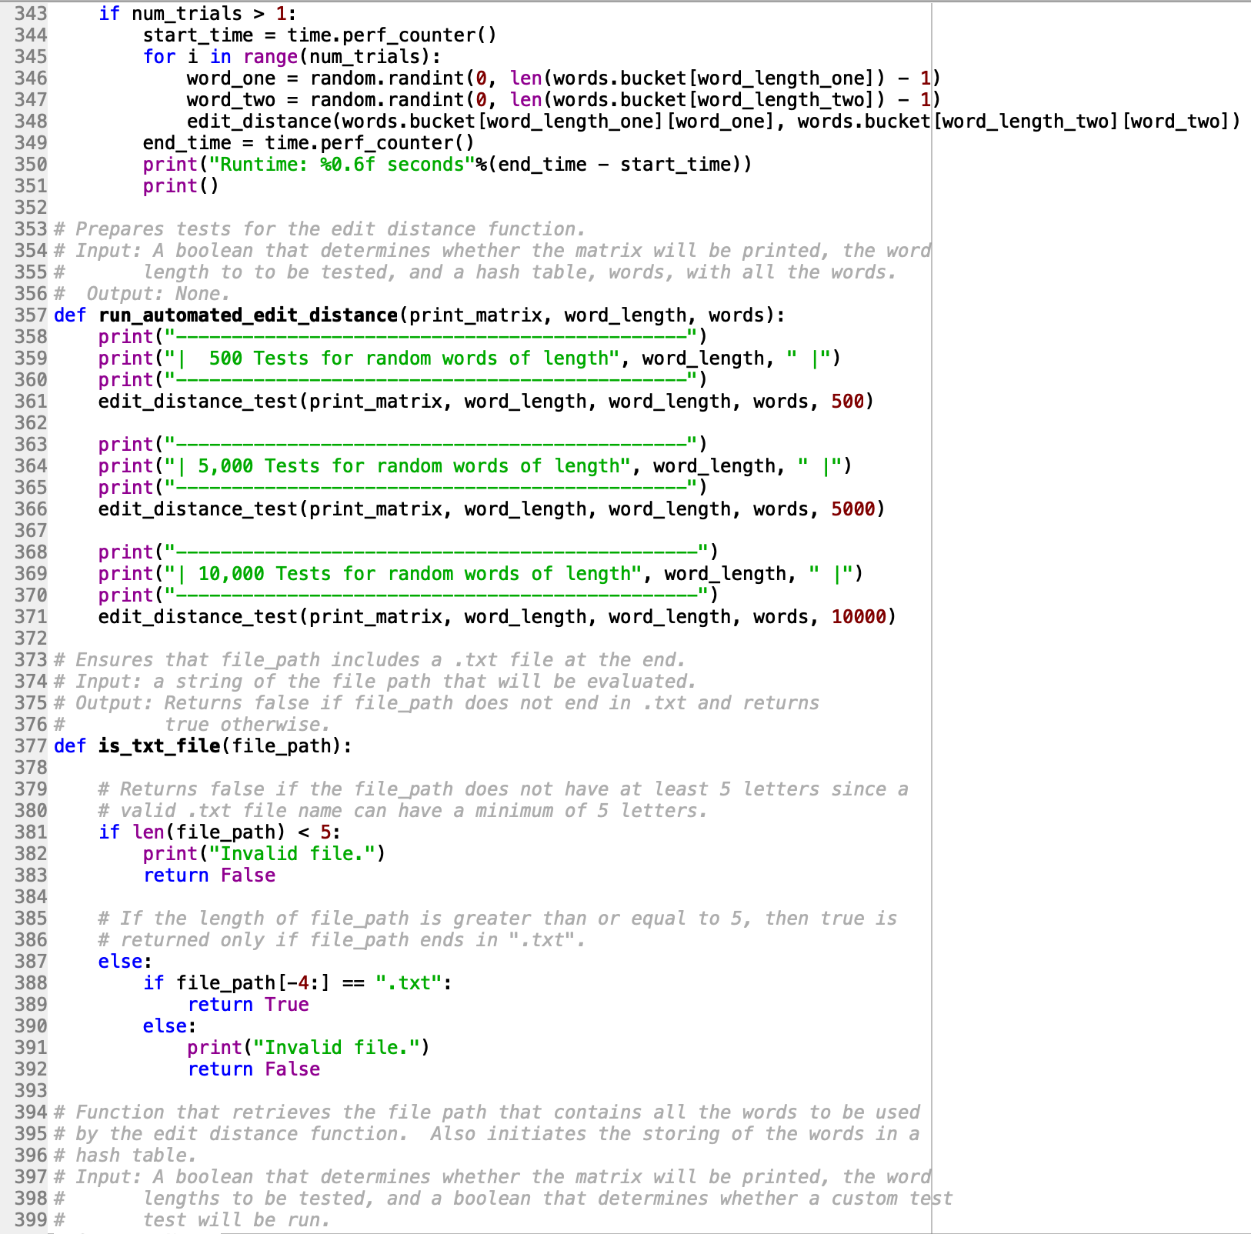

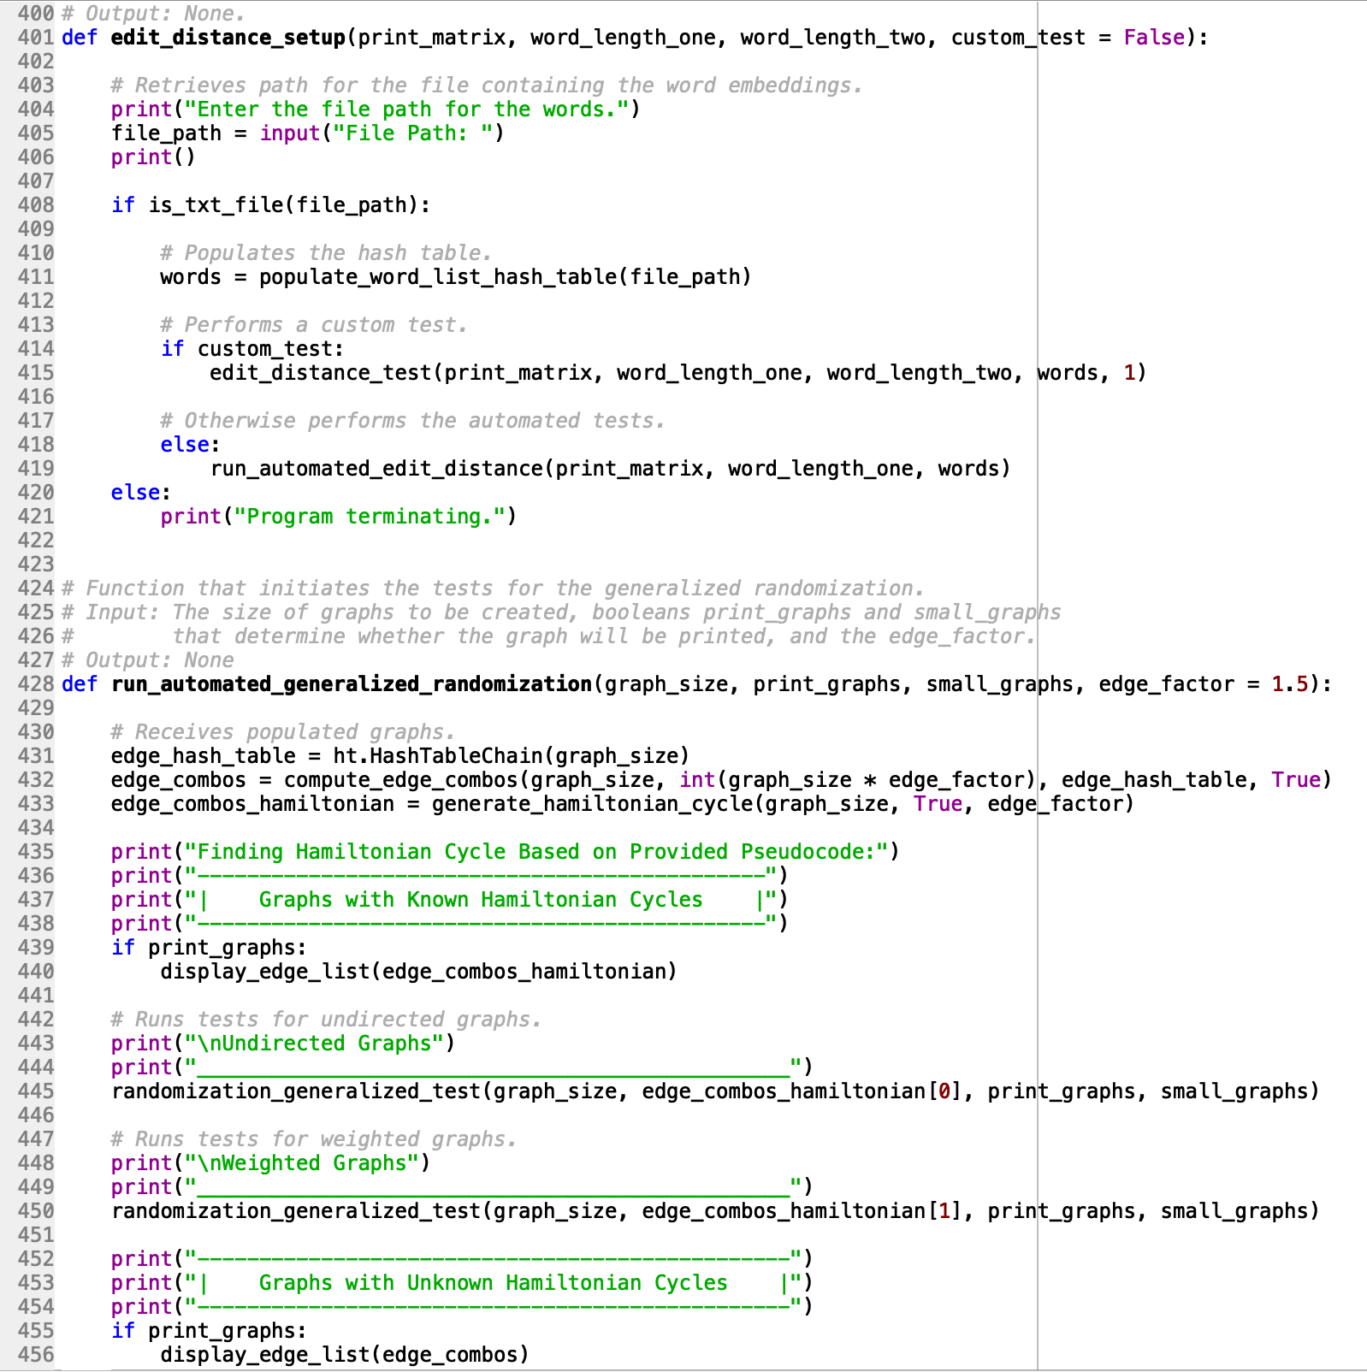

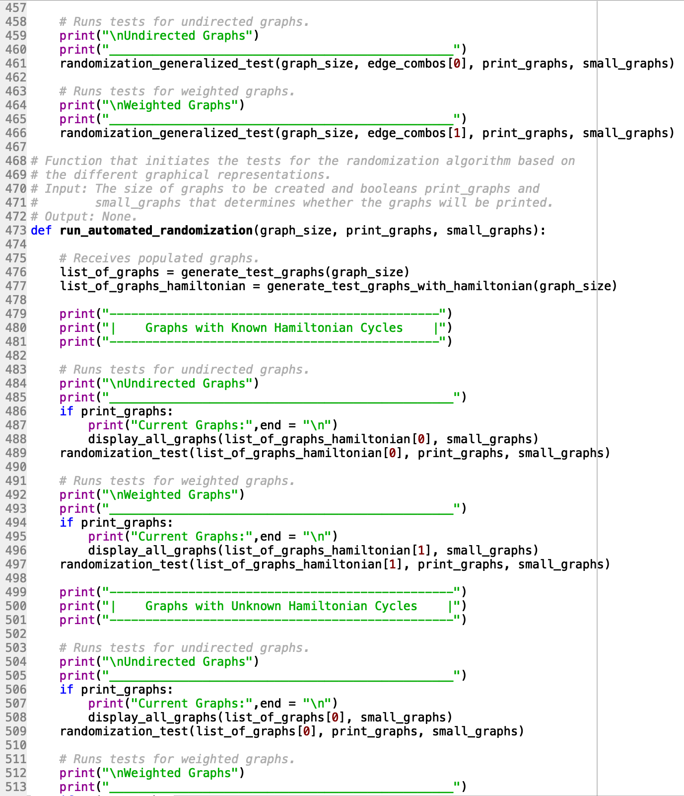

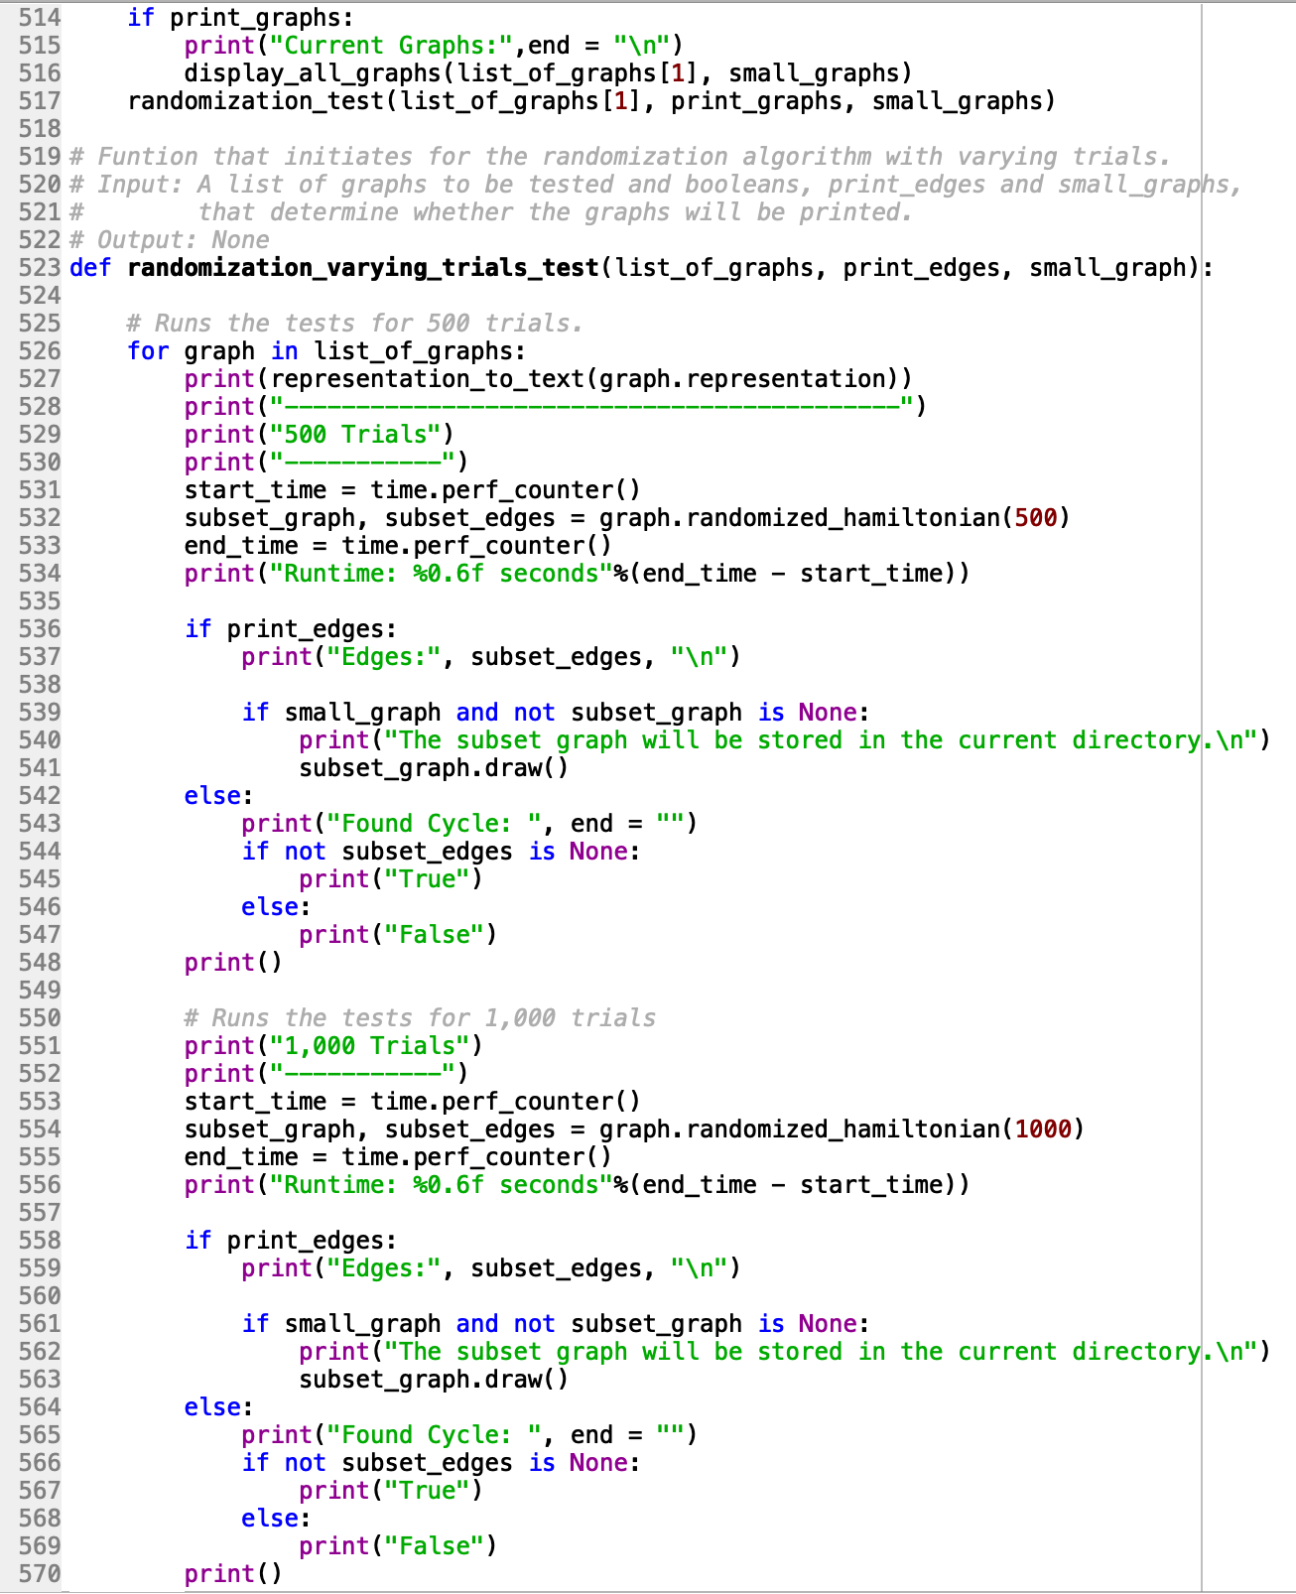

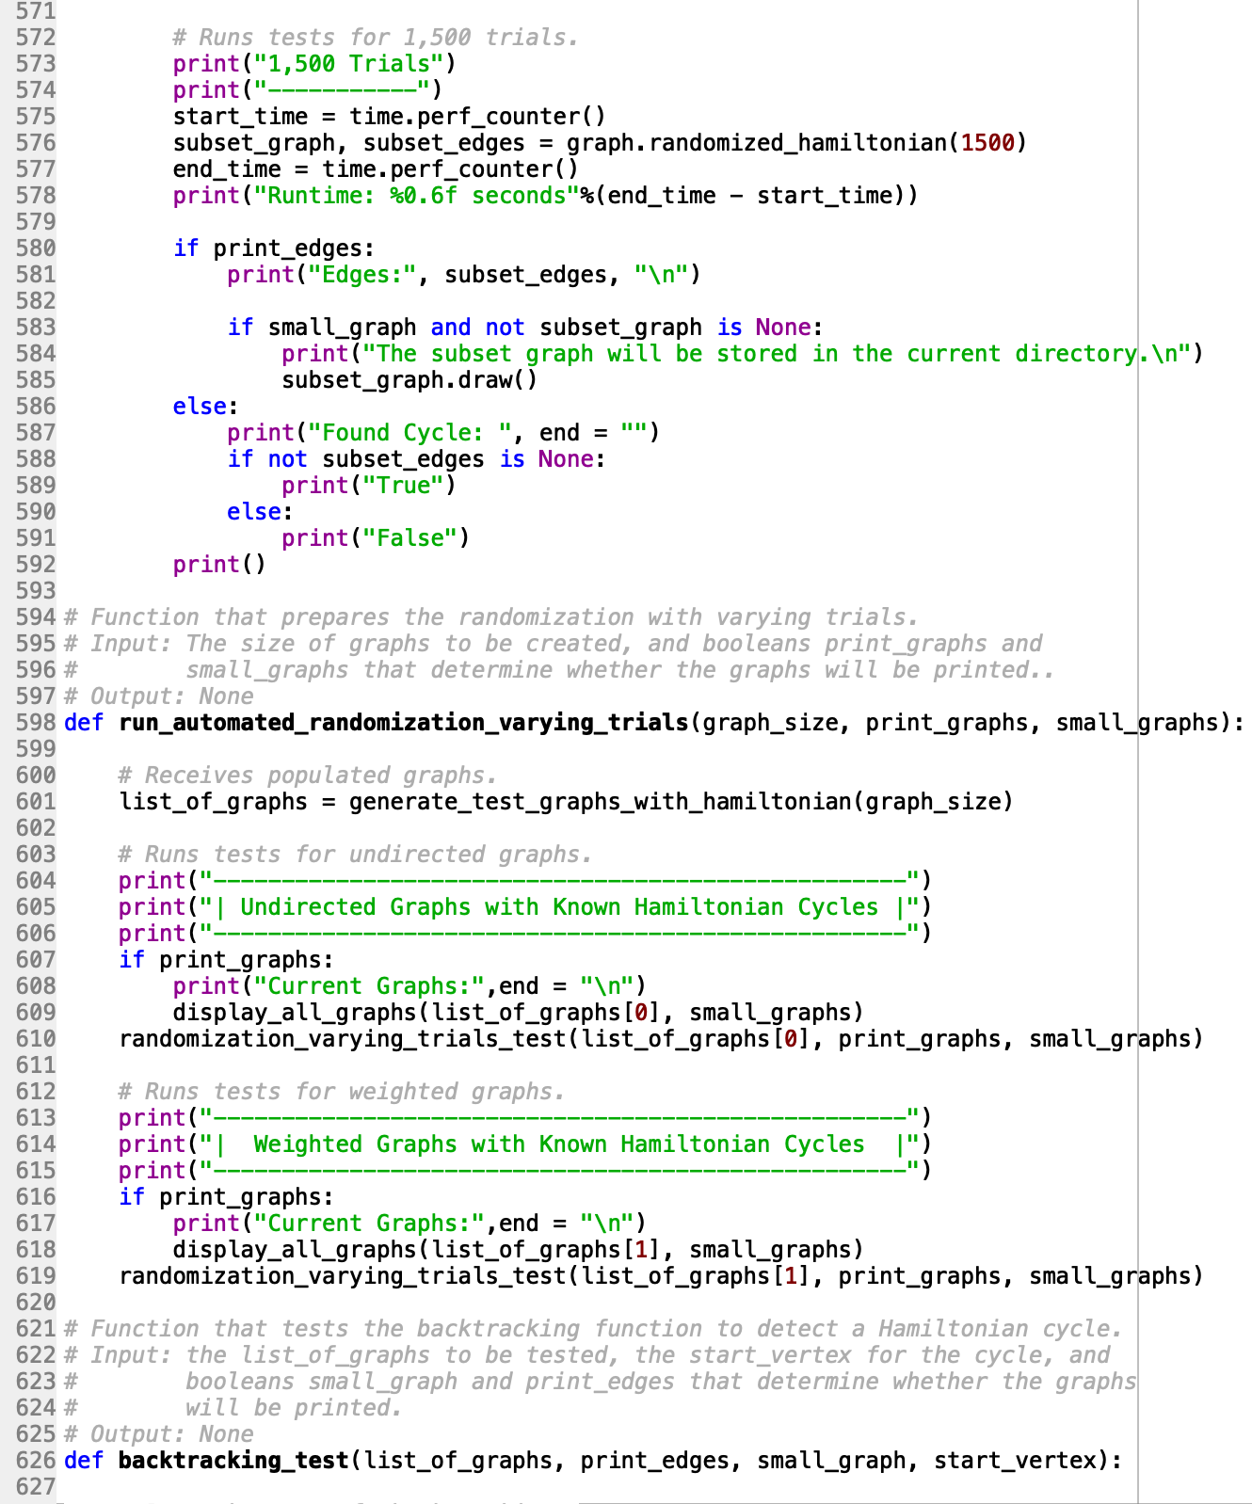

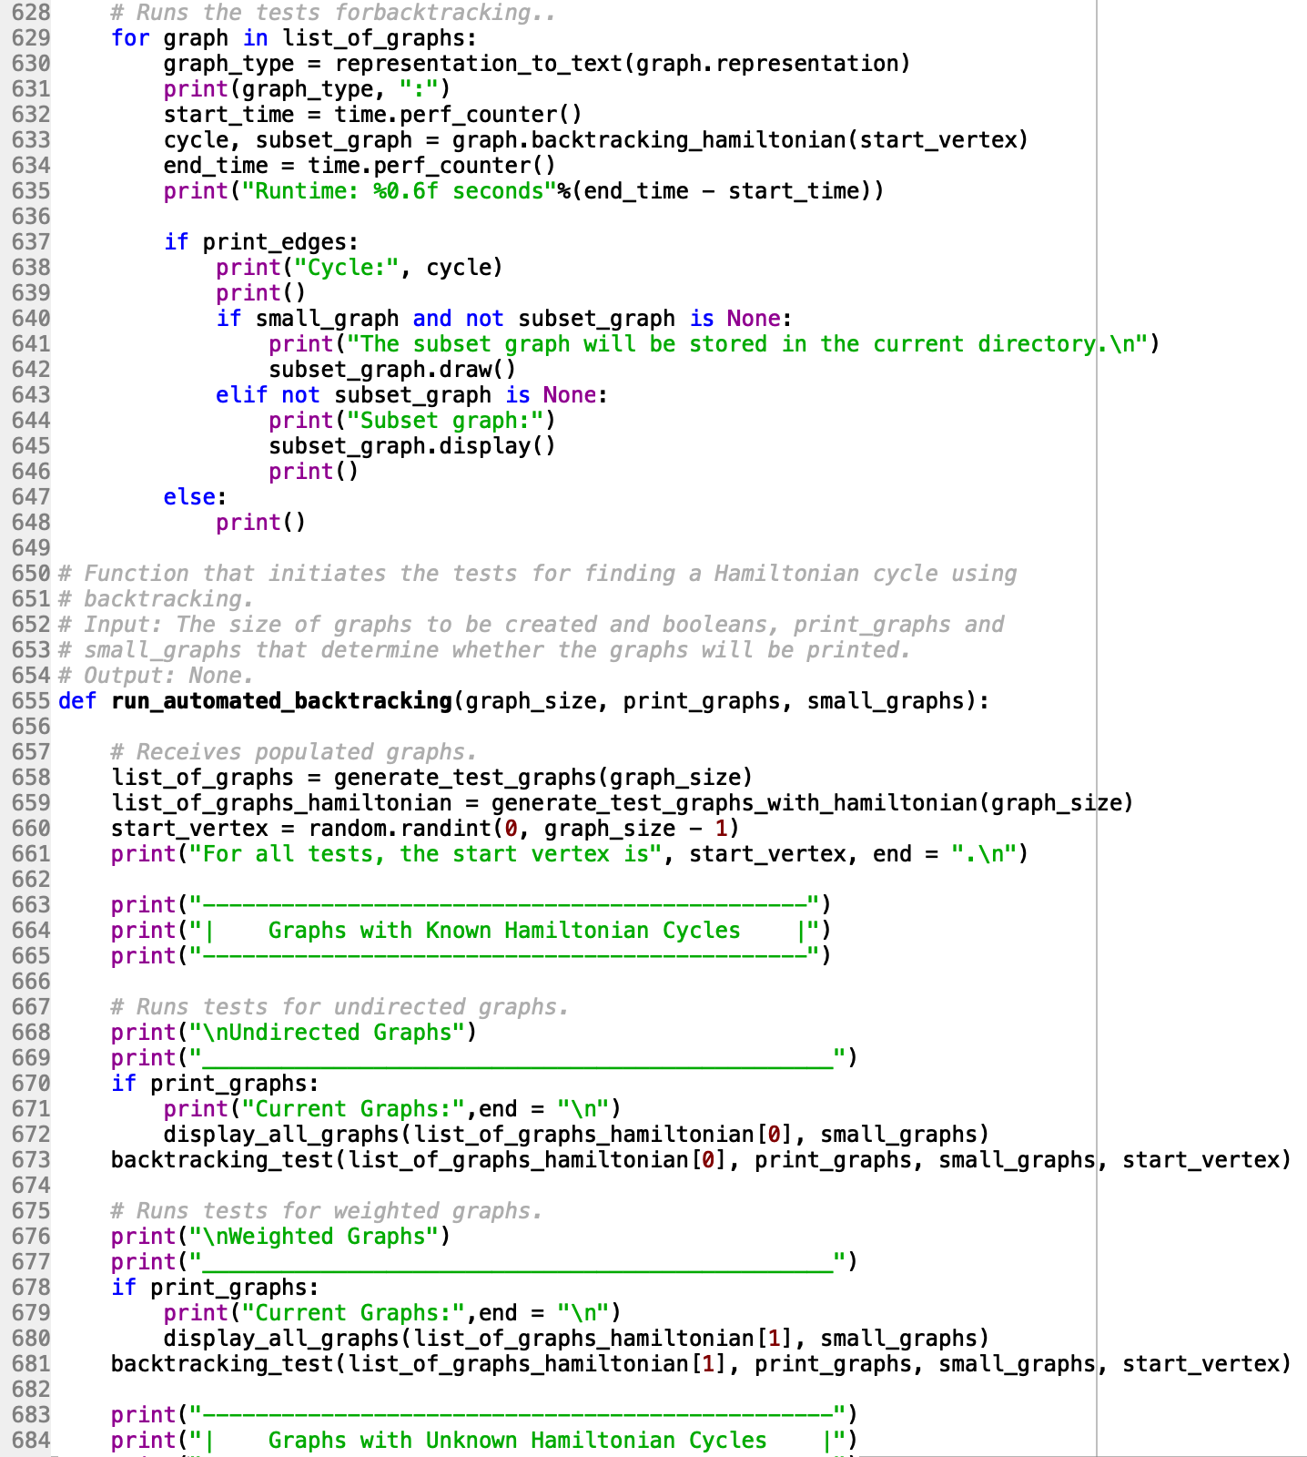

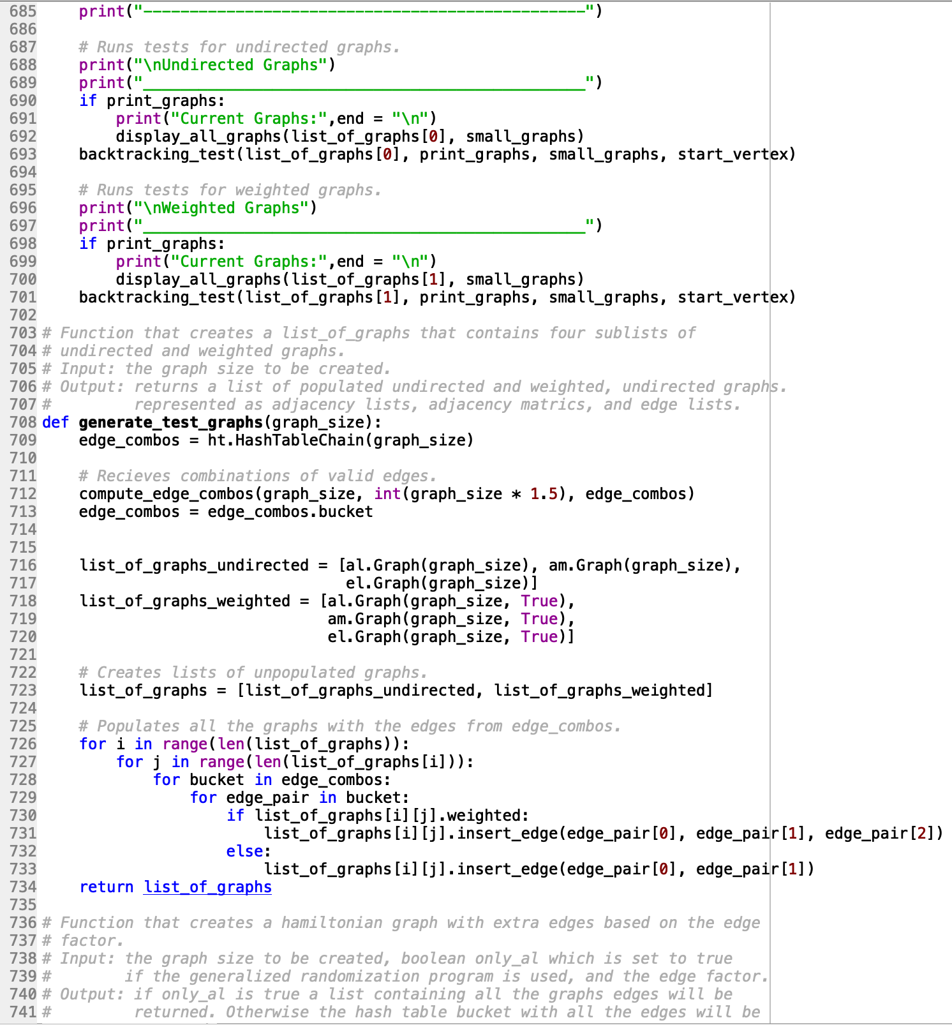

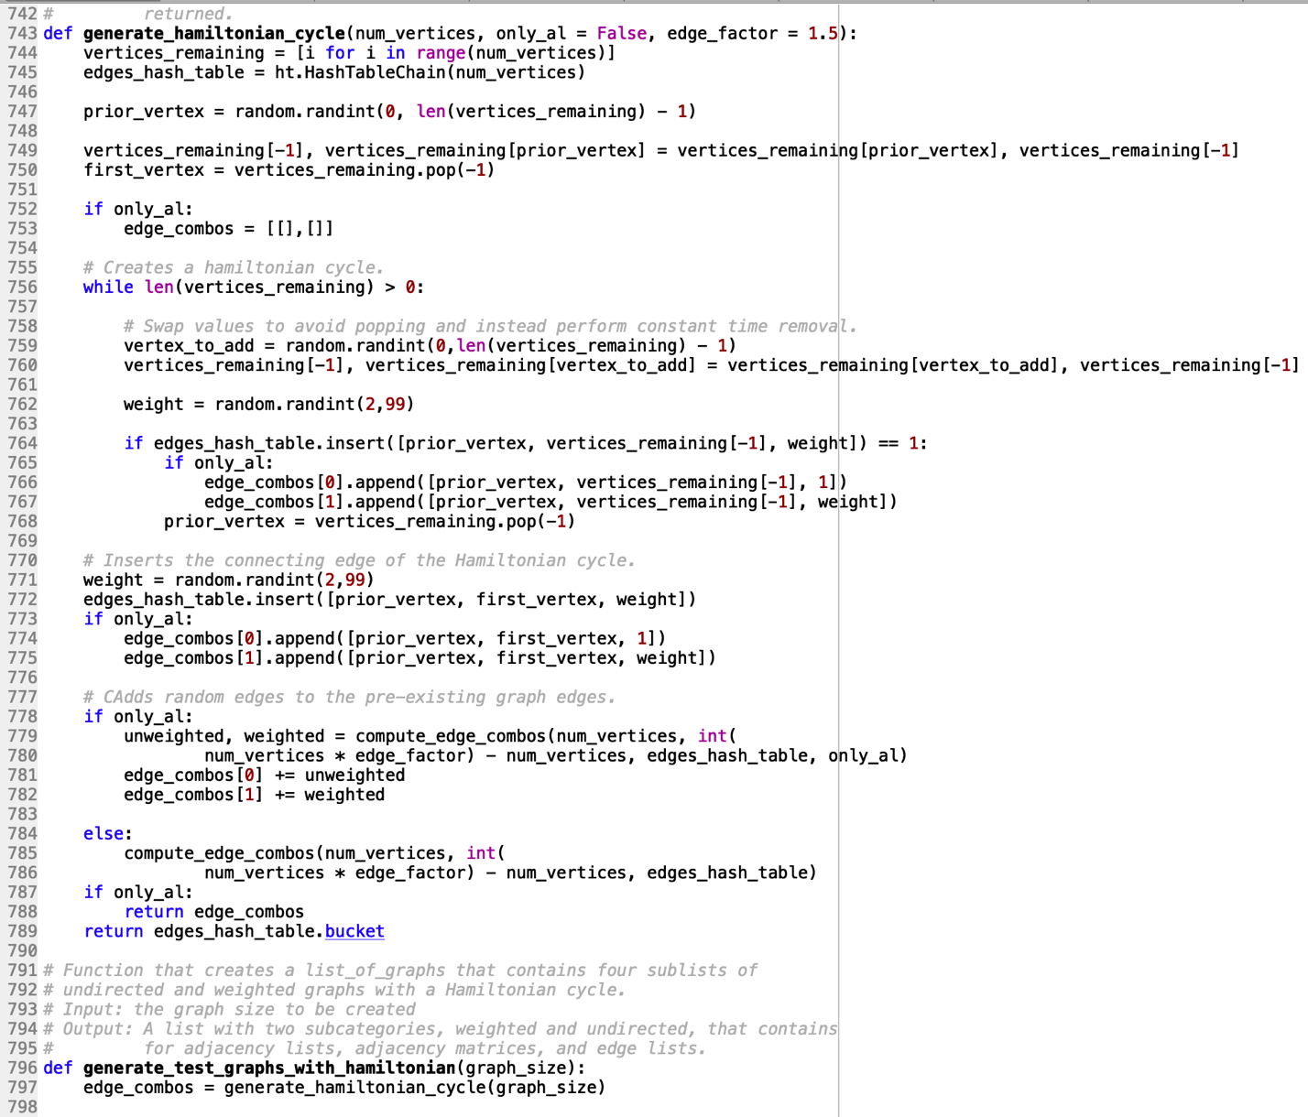

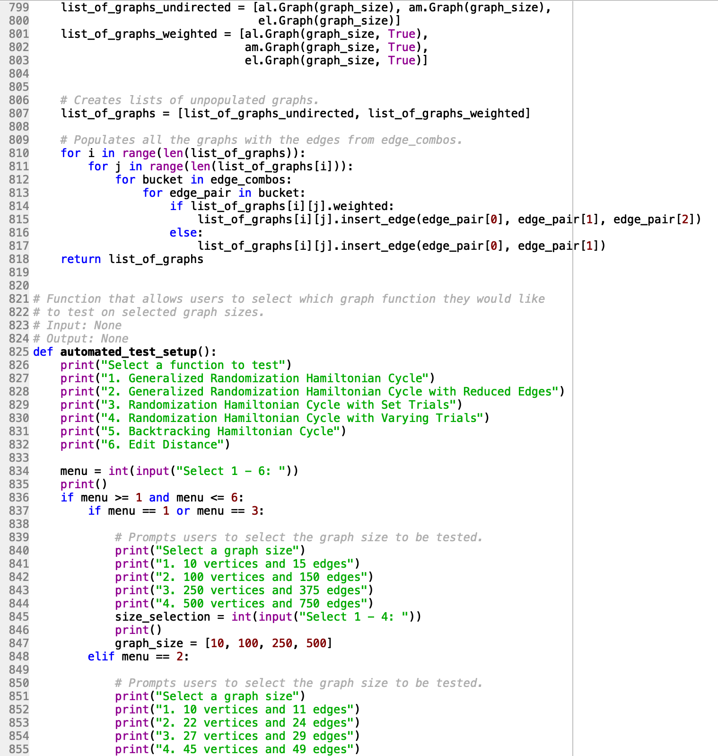

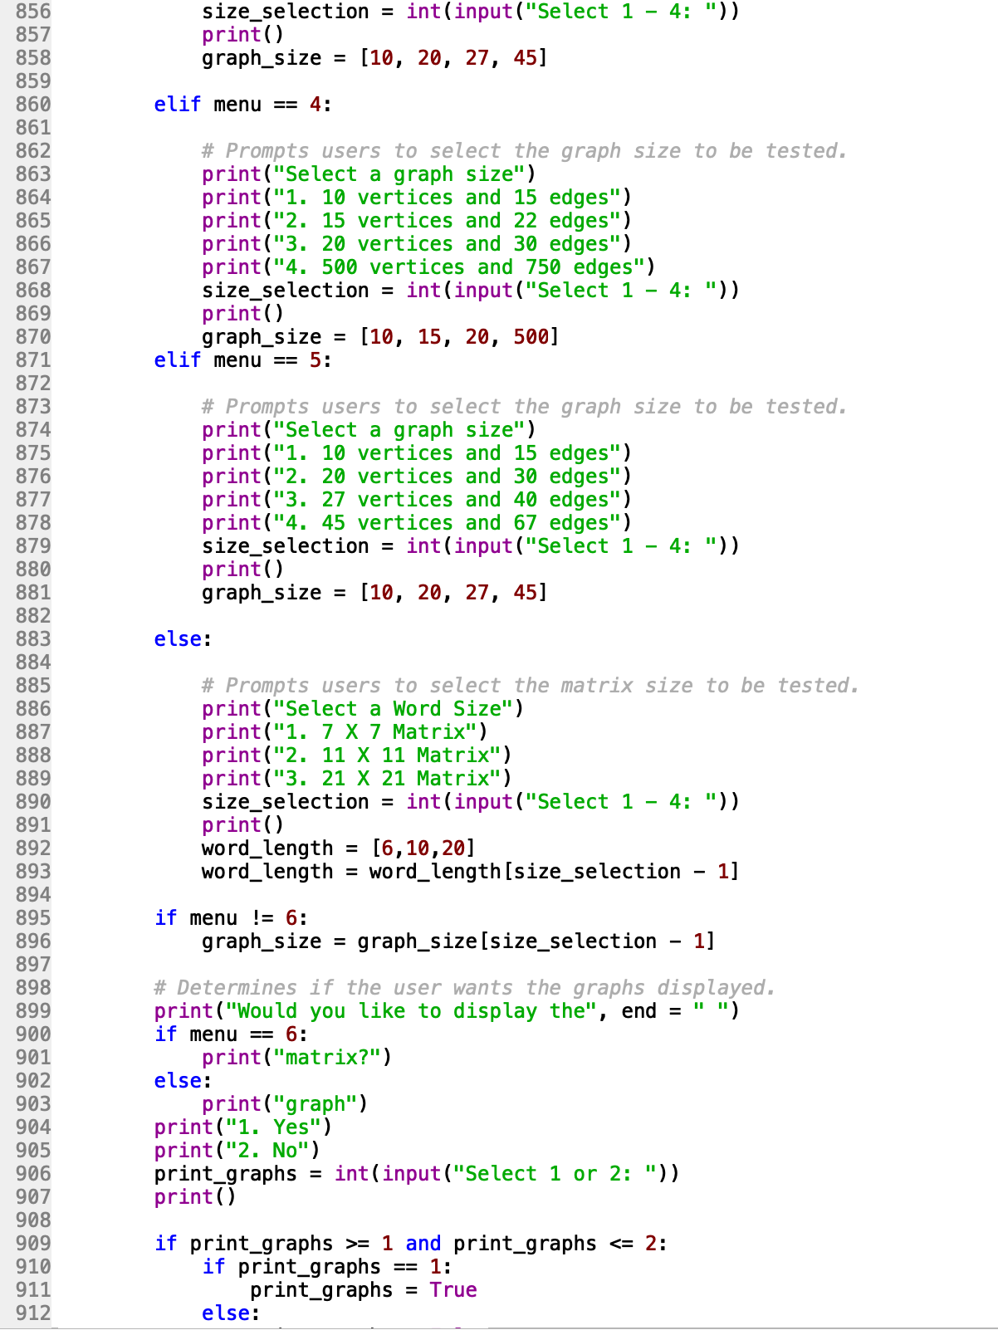

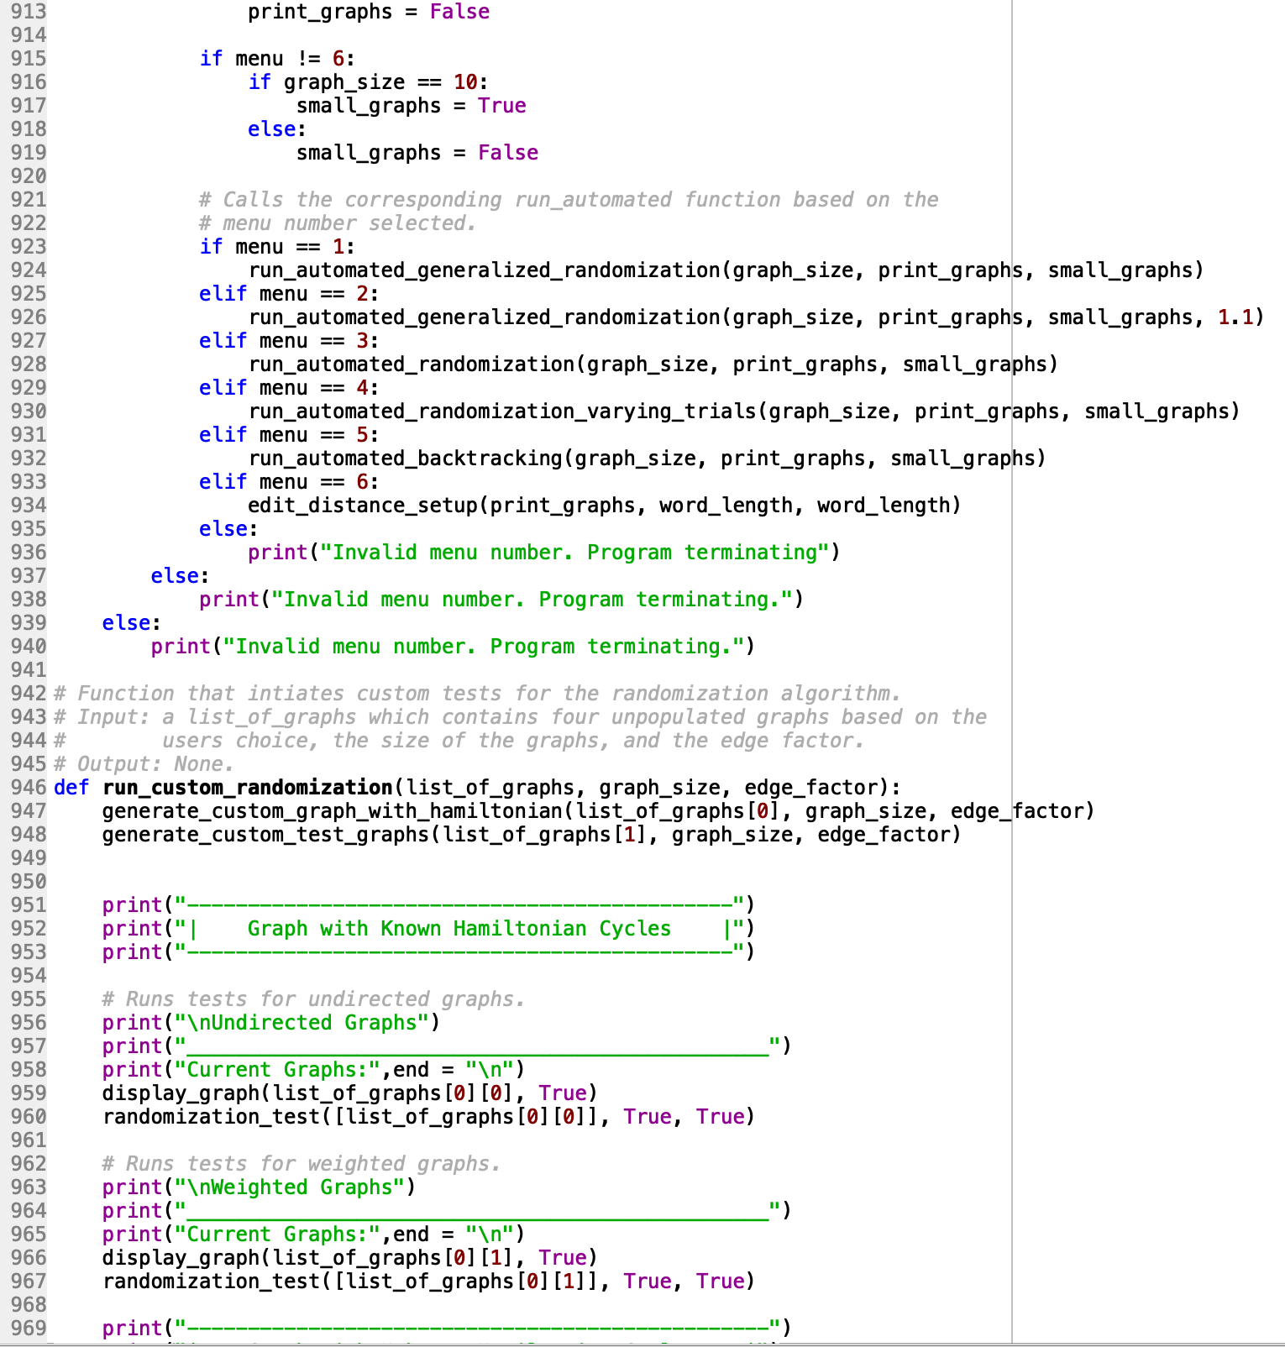

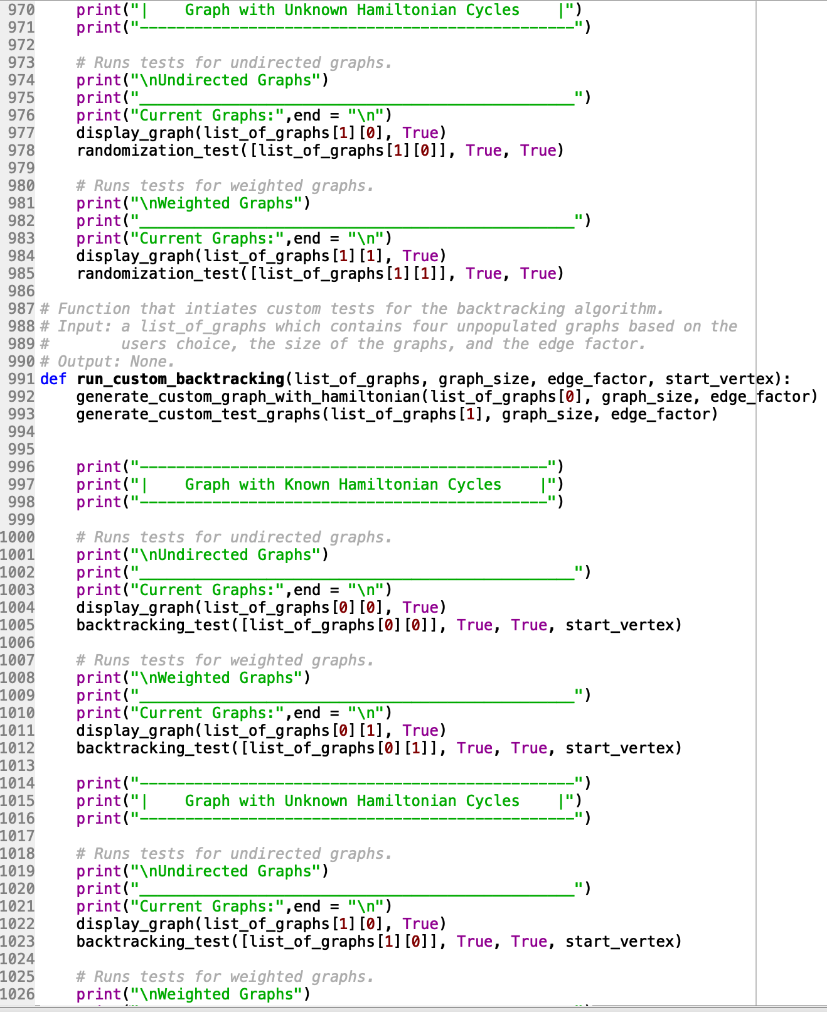

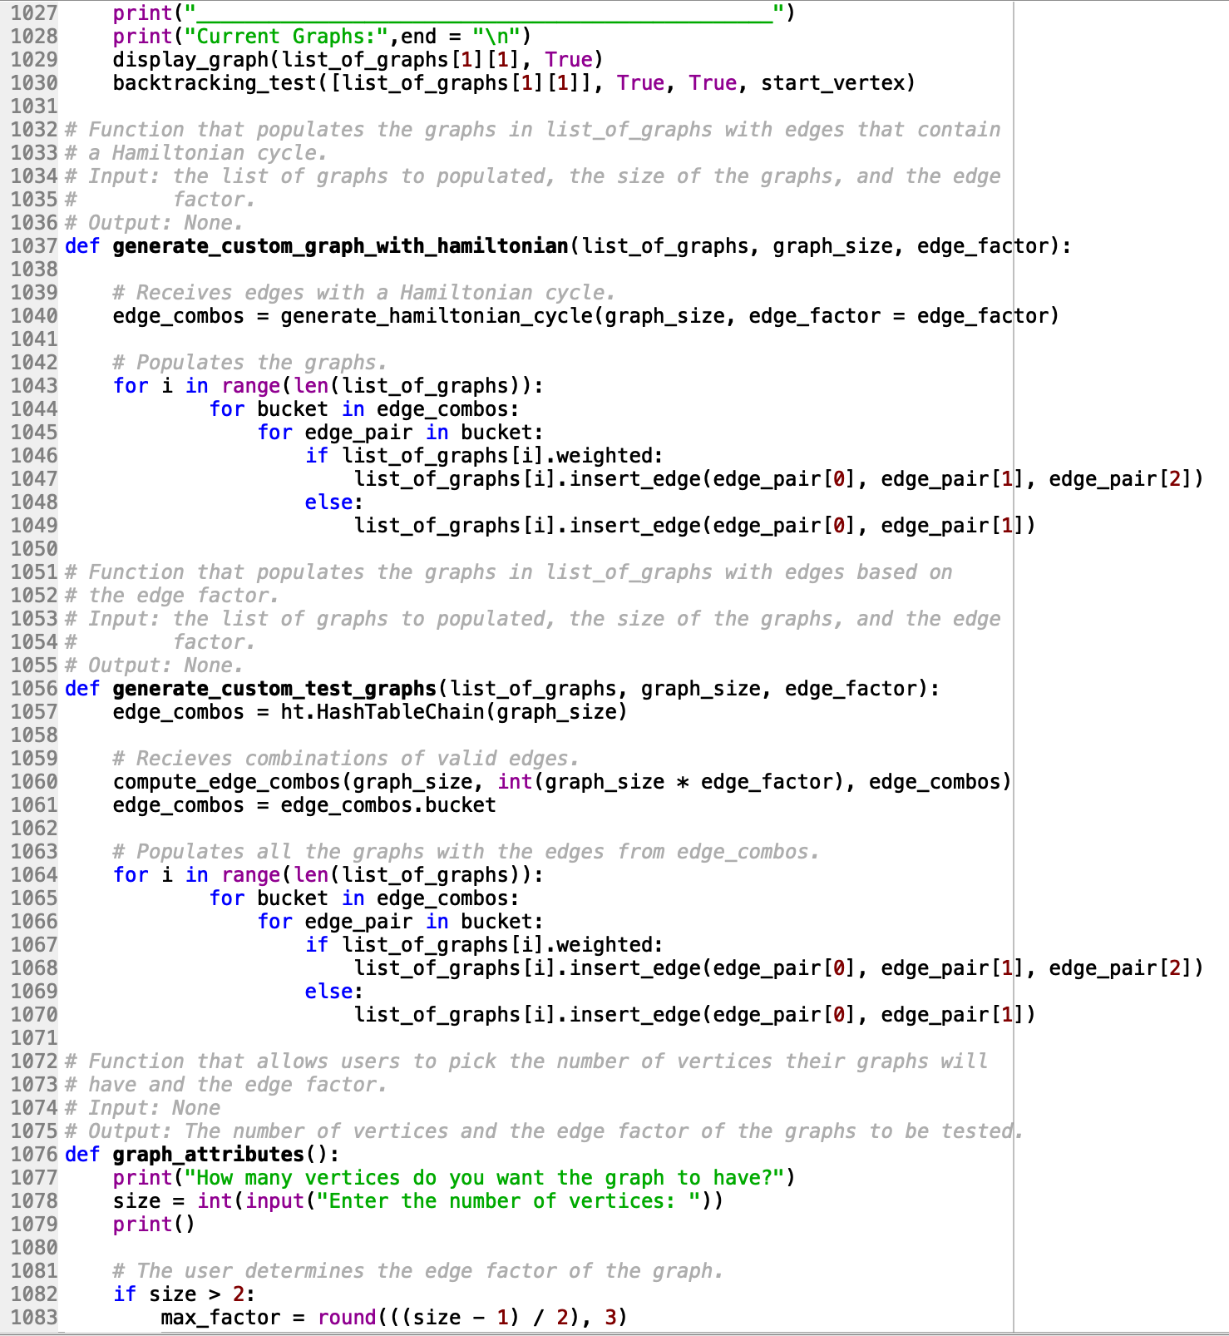

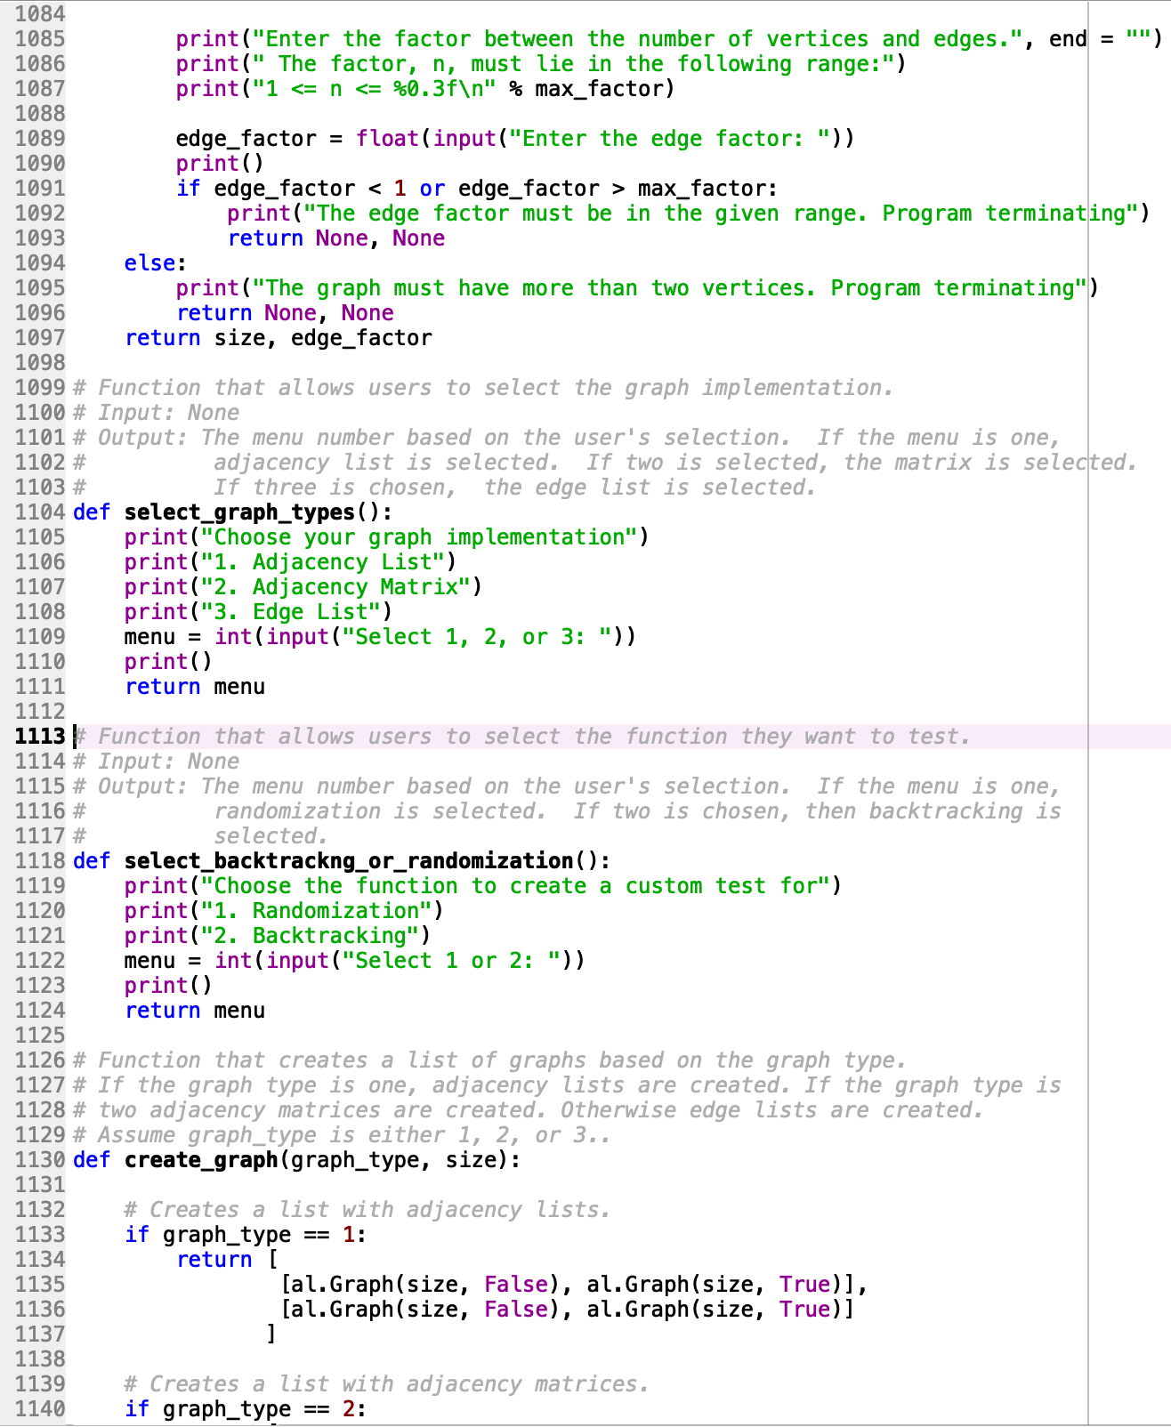

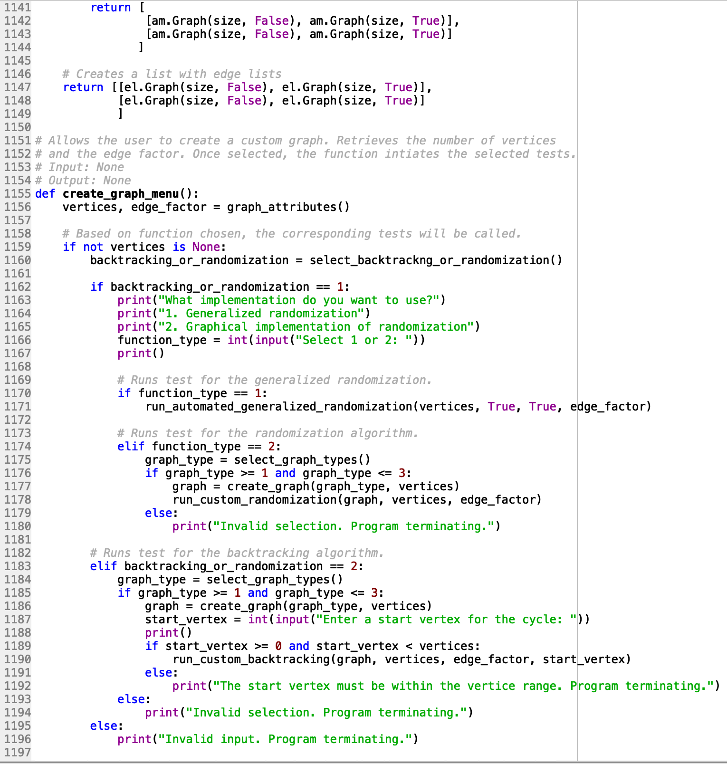

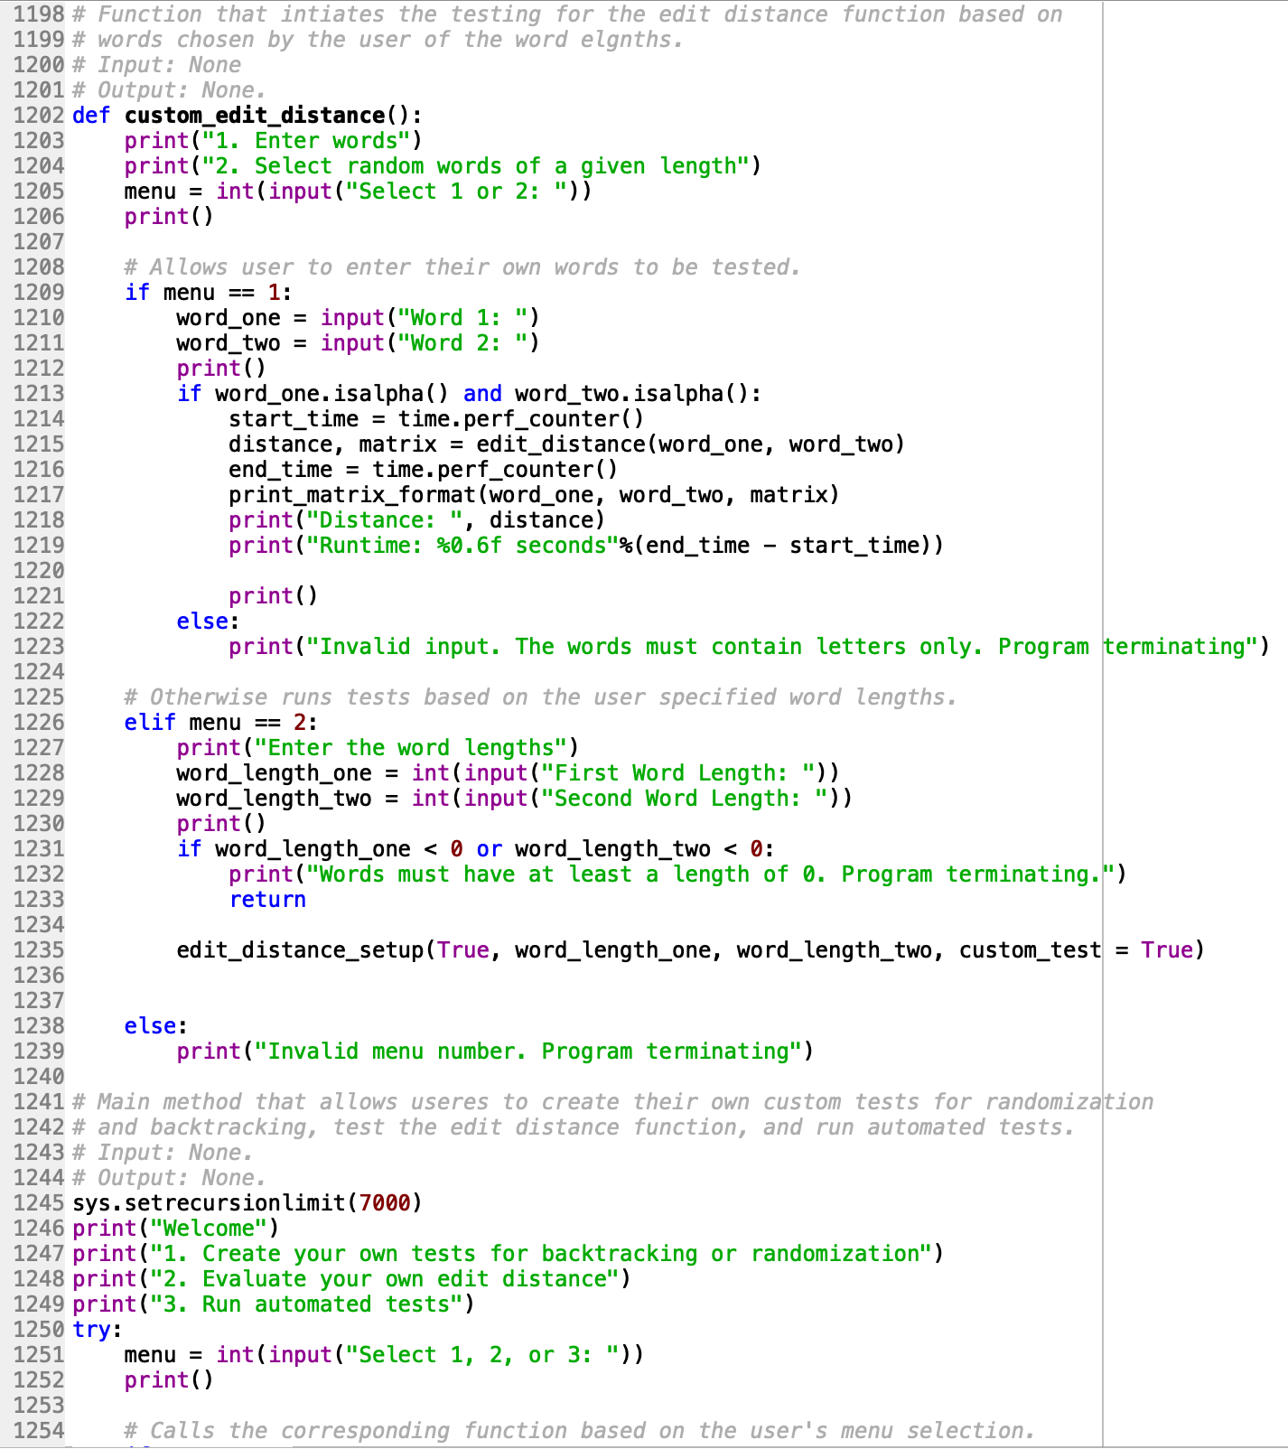

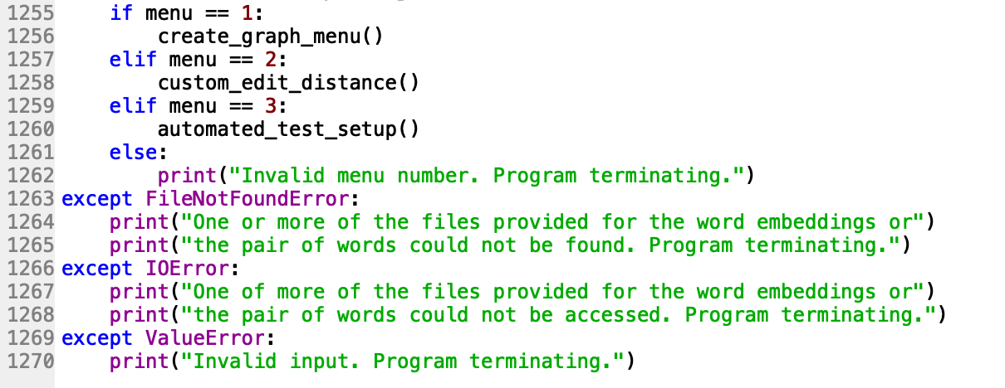

graph_AL.py

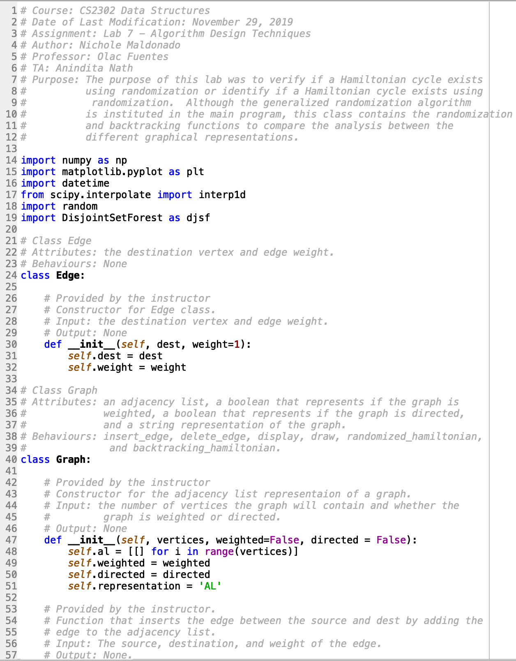

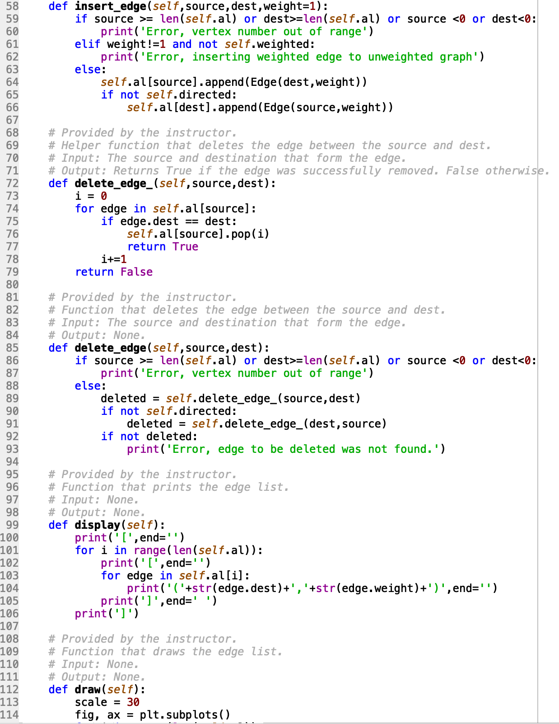

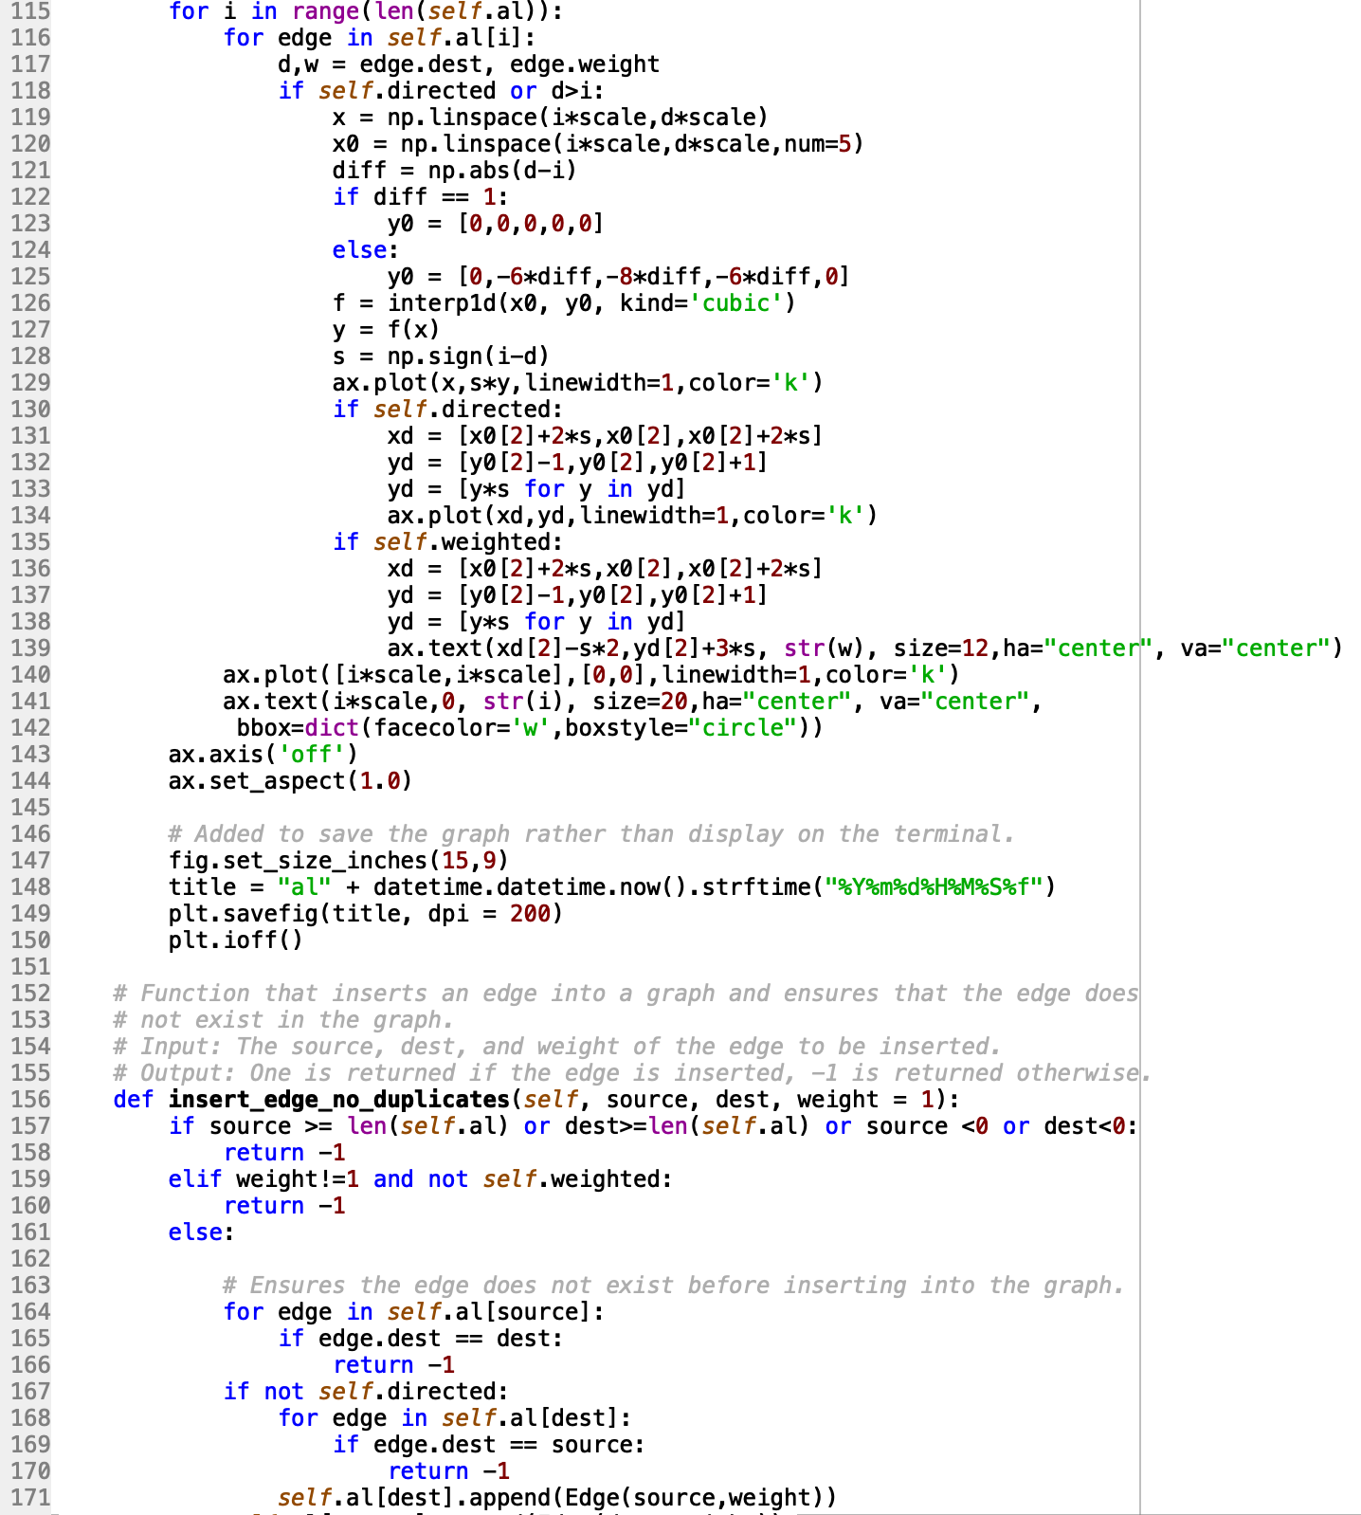

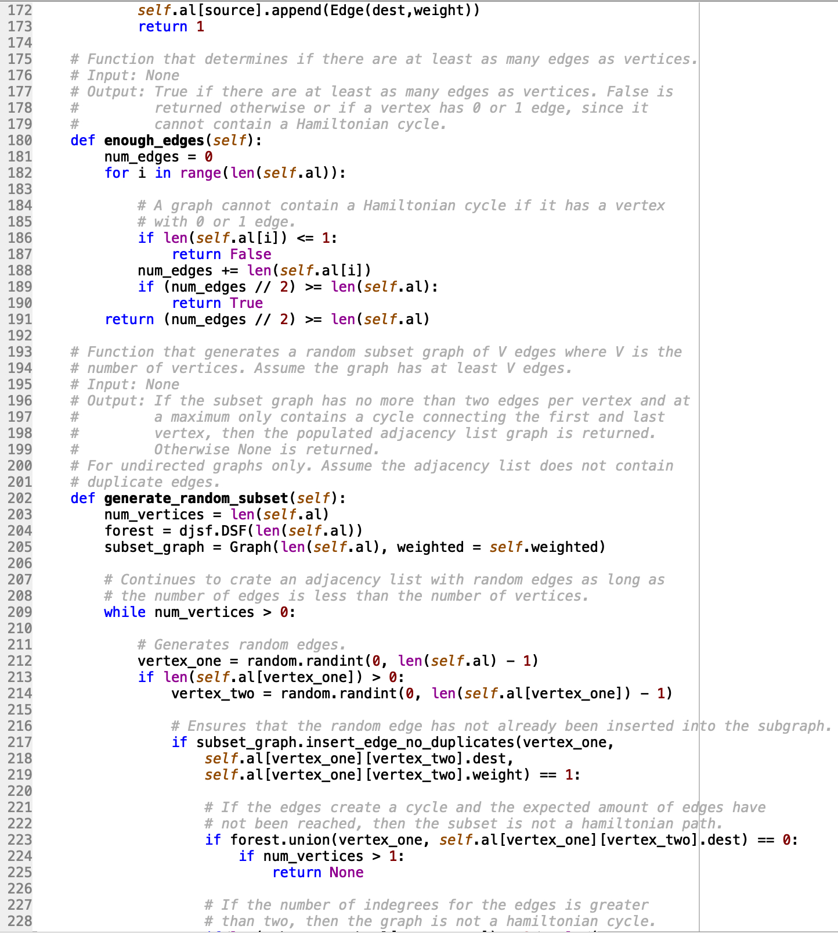

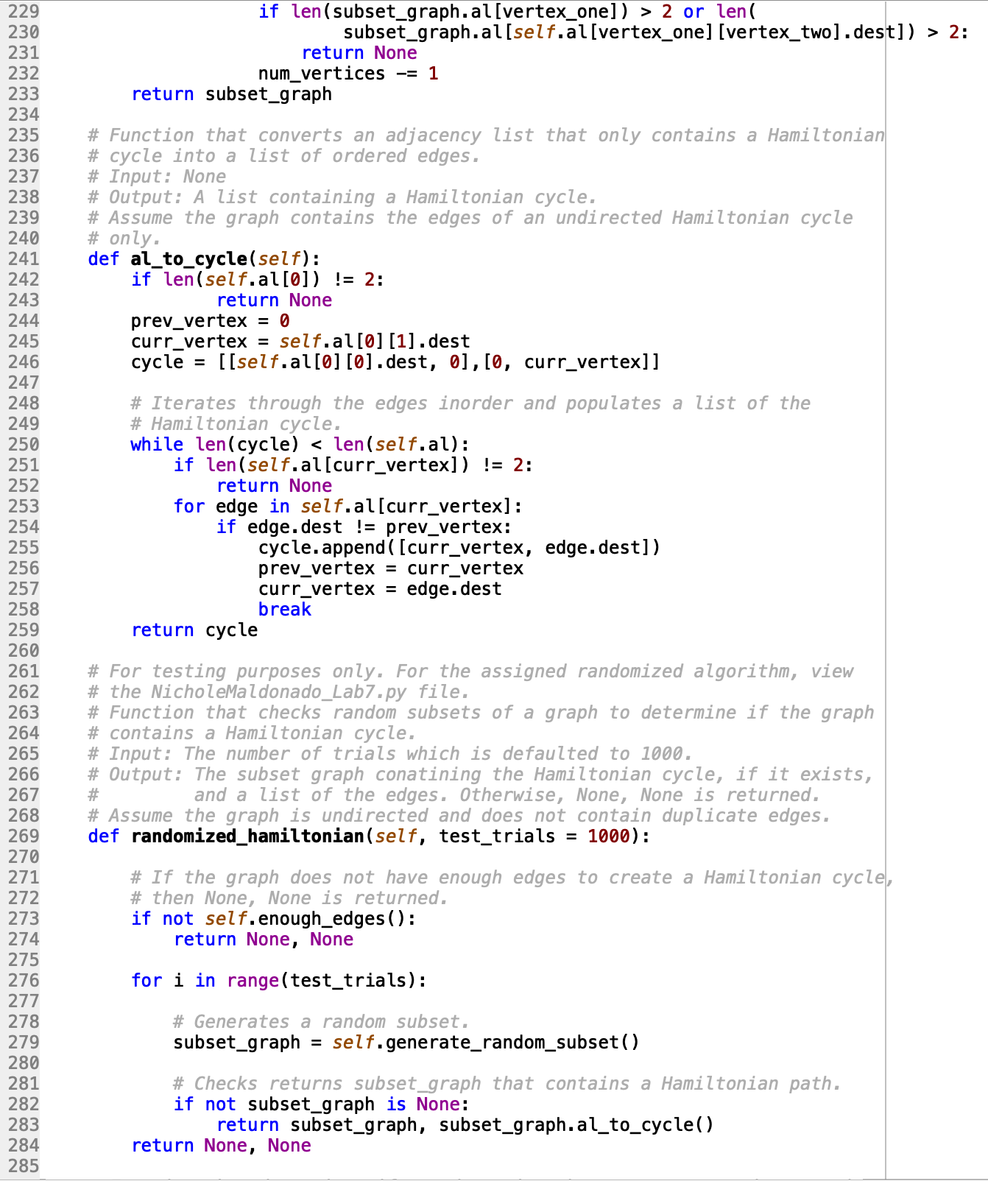

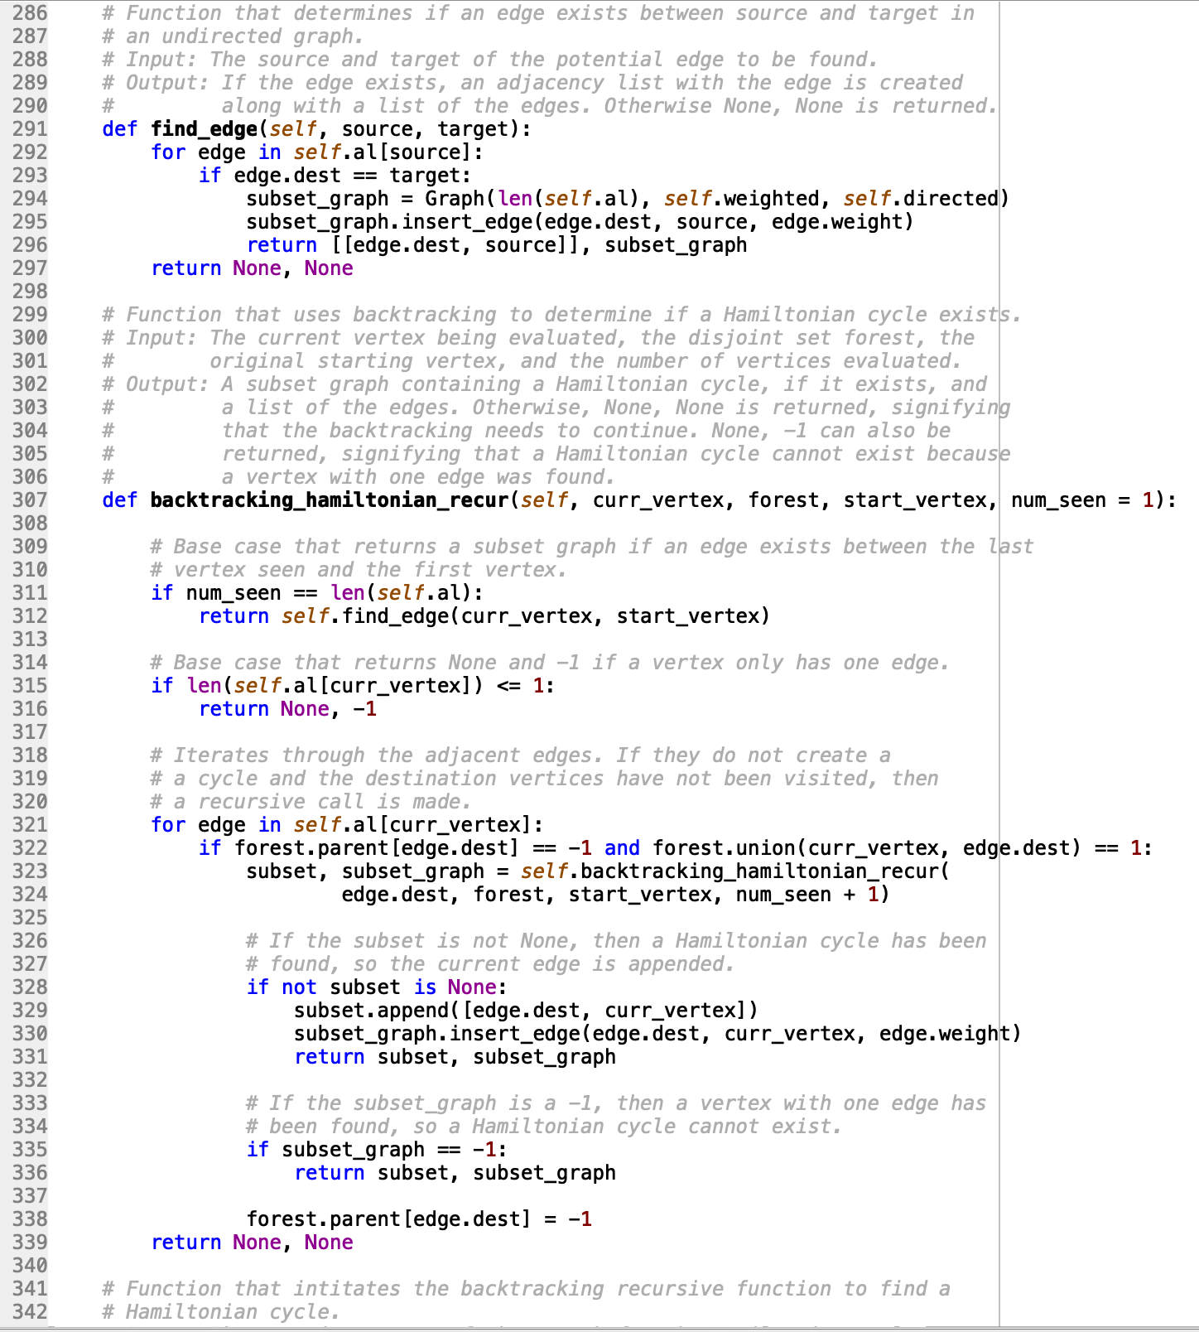

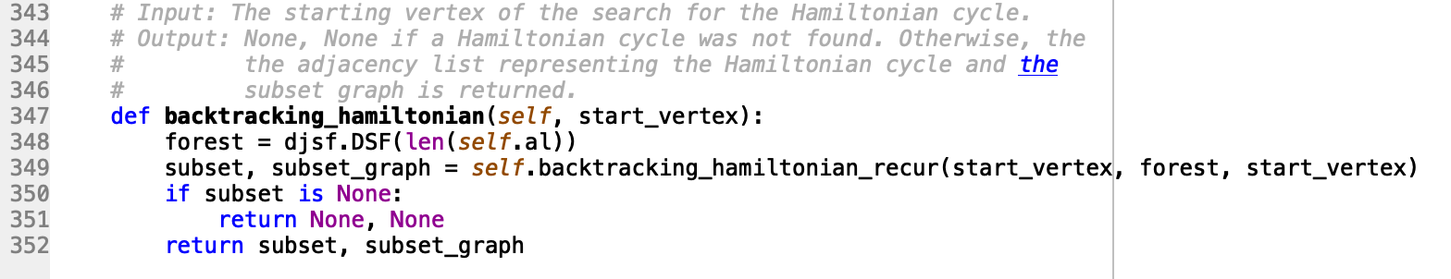

graph_AM.py

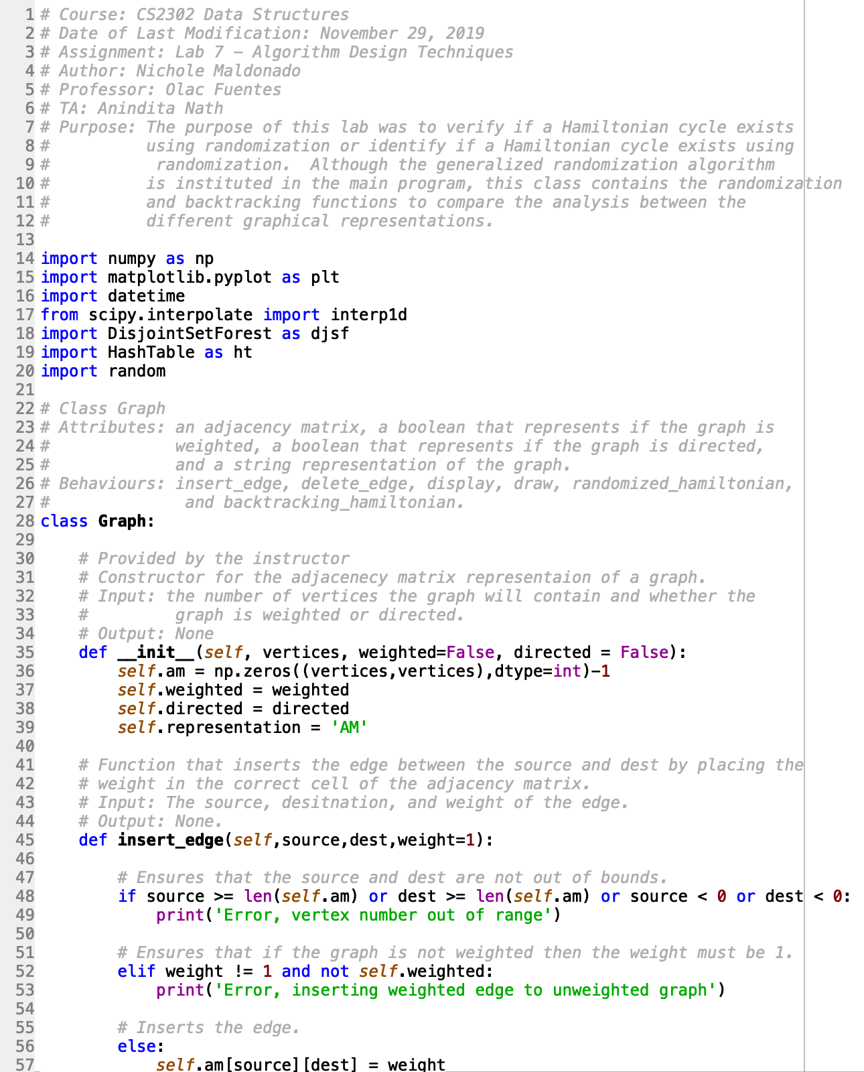

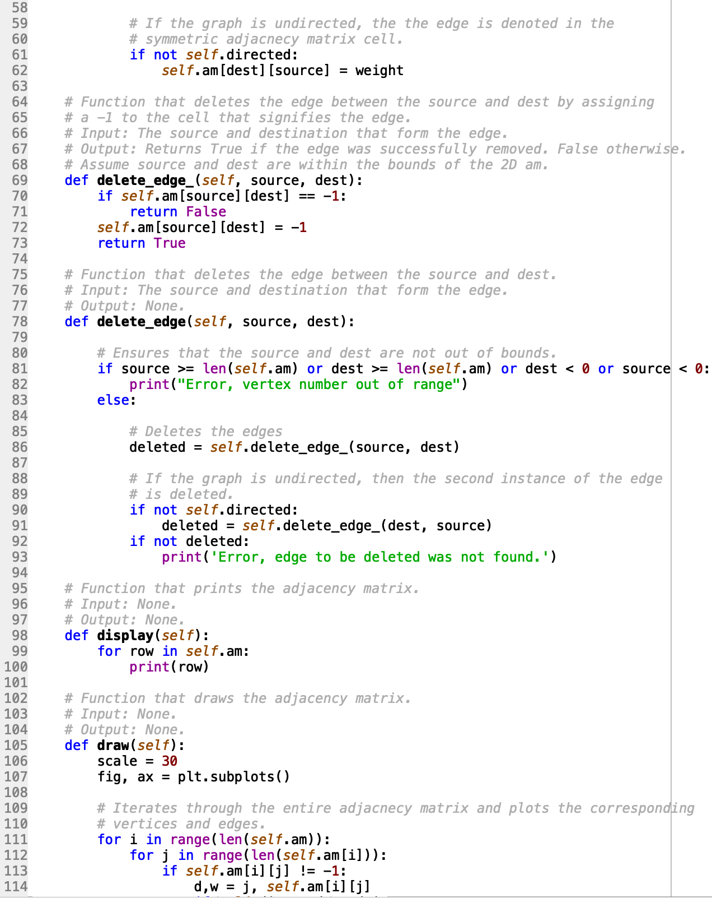

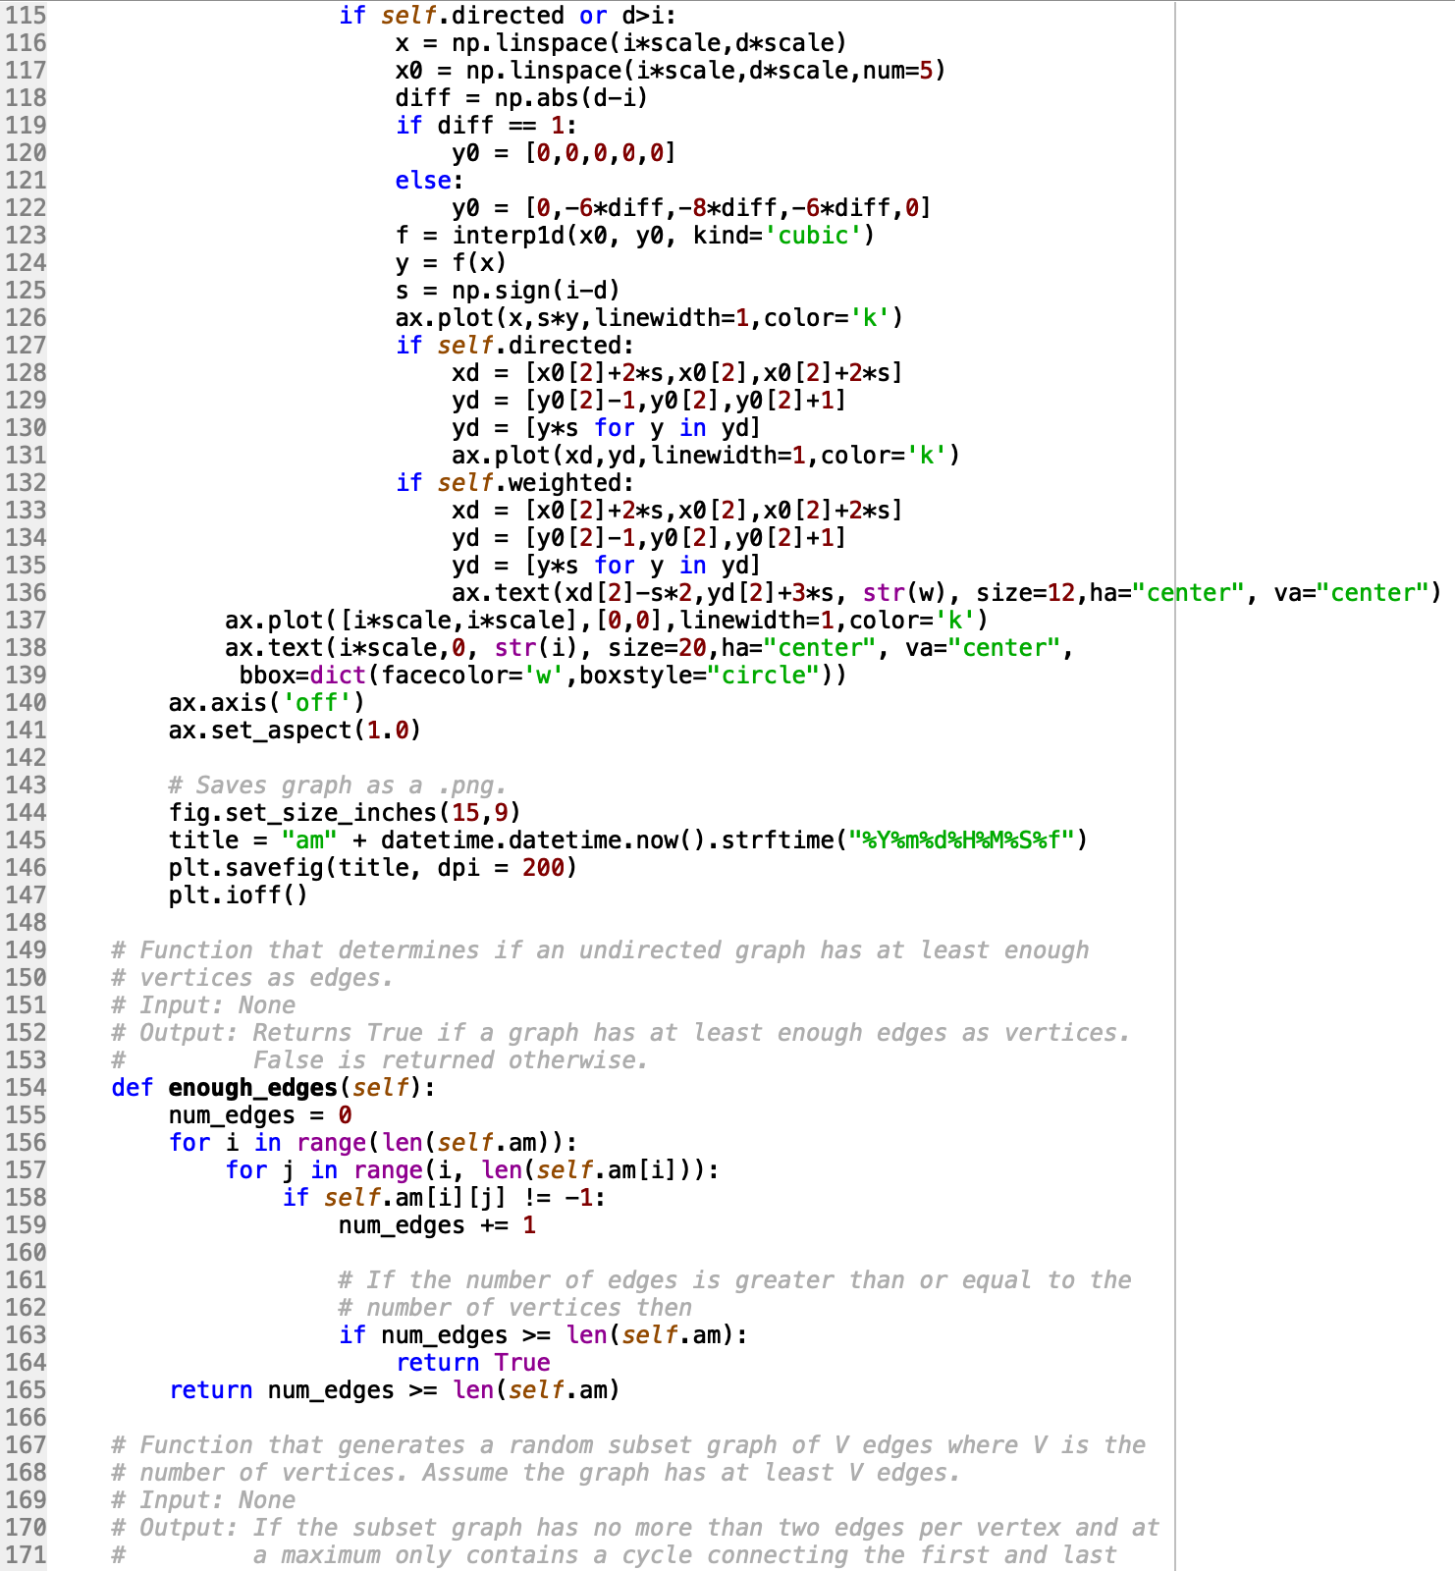

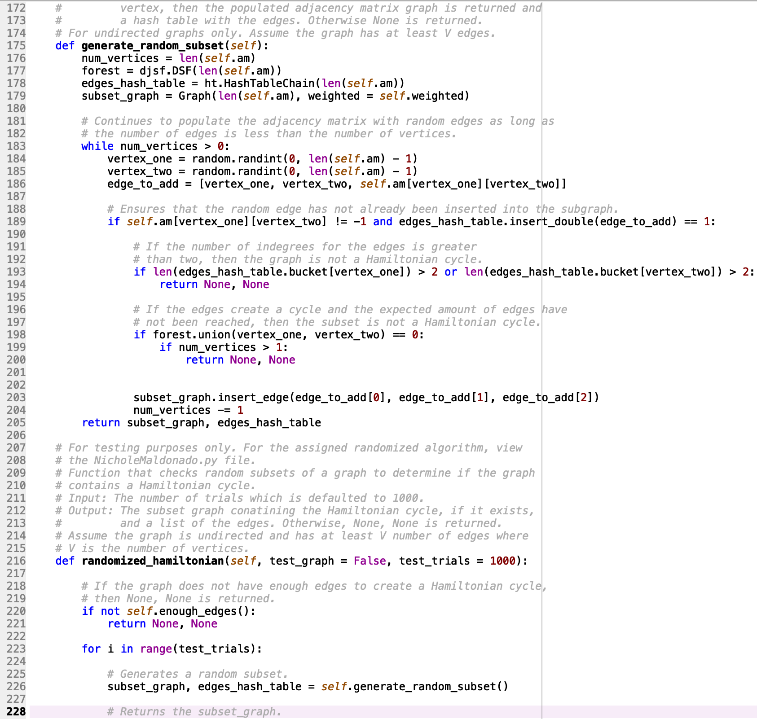

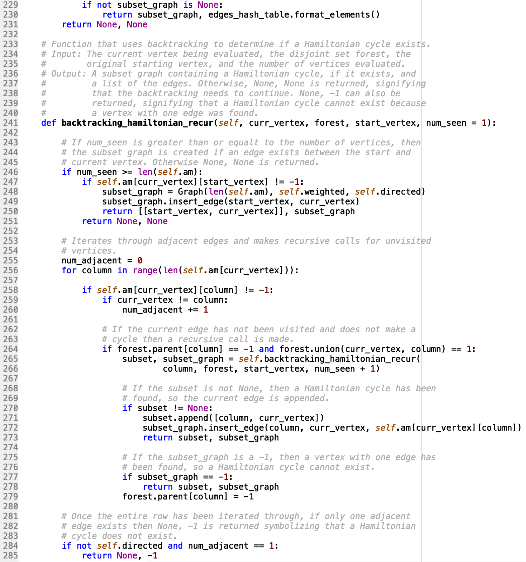

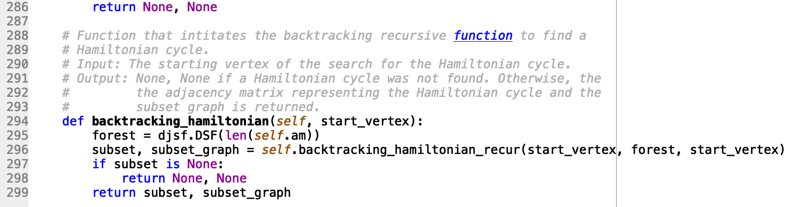

graph_EL.py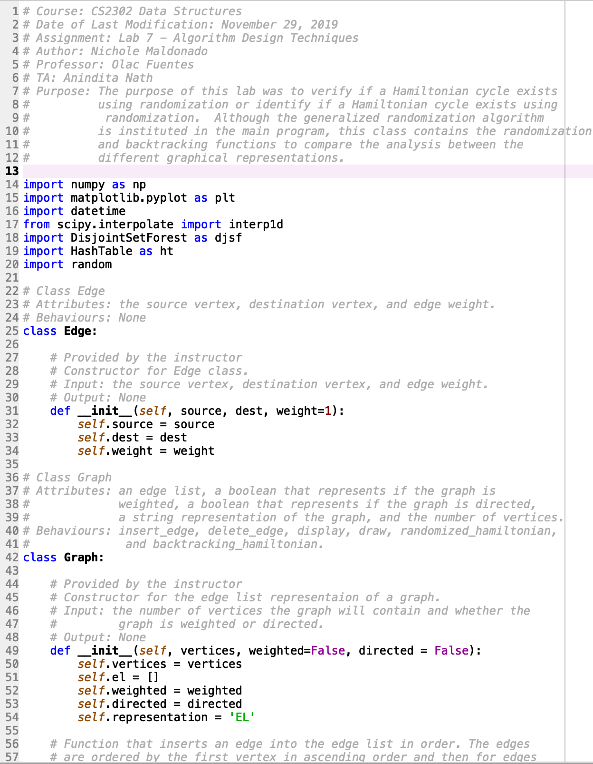

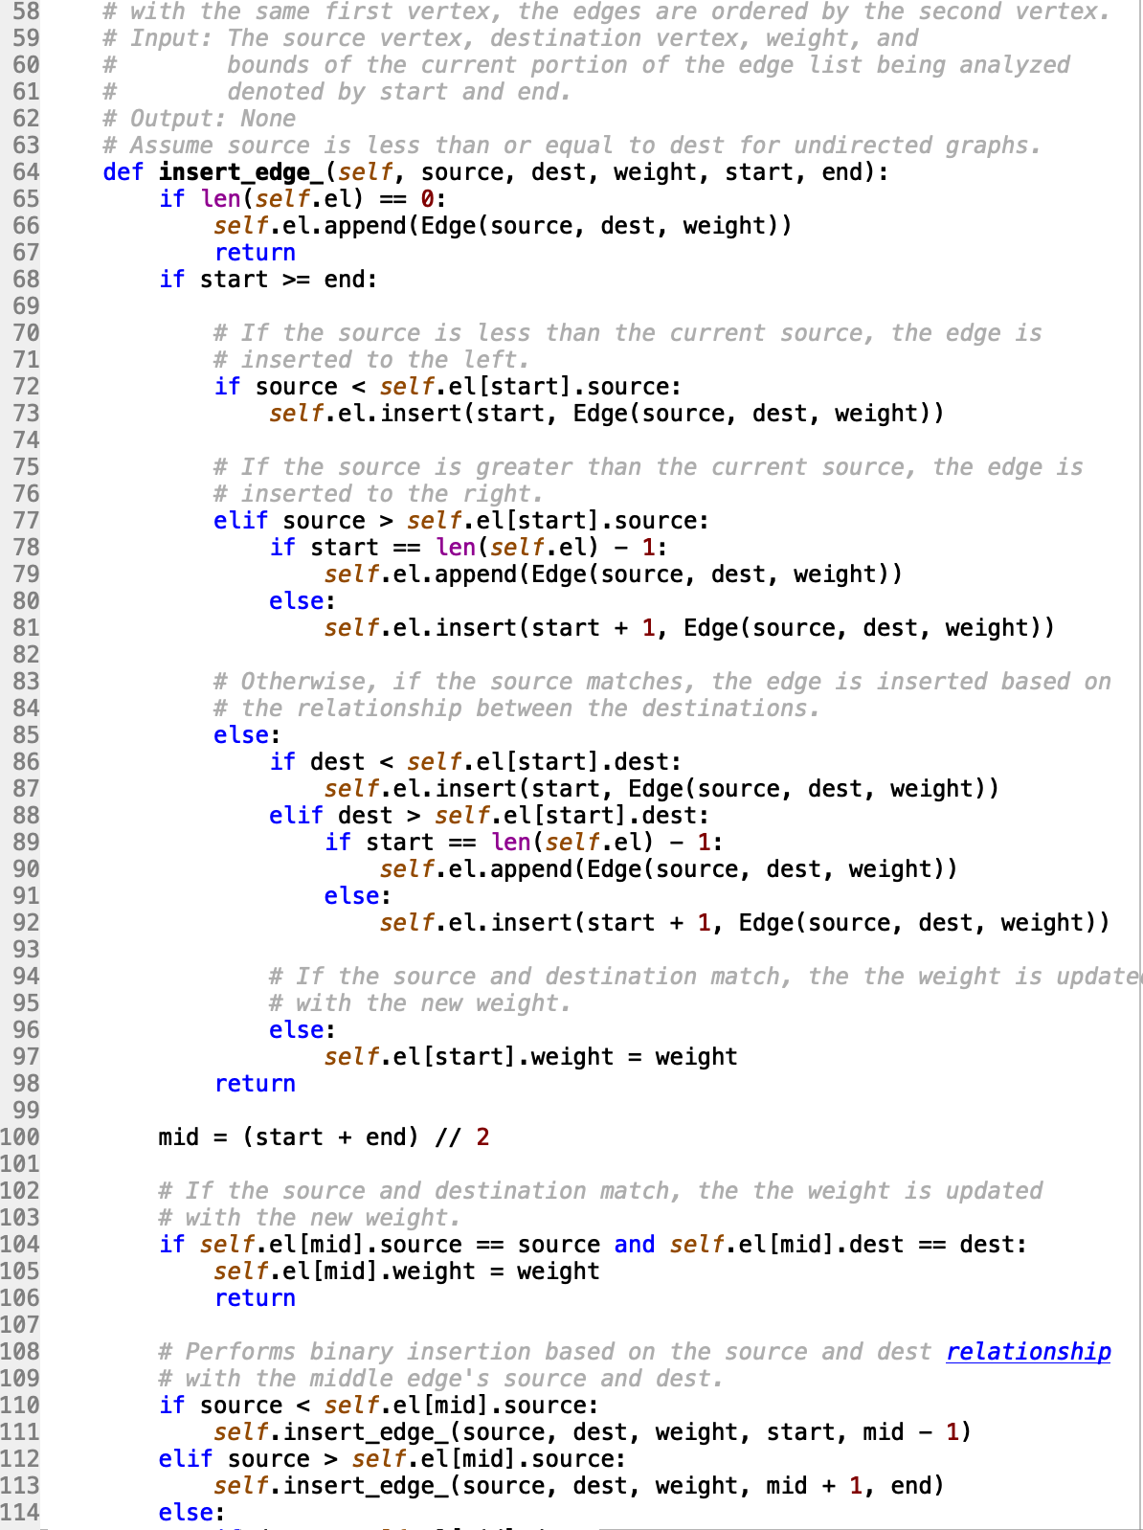

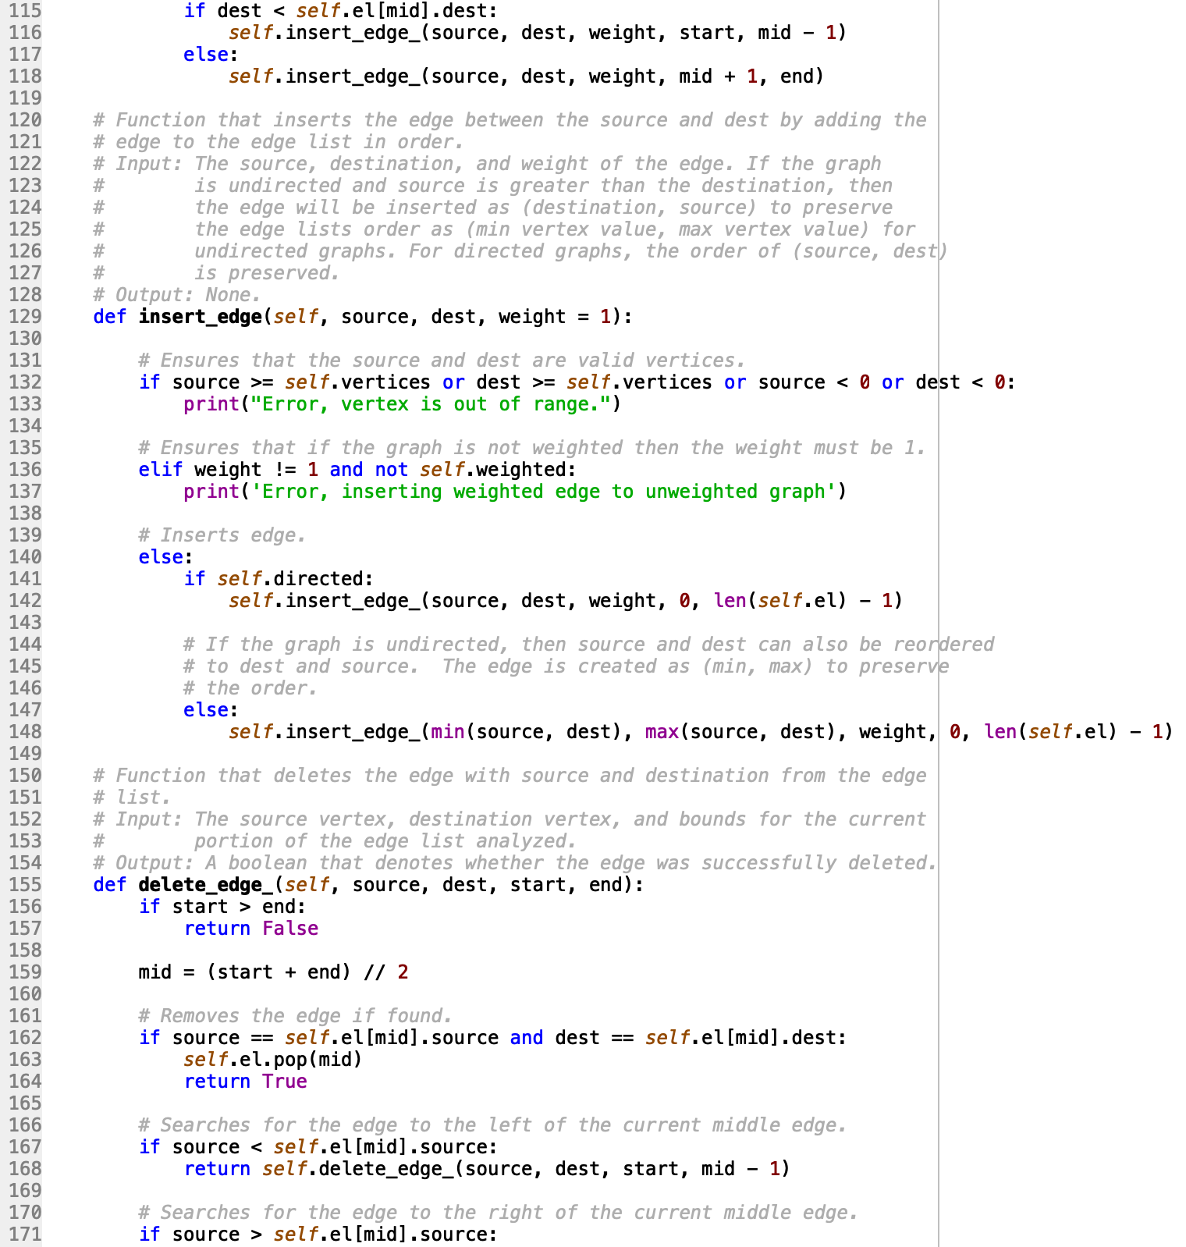

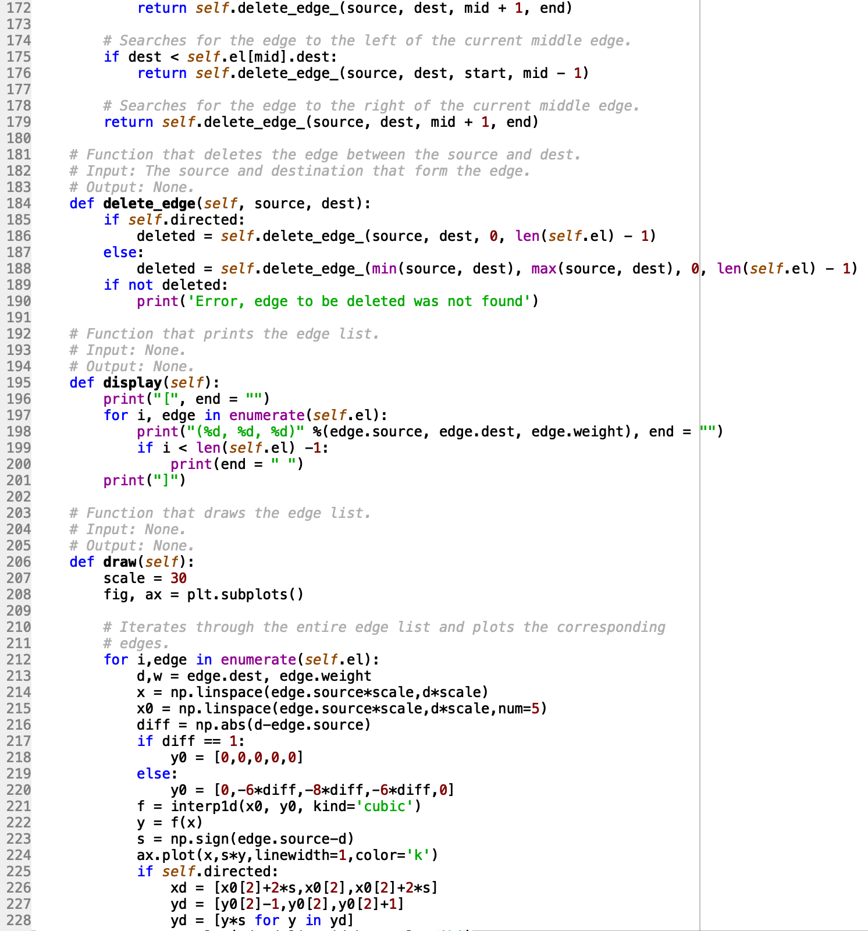

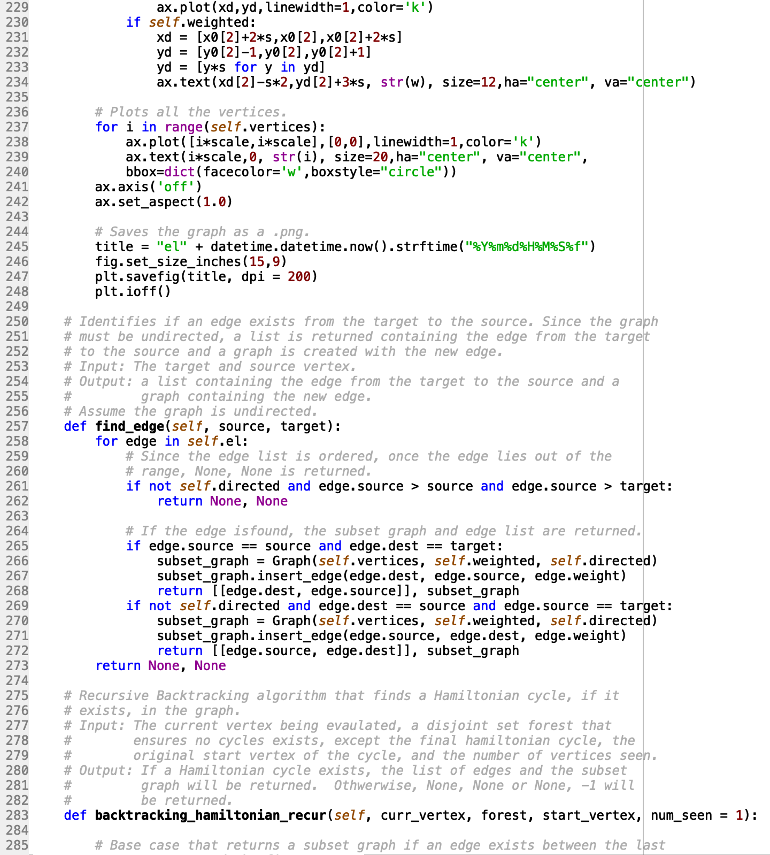

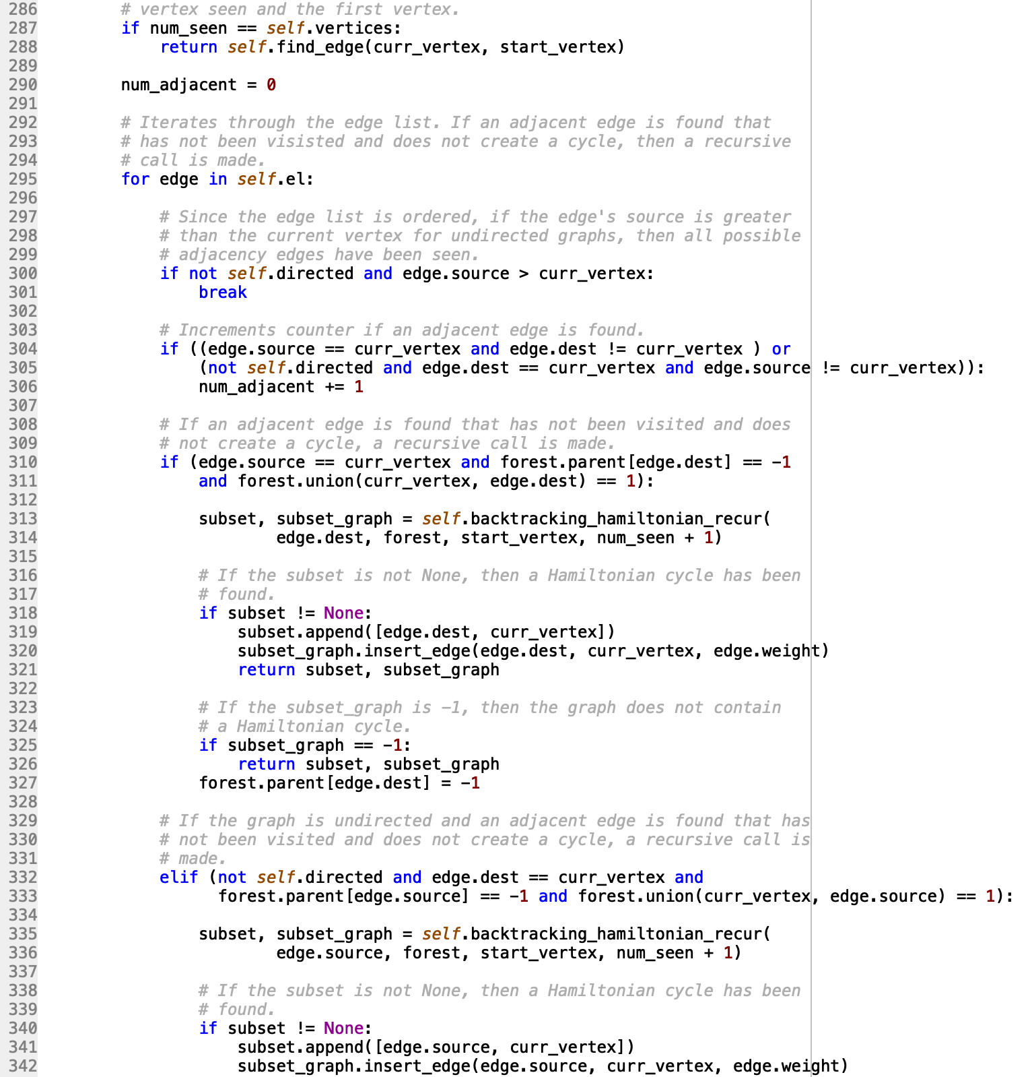

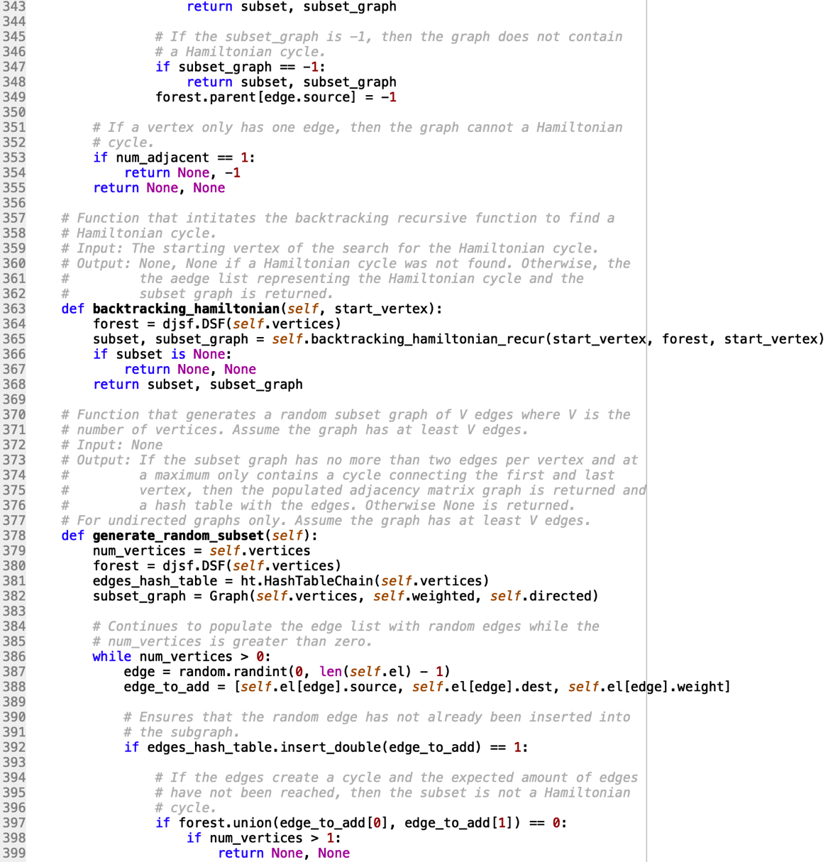

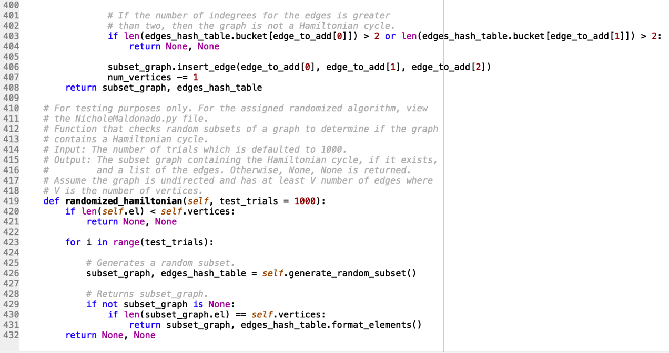

DisjointSetForest.py

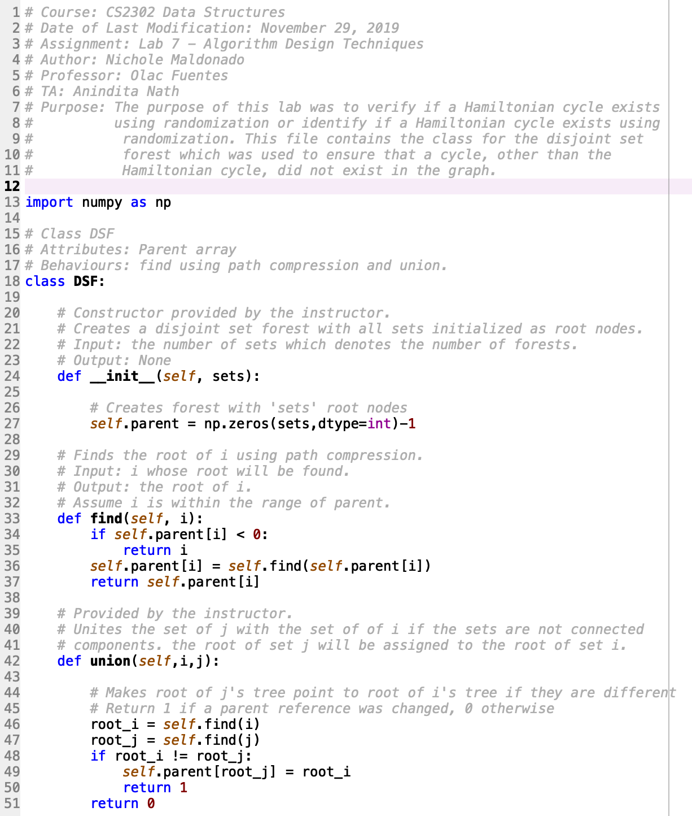

HashTable.py

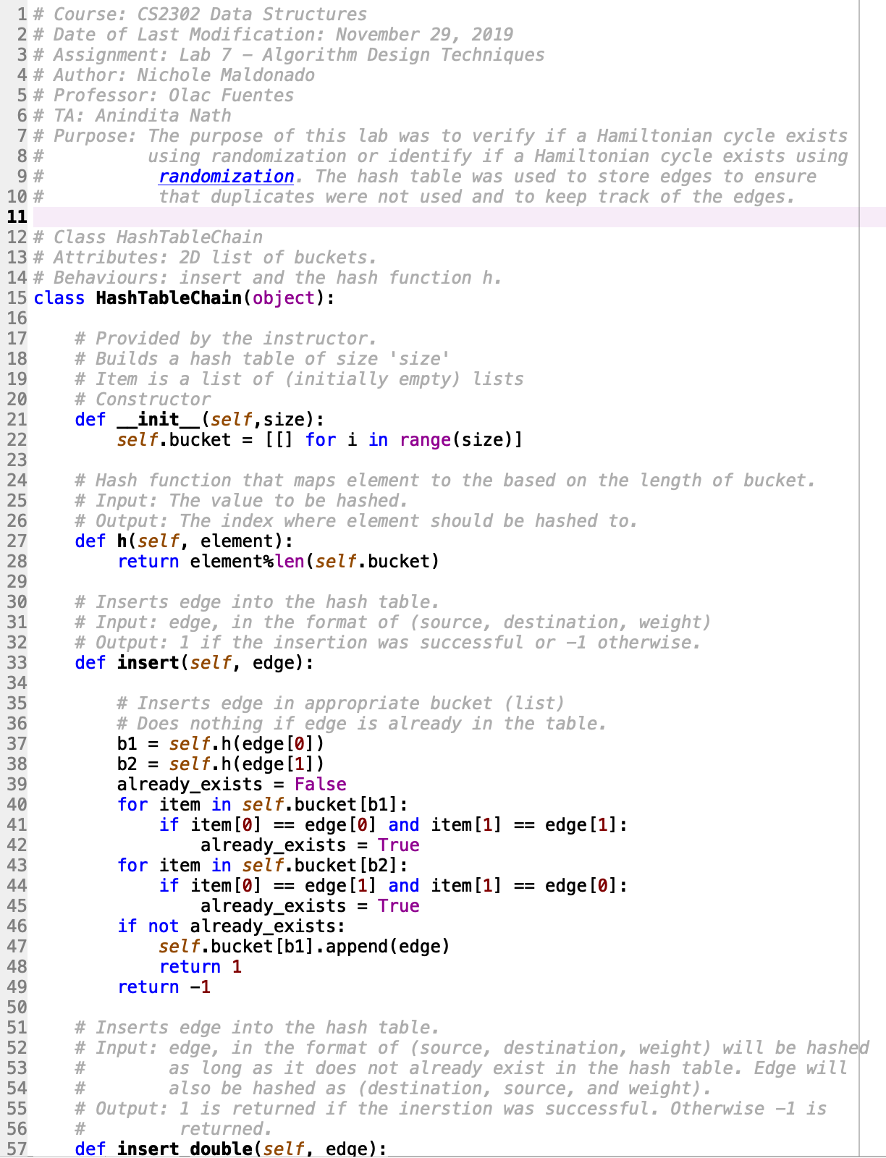

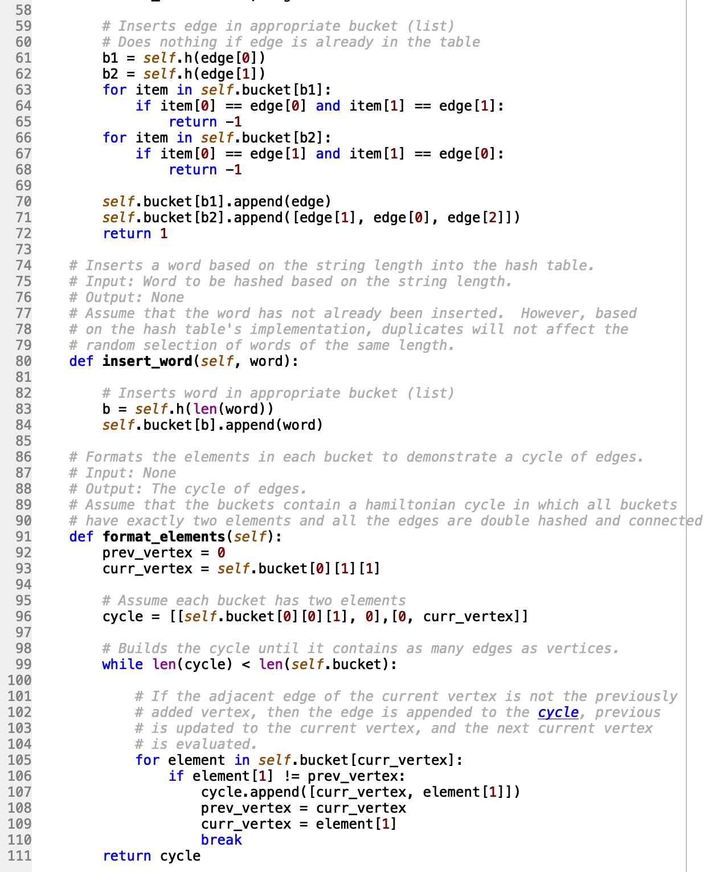

I certify that this project is entirely my own work. I wrote, debugged, and tested the code being presented, performed the experiments, and wrote the report. I also certify that I did not share my code or report or provided inappropriate assistance to any student in the class.

X



-----------------------------------